Stitcher Chooses WSDG to Design NYC Headquarters
Innovative podcasting company the latest in a series of audio content facilities designed by WSDG

New York, May 29, 2019 — Like a number of leading companies in podcasting and audio content production, Stitcher — the parent company of Midroll Media, a leading podcast advertising network representing over 200 of the world’s largest podcasts, as well as top comedy podcast network Earwolf — became the latest in the industry to hire acoustic consulting/A/V integration firm WSDG (Walters-Storyk Design Group) to design its New York studio. Stitcher’s investment in the future of its production facilities in both its New York and Los Angeles offices will help the company better service the artists, entertainers and thought leaders with whom it works, offering a complete set of audio content-related services — from production, to distribution and monetization.

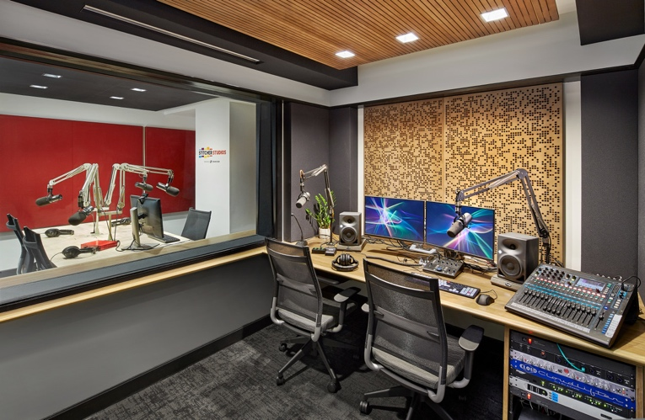
Chief Engineer John Delore began the project by setting out to find the best architectural/acoustic design firm to build out Stitcher’s New York City studio, and — like a growing list of companies in the podcasting industry, including Gimlet and Audible — Delore chose WSDG. “Our brand new headquarters are in an incredible 20,000-square-foot space in midtown Manhattan overlooking Bryant Park,” Delore said. “We identified a specific footprint of about 2,000 square feet to be our new production studios. From the beginning, we worked closely with [WSDG Project Manager] Romina Larregina to define our operational needs, both present and future, and to weigh those against the available space.”

Noting that consumers of podcasts often listen in earbuds or headphones, Delore pointed out the importance of achieving the highest quality sound possible in Stitcher’s Studio. “The voices are right there next to your ear drums, so we need to be extremely particular about getting high-fidelity sound up front,” he said. “That starts wish the room design, and WSDG understood how vital it was that our design incorporate complete within-room, floating floor isolation to preclude any leakage.”
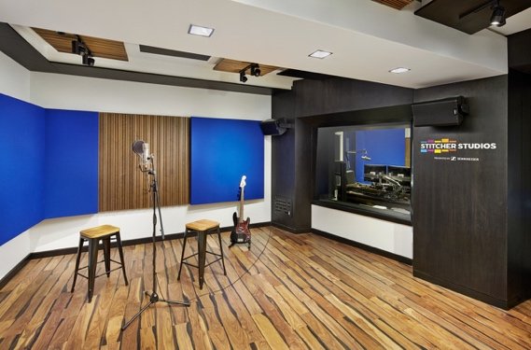
WSDG designed Stitcher’s new studio space to meet the hi-fi needs of the growing audio content industry, included decoupled floors, walls and ceiling structures to ensure the level of isolation required between the various adjacent studios. Key gear components in the studios include Sennheiser microphones and Neumann monitors.“The end result is a beautiful suite of three studios and two edit rooms, plus two additional ISO booths, where we can accommodate anything from a one-on-one interview, to an eight-person roundtable, to the recording of live music in Studio A,” Delore said.

“Studio A was designed to set frequent musical guests completely at ease for their performance session” Larregina said, highlighting WSDG’s uncompromising attention to detail on the project. “A clean, bright, straightforward floor plan optimizes every inch of allotted floor space with the most appropriate acoustic treatments to further enhance the overall high quality sound environment. Stitcher Studios represent a new standard for podcast production.”

ABOUT WSDG, LLC
For nearly 50 year, acoustic consulting and A/V integration firm WSDG hasbeen designing media production facilities worldwide, over 3500, and counting. Projects range from Jimi Hendrix’s Electric Lady Studio and Jazz At Lincoln Center in New York, to broadcast facilities for The Food Network, CBS and WNET, over twenty teaching studios for The Art Institutes, and corporate clients such as Sony, IBM and Novartis. Recent credits include Jungle City in New York, The Church Studio, in London, private studios for Green Day, Jay-Z, Bruce Springsteen, Alicia Keys and Academy Award-nominated film composer Carter Burwell. WSDG has collaborated with such noted architects as Frank Gehry, Philippe Stark, Rafael Viñoly, Santiago Calatrava, Grimshaw, and Norman Foster. An eleven-time winner of the prestigious pro audio NAMM TEC Award for outstanding achievement in Acoustics/Facility Design, WSDG maintains U.S. offices in New York, Washington, DC, San Francisco and Miami and global offices in Barcelona, Basel, Berlin, Belo Horizonte, Buenos Aires, Guangzhou, Mexico City and Mumbai.

Contact:

Steve Bailey
Hummingbird Media, Inc.
+1 (508) 596-9321
steve@hummingbirdmedia.com

Jeff Touzeau
Hummingbird Media, Inc.
+1 (914) 602-2913
jeff@hummingbirdmedia.com

