The Show Must Go On: Broadway Keyboard Programmer Turns to RME Fireface 802
for Robust Sound and Dependability
Dave Weiser employs the 60-channel high-end audio interface on Broadway and touring productions of ‘Phantom of the Opera’ and ‘Mary Poppins’ for guaranteed reliability night after night
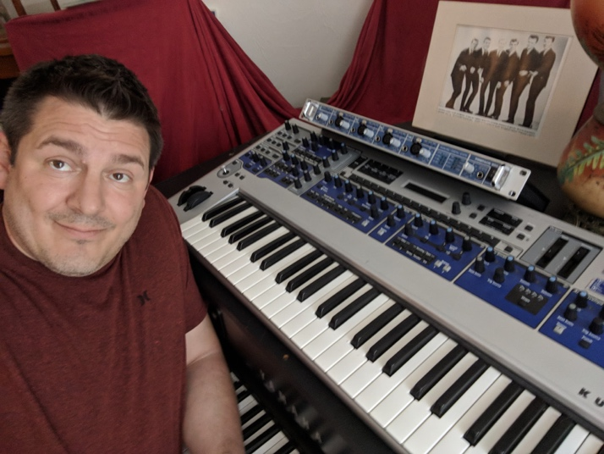
Boston, MA – June 18, 2018 – For the last six years, Dave Weiser has worked as an associate keyboard programmer on some of the biggest hit musicals on Broadway, including “Evita,” “Le Mis” and “Phantom of the Opera” as well as a number of worldwide and touring productions, including “Mary Poppins,” “Jesus Christ Superstar” and “The Wizard of Oz.”
With nearly 100 productions going on across the world at any given time, Weiser and his team are responsible for providing hundreds of sounds from three keyboard rigs, including pianos, celeste, harp, strings, horns, winds and sound effects. To complete this task, Weiser employs RME’s Fireface 802 for quality performance and sound from his keyboard rigs, show after show.
“In our business, everything has to sound perfect during every minute of every performance — once a day and twice on Saturday,” Weiser explains. “Both hardware- and software-wise, RME’s level of quality is something I can count on every single night. I get top-notch sound, low latency and reliable operation.”
Robust & Reliability
An avid user of RME products since 2013, Weiser uses keyboards to augment a theatre pit ensemble of 10-15 musicians and make it sound like 40-50. Weiser runs his software through a Fireface 802, a 60-channel, high-end 192 kHz USB/FireWire audio interface that provides him with a solution that is both robust and reliable.
“The 802 checks all the boxes,” Weiser says. “Not only does it sound amazingly good, but just as importantly, it’s extremely robust and reliable. I need everything to work night after night with no exceptions. The software is completely dependable, and you can literally drop the unit off the back of a truck and it’ll still work.”
Because the occurrence of random glitches is always a present threat for engineers working with computer audio, Weiser used to keep spare interface units on hand — until he began working with RME.
“We have three keyboard players at every show, so each player’s rig has an 802 and then there’s one spare per show,” he explains. “Before we were on RME, we had one back up interface per rig, but after RME we went down to one spare for the whole show. With RME, we just don’t need the same amount of spares.”
‘Jesus Christ Superstar’ Live
Weiser turned to his Fireface 802 once again while working on the live, televised production of “Jesus Christ Superstar Live in Concert” on network TV back in April 2018. Posing similar demands as the Broadway productions, Weiser needed a unit that he could rely on to offer quality sound and low latency for the program that featured musical acts such as John Legend and Alice Cooper.
“The Fireface 802’s sound quality, lightning-fast performance and unwavering reliability are simply unmatched,” Weiser said. “Those things are absolutely critical for a live TV production like ‘Jesus Christ Superstar’ where everything has to be flawless. On a pressure-cooker show like that, we’re endlessly thankful for the peace of mind that RME interfaces provide.”
Lifelong Recording Experience
Before working as a keyboard programmer on Broadway, Weiser began his sound programming career at Kurzweil Music Systems where over the course of 13 years he was lead sound designer and product manager.
As a former manufacturer — and someone who still consults for Kurzweil — Weiser has an extra appreciation for quality-made recording gear.
“It’s very satisfying as a guy who used to manufacturer musical gear to use RME products. I used to fight and argue and drive myself crazy with the lofty goal of trying to imitate RME’s level of quality when I worked for a manufacturer,” Weiser says. “I’m just thrilled now to be able to use RME on a daily basis.”
For more on RME, visit rme-usa.com

About Synthax, Incorporated
Synthax Inc. is the exclusive USA distributor for RME digital audio solutions, Ferrofish advanced audio applications, myMix audio products, and ALVA cableware. We supply a nationwide network of dealers with these products for professional audio, broadcast, music industry, commercial audio, theater, military and government applications. For additional information, visit the company online at http://www.synthax.com.
Media Contacts:
Katie Kailus
Public Relations
Hummingbird Media
+1 (630) 319-5226
katie@hummingbirdmedia.com

Jeff Touzeau
Public Relations
Hummingbird Media
+1 (914) 602 2913
jeff@hummingbirdmedia.com

