Specialised PR Agency for Cutting Edge Hair Professionals.
Creative Hairdressers are our clients.

For more information, please contact Marta de Paco
On +34670780664 or email press@dreamscometrue.es

Important:
These images are only available for editorial content.
Credits must be included.
Notification of their publication is expected.

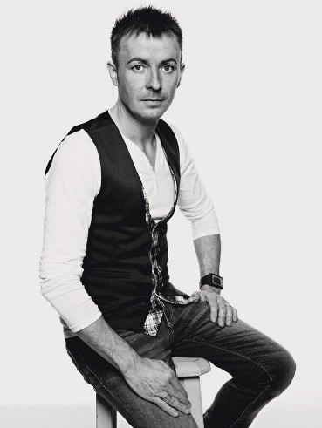
MANUEL MON
OLIMPIA Collection

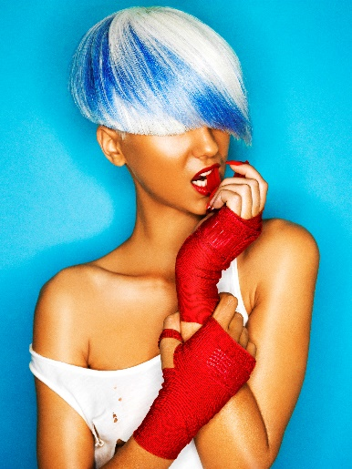
WARDS 2Hair: Manuel Mon @Manuel Mon Estilistas
Instagram: @manuelmonoficial
Photographer: Bernardo Baragaño Instagram: @vertigoestudio
Make-up: Helena Truébano y María Montes
Styling: Adriana Miranda
Products: Revlon Professional Instagram: @revlonprofessional_es

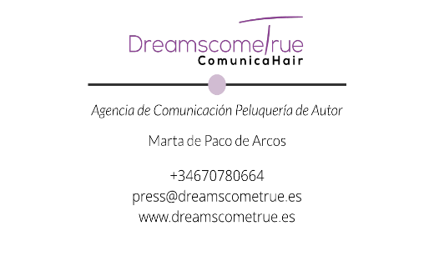
MANUEL MON
OLIMPIA Collection

In each effort, in the impetus of each of our actions, we express the electricity of our being. We transpire vibrations and exhale the energy that moves us.
Olimpia by Manuel Mon is the representation of our transmuted power in the symbology of sport. Short hairstyles full of strength and colours that are like the explosion of our character: agility, vigor and originality.

