

Biuro prasowe better. gaming agency
bettergamingagency.prowly.com

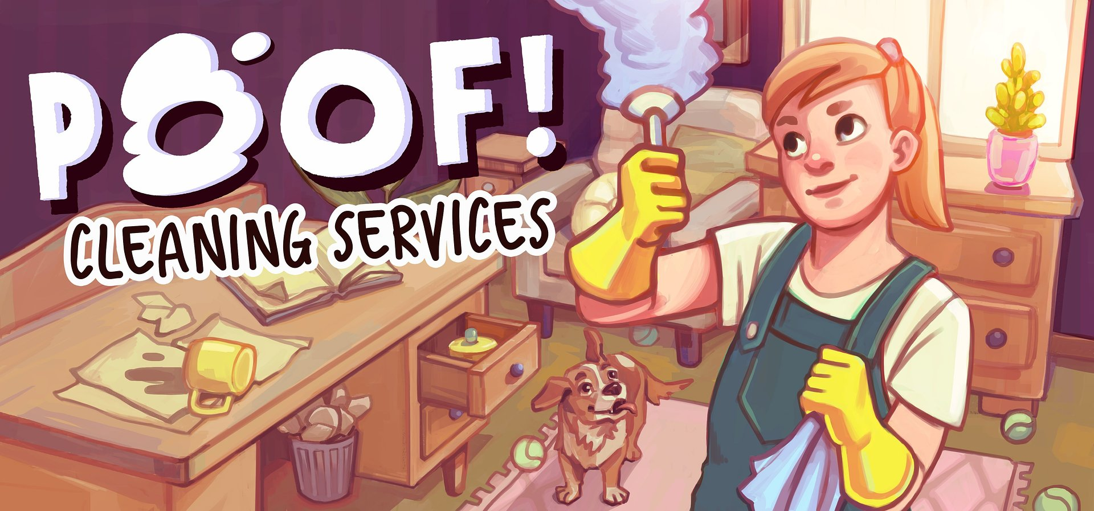

Time for a big clean-up – Poof! Cleaning Services will help you find joy in tidying up

Serious Sim – the team behind titles like Radio Commander and Heading Out – invites you to roll up your sleeves for some serious dusting. In Poof! Cleaning Services, players step into the shoes of a cleaner who’s moved abroad to make a living by organizing and taking care of other people’s homes. The team has just officially unveiled the game with its first trailer, and the release is slated for 2026.

Working, cleaning, emigration – these keywords might make Poof! Cleaning Services seem like just another souls-like – but nothing could be further from the truth! The developers have focused on creating a relaxing experience, with no time pressure or risk of failure. Tidying up rooms full of secrets and curiosities is meant to be primarily calming and satisfying – and that’s the core idea behind the game.

Poof! Cleaning Services – announcement trailer

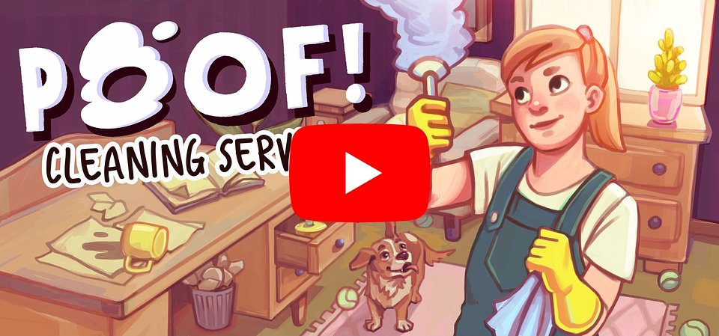
https://www.youtube.com/watch?v=py7p75wdvGs&ab_channel=SeriousSim

Throughout the adventure, players take on the role of Lena, an immigrant who knows only the basics of her new language. However, it quickly becomes clear that her role goes beyond just helping with cleaning. In Poof! Cleaning Services, every room tells its own story through the items discovered while sweeping and wiping. Driven by curiosity or a motivation to help clients deal not only with the mess in their homes but also the troubles in their lives, players will search for various objects and interpret their findings, putting the pieces together to learn more about homeowners' stories - seemingly insignificant items might hide intriguing secrets.

Lena’s sanctuary during her time abroad will be the modest flat she rents. Her cozy little space can be decorated with gifts received from clients – these will vary depending on what is discovered during each cleaning job. Poof! Cleaning Services is a game inspired by real-life experiences, showcasing the concerns, challenges, and hopes that come with the life of an immigrant worker.

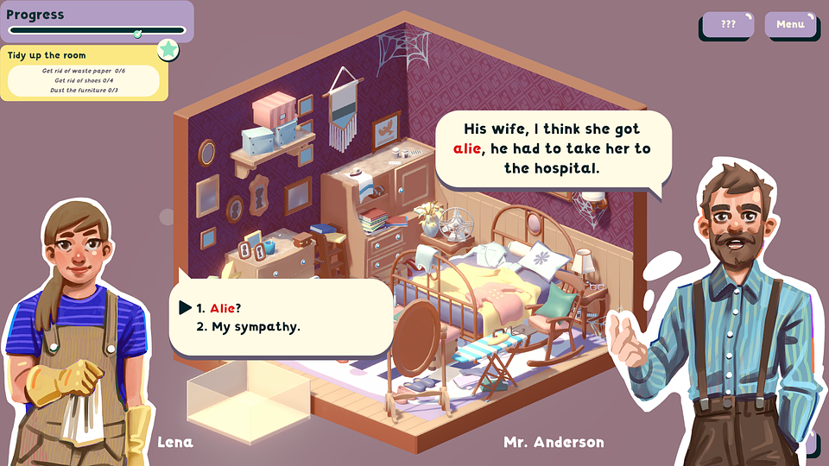

Poof! Cleaning Services – key features:

🧹 Finding pleasure in simplest tasks – gameplay in Poof! Cleaning Services is designed in a way that allows players to experience satisfaction from performing ordinary tasks.

🧹 At your own pace – players can expect a relaxing experience free from stress and pressure, with no time limits or risk of failure, offering multiple solutions and outcomes.

🧹 Rooms full of stories – charming dioramas hide hundreds of interactive objects to organize, and each room tells a touching story of life abroad.

🧹 Make it yours – create your environment in the small rented flat using items you discover while cleaning.

🧹 A life unfolding – a story about life abroad, daily challenges like learning a new language, and hopes that come with the journey of starting over.

🧹 Calm lies in the details – Poof! Cleaning Services charms with its warm, illustrated style, minimalist animations, and a calming soundtrack. Soft colors and soothing sounds create an environment perfect for relaxing and taking a breath.

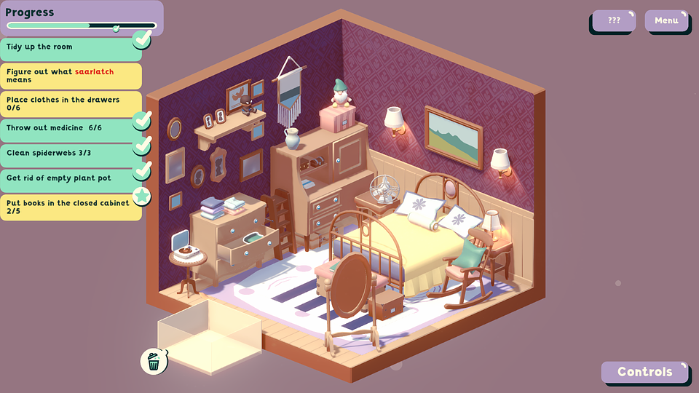

If Poof! Cleaning Services caught your attention, you can now add the game to your wishlist on Steam. The game is set to release in 2026, and more information about Serious Sim's projects can be found on the official website, social media profiles (Facebook and X), and Discord.

The full press kit is available here.

About Serious Sim:

A group of passionate gamers who decided that since they love games so much, it was time to create their own, and then another, and another… Today, they've got a few games under their belt and still find joy in bringing new projects to life. As developers, they’re all about stories that tackle tough topics, and when it comes to creating, they put collaboration first, believing it brings the best results. Right now, the team’s focused on their recently announced Poof! Cleaning Services.

