April 18, 2017
Toyota Motor Corporation
GAZOO Racing Company

Lappi to make World Rally Car debut on Rally de Portugal
in TOYOTA GAZOO Racing testing role

TOYOTA GAZOO Racing World Rally Team test driver Esapekka Lappi and his co-driver Janne Ferm will make their first appearances at the top level of the FIA World Rally Championship (WRC) on Rally de Portugal in May.

Lappi will join his team-mates Jari-Matti Latvala and Juho Hänninen in the squad for the May 19-21 event, driving a third Yaris WRC at the start of a limited programme of WRC rounds, which will be selected according to development requirements.

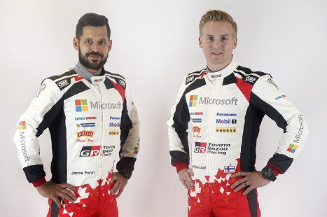
Janne Ferm, Esapekka Lappi

The car has performed well since its debut on Rallye Monte-Carlo, and was driven to victory by Latvala on just its second event in Sweden in February, but TOYOTA GAZOO Racing is continuing to learn during the first season of the WRC project. With the team having collected plenty of data from the previous events, adding a third car when needed will help to accelerate the development of the Yaris WRC.

Lappi, who is one of the brightest prospects in rallying and last year won the WRC 2 title, joined TOYOTA GAZOO Racing prior to the 2017 season and has got to know the Yaris WRC well during testing. Through real competition, the 26-year-old Finn will be able to gain further experience to keep him match-fit.

Quotes:
Tommi Mäkinen (Team Principal)
“Esapekka is a very young and very hungry driver, this is for sure, but of course he has not had so much time to test the car before his first rally. I know that he will do his best, and the objective for him personally is the same as the objective for the whole team: he needs to finish the rallies and collect as much information as possible. There is still a lot of progress that we can make with our car and he is going to be an important part of that development process. Of course, you learn a lot from testing on your own but you learn even more from real competition against everyone else when that is part of a testing programme, which is why we have made this decision to run Esapekka and Janne on some rallies this year. It is good to give some young boys a chance as well.”

Esapekka Lappi (Test Driver)
“This is the moment I have been working for all of my life: it is an amazing opportunity to drive a World Rally Car and I am so happy. I actually first met Tommi and Mr Toyoda together on Rally Finland in 2014, just to say hello, but I had no idea back then that I would end up driving for them now! I have not had a lot of testing with Yaris WRC so I will need to build my experience as it is a very big step up from R5. For Janne too, there will be plenty to get used to, as the pace notes are coming so much faster! But step by step we will all learn together. My goal is to try and get to the finish of the rallies without issues. If you can do that, then you always have a good chance of scoring some points.”

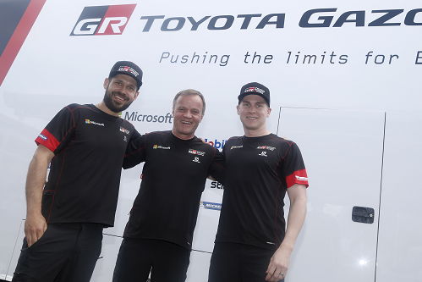
Janne Ferm, Tommi Mäkinen, Esapekka Lappi

Esapekka Lappi Highlights
Date of birth: 17 January 1991
Age: 26 years old
Nationality: Finnish

2007: Karting Finnish Champion
2008: Rally sprint (won all the rounds)
2009: First rally
2011: First WRC rally (Rally Finland, Rookie of the Year award)
2012: Finnish Rally Champion (won all the rounds)
2013: First WRC 2 victory in Vodafone Rally de Portugal
2014: FIA ERC Champion
2016: WRC 2 World Rally Champion (5 wins)

WRC 2 Statistics
WRC 2 starts: 17, Victories: 7, Podiums: 11,
Points scored: 245, Stage wins: 126

Press release (You can download pictures and media kit)
URL: http://toyotagazooracing.com/release/2017/wrc/0418-01.html

Follow us!
Follow TOYOTA GAZOO Racing WRT:
∇Facebook: https://www.facebook.com/TOYOTAGAZOORacingWRC
∇Twitter: https://www.twitter.com/TGR_WRC (@TGR_WRC)
∇Instagram: https://www.instagram.com/tgr_wrc/ (@TGR_WRC)
∇YouTube: https://www.youtube.com/channel/UCCtALHup92q5xIFb7n9UXVg

<Contact>

TOYOTA GAZOO Racing PR Office
Email: tgr_pr @rights-apartment.com

TOYOTA GAZOO Racing Official website
http://toyotagazooracing.com/

TOYOTA GAZOO Racing World Rally Team is supported by following partners:

