SIM Digital Chooses Xytech's MediaPulse

Media production giant implements MediaPulse across its North American facilities, streamlining billing, scheduling and mission-critical back office operations

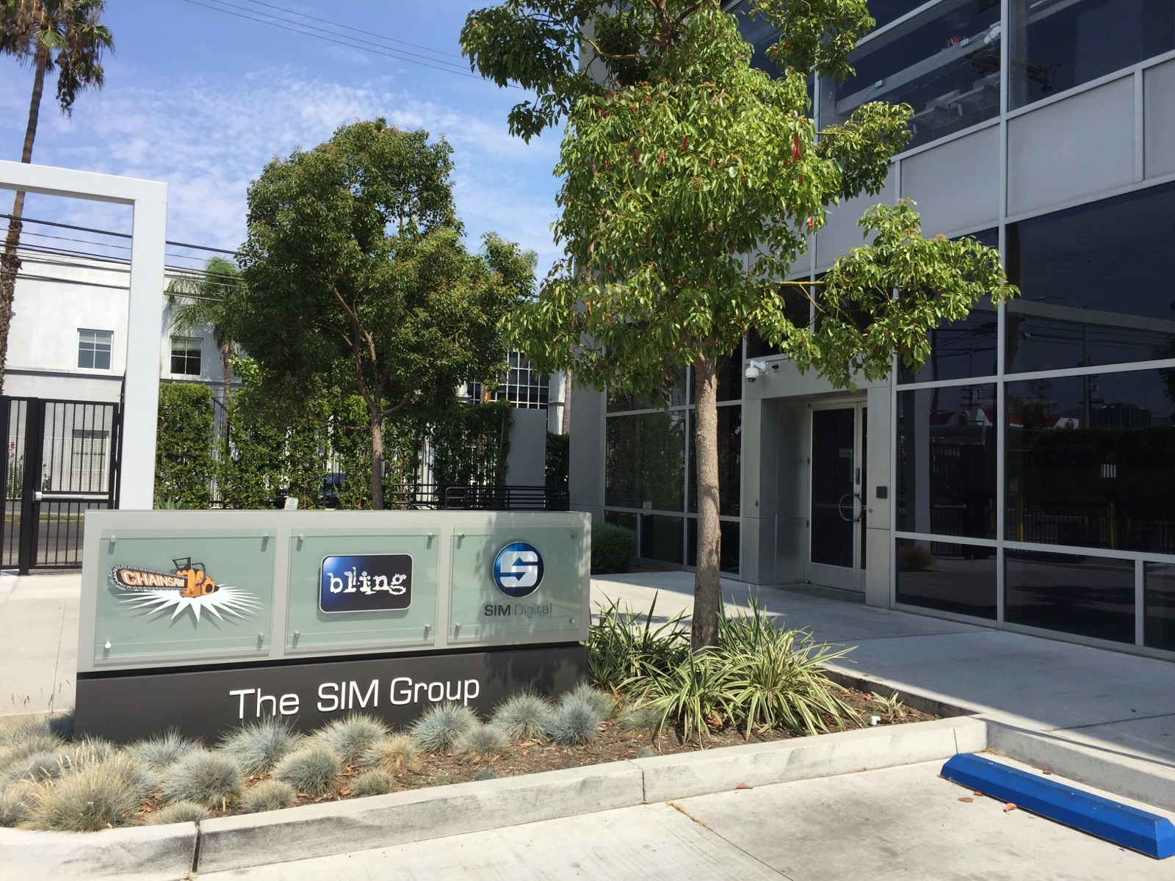
Toronto, November 13, 2017 — For more than 35 years, Toronto-based Sim has been an innovator in the film and broadcast markets, providing both the equipment and technical expertise needed to help A/V professionals realize their creative visions throughout the entire production process. Over the last several years, through a series of mergers and acquisitions, the company has expanded both its geographic footprint and production capabilities. In order to streamline back office functionality and increase production efficiency among its North American facilities, the company chose to implement Xytech’s MediaPulse facility management software.

Sim’s recent mergers and acquisitions include Bling Digital, PS Production Services, Ltd., Chainsaw, Pixel Underground, Tattersall Sound & Picture, Post FactoryNY and The Crossing Studios among others. In tandem, the company has also increased the services it offers, with the goal of delivering turnkey solutions to suit just about any production need. The company sought a facility management software platform able to handle not only its extensive billing and scheduling requirements, but offer the ability to streamline more complex operational tasks. After a thorough evaluation of competitive market solutions, Xytech's MediaPulse was chosen for its ability to deliver mission-critical functionality across the enterprise.
Systems in Harmony
"Our first objective was to harmonize was our billing system, since this is mission-critical," says Chris Webb, IT Manager, Infrastructure, Sim. "Once we had MediaPulse in place, we were able to assign common codes for specific needs in our different facilities. For instance, if our facilities in New York and Los Angeles want to charge different rates for their rooms, they can do so using the same billing code, while setting different rates as applicable."

After recognizing immediate benefits across the company, Sim soon added MediaPulse's scheduling module — providing the visibility needed to ensure resources and facilities were being used to their full potential. The scheduling module also allowed the company to plan for and allocate alternate resources for customers if any single facility was at full capacity or otherwise unavailable.

Cohesive Planning
"Some of the companies we had acquired didn't possess any formal scheduling software and others were using a myriad of software combinations," Webb explains, "At the time, we didn't have a cohesive strategy to unify all of our disparate facilities and departments. Once we had the billing module in place, we implemented the scheduling module in MediaPulse. This allowed the individualization we needed to manage the nuances of our different facilities. Now, the local facilities have what they need to maintain a seamless operation, while headquarters has the transparency and global view they need as well."
"One of the best features of MediaPulse is its ability to provide scheduling transparency into the entire organization," observes Doug Gingrave, Business Development Manager at Xytech. "Scheduling can get very complicated across multiple locations in diverse geographies, and having visibility across the entire enterprise can make the difference in taking on a new project rather than having to turn away work. With the scheduling module on MediaPulse, customers can easily assign work according to resource availability — this is a great solution for everyone."
Fine-tuning Workflows
In addition to its core strengths in allocating and scheduling resources, MediaPulse is able to process and analyze discrete production workflows across different facilities or divisions. "Companies can set the system up to capture any provisions or business nuances on the front end, and since information is coming into a central database, our customers can then analyze this data to increase the efficiency of any component within their operations," says Gingrave.

Webb appreciates how MediaPulse is able to synergize workflows: "The system definitely gives us insight into the facilities, how their workflows are set up and how they are managing projects," he says. “For example, we have a daily division in Los Angeles working with dailies and cameras, and we have a post division working with post and editing at the same time. Using the insight gained from MediaPulse, these two entities can now collaborate on similar projects and share information as if they are working on the same project."

Since the team is now on the same platform, they can track resources, scheduling and project status among any of its entities. Further, the Canadian operation is able to access a holistic, real-time view of any facility or system component. "Moving forward, we are hopeful our new MediaPulse system will encourage an even greater degree of interaction, collaboration and efficiency across the enterprise."

"Now with MediaPulse in place for all the lines of our business, we could easily expand should we need to add other facilities or departments. Further, we are very pleased with the system and always looking at new features as our needs arise."
Xytech will be at IBC 2017. Those interested in scheduling an appointment may contact Alexandra Kuipers at akuipers@xytechsystems.com, + 1 (818) 698-4958 or Aurore Gilewicz at agilewicz@xytechsystems.com, +44 203 478 1462.

About Xytech Systems
For over 25 years, the world’s premiere media companies have depended on Xytech to run their businesses. MediaPulse is the only end-to-end solution for the complete content lifecycle. MediaPulse provides scheduling, automation, asset management, billing and cost recovery for broadcasters, media services companies and transmission facilities in a scalable platform-independent solution.

For more information, visit xytechsystems.com.

Media contacts:

Jeff Touzeau
Public Relations
Hummingbird Media
+1 (914) 602 2913
jeff@hummingbirdmedia.com

Katie Kailus
Public Relations
Hummingbird Media
+1 (630) 319-5226
katie@hummingbirdmedia.com

