For immediate distribution

MEDIA ALERT: Ferrofish RemoteFish App Now Supports Remote Operation via Dante Connection
The new V3.0 firmware for the A32 Dante and Pulse 16 DX allows the app to support remote-over-Dante
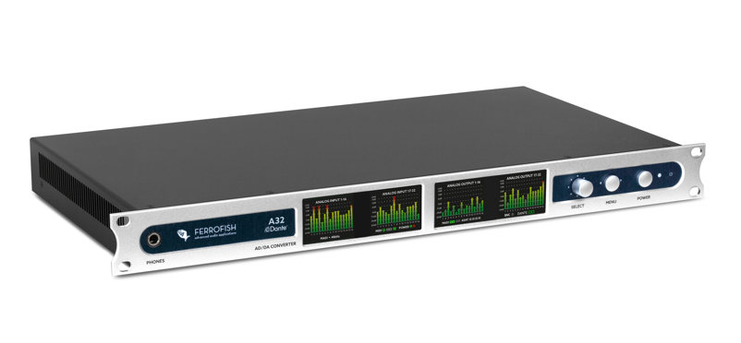
Fort Lauderdale, Florida, September 2, 2021 — Leading German converter manufacturer Ferrofish has announced its RemoteFish App, which supports all versions of its A32 and Pulse 16 audio converters, now supports remote-over-Dante, Catalina, Big Sur and M1 compatibility mode. Together with the new V3.0 firmwares for Ferrofish’s A32 and Pulse 16 models, the free RemoteFish App supports remote operation via Dante, eliminating the need for MIDI or USB cable connection.
Additionally, Ferrofish has added support for Big Sur and Catalina on Intel and M1 machines.
“We are very excited to announce the V3.0 firmware,” said Marie Sorenson, Marketing Manager for Synthax US, distributor of Ferrofish. “This new update will allow Dante users the ability to seamlessly and remotely control their Ferrofish device from any computer on the Dante network, adding to the long list of benefits Ferrofish provides audio engineers.”
Full Control — Anytime, Anywhere
The RemoteFish software expands on the already impressive control of Ferrofish’s A32 and Pulse 16 series of converters by allowing a range of control directly from any PC or Mac. RemoteFish allows users to control every aspect of the Pulse 16 series of converters, including the I/O levels, routing as well as saving and recalling presets. Because presets are saved to the device, not a computer, it’s possible to configure the unit easily on a computer and recall it when needed again without RemoteFish.
Improving the ease of use, multiple units can also be used together from the within the same software window, with each unit easily identifiable via the serial number on the left-hand side of the user interface.
The new V3 firmwares can be downloaded at: https://www.ferrofish.com/downloads/
For more information about Ferrofish, visit ferrofish.com.
About Ferrofish
Known for its precision-engineered German technology, Ferrofish manufacturers high quality, innovative advanced audio applications. From its class-leading A16 MK-II and A32 AD/DA converters to its Verto Series of intuitive Dante converters, Ferrofish is known for its premium conversion solutions that are ideal for a wide range of applications. For additional information, visit the company online at http://www.ferrofish.com.

About Synthax, Incorporated
Synthax Inc. is the exclusive USA distributor for RME digital audio solutions, Digigram broadcast audio systems, Appsys digital audio tools, Ferrofish advanced audio appliations, myMix personal monitoring systems and ALVA cableware. We supply a nationwide network of dealers with these products for professional audio, broadcast, music industry, commercial audio, theater, military and government applications. For additional information, visit the company online at http://www.synthax.com.
Media Contacts:
Katie Kailus
Public Relations
Hummingbird Media
+1 (630) 319-5226
katie@hummingbirdmedia.com

Jeff Touzeau
Public Relations
Hummingbird Media
+1 (914) 602 2913
jeff@hummingbirdmedia.com

