More MOMENTUM
Multipoint connectivity, studio-grade sound, and a host of additional features come to the Sennheiser MOMENTUM True Wireless 3
Marlow, UK, November 2, 2022 – The acclaimed Sennheiser MOMENTUM True Wireless 3 gets even better with just a tap. The new firmware update, available via the Smart Control App (iOS, Android) enables multipoint device connectivity and a high-resolution sound mode for convenience and quality.
"Our latest update reflects the dynamic ways people want to use MOMENTUM True Wireless 3, including our most-requested feature – multipoint. For example, one can switch from their favorite music streaming app to join an incoming conference call from their laptop – and back again – without having to reconnect manually.”, says Frank Foppe, Sennheiser True Wireless Product Manager. “And our new high-resolution sound mode enhances the listening experience even further, letting customers enjoy wireless audio that rivals the rich and lively detail found in a wired connection.”
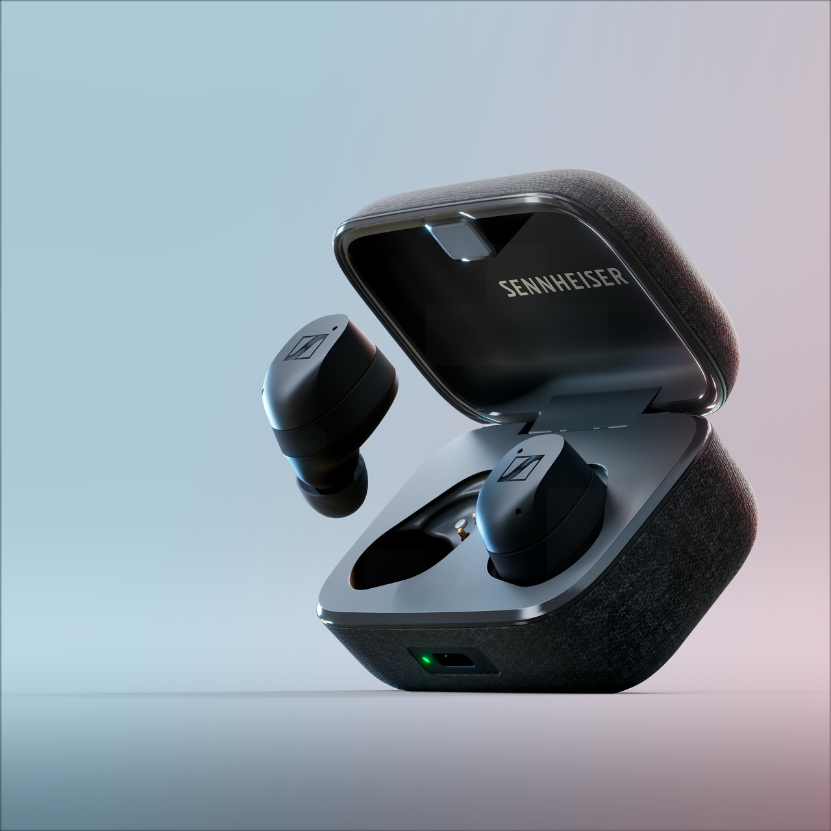
The power of connection
Now, the premium MOMENTUM True Wireless 3 sound experience is available on multiple devices with a simple tap. The latest update allows users to instantly switch between two paired devices for dynamic management of active connections. Examples include streaming a podcast on a smartphone before switching over to an incoming video call, shifting from a television series on your tablet to a mobile voice call, and balancing voice calls between work and personal phones. Multipoint also switches back to the original audio source device if a call is answered mid-stream, and otherwise allows for effortless switching between two Bluetooth audio devices. Lastly, the multipoint update allows for seamless switching through all mutually supported codecs, such as aptX Adaptive, and SBC – even across mobile operating system platforms from various manufacturers.

Next level performance
Bringing listeners even closer to the details in their music, the MOMENTUM True Wireless 3 update also introduces a high-resolution sound mode featuring 24-bit depth and 96 kHz sample rate capability, unlocking sound quality comparable to a wired headphone. By connecting MOMENTUM True Wireless 3 to an audio source also using the aptX Adaptive codec, this mode increases the Bluetooth bitrate up to 420 kilobits per second for optimum sound. In RF-challenged environments, such as bustling public transportation, the MOMENTUM True Wireless 3 may utilise the codec’s data scaling capabilities to seamlessly adapt the connection integrity at any given moment. Users can enable the high-resolution sound mode via Sennheiser’s Smart Control App, making MOMENTUM True Wireless 3 the ideal companion for all popular music streaming services and their highest quality subscription tiers.
Availability
Multipoint and high-resolution mode are available after updating the MOMENTUM True Wireless 3 to the latest firmware (Release 2.10.19 or higher) and updating the Smart Control App (App Store, Google Play; release 4.1.5 or higher). The release also contains numerous optimisations and enhancements for Bluetooth and touch control features.

About the Sennheiser brand
We live and breathe audio. We are driven by the passion to create audio solutions that make a difference. Building the future of audio and bringing remarkable sound experiences to our customers – this is what the Sennheiser brand has represented for more than 75 years. While professional audio solutions such as microphones, meeting solutions, streaming technologies and monitoring systems are part of the business of Sennheiser electronic GmbH & Co. KG, the business with consumer devices such as headphones, soundbars and speech-enhanced hearables is operated by Sonova Holding AG under the license of Sennheiser.

www.sennheiser.com
www.sennheiser-hearing.com

Press contact
Milan Schlegel
PR and Influencer Manager EMEA, Sennheiser Consumer
Milan.Schlegel@sennheiser-ce.com

Harvard PR
Sennheiser UK&I PR agency
sennheiser@harvard.co.uk

