NEUMANN MONITORS FOR PODCAST INNOVATOR STITCHER
KH 120 AND KH 310 NEARFIELD MONITORS SPECIFIED IN NYC-BASED STUDIO

NEW YORK CITY/BERLIN, April 8, 2019 – As podcasting becomes the content medium of choice for an increasing number of listeners around the world — including 73 million people in the U.S. alone — top facilities are insisting on best-in-class monitoring solutions to outfit their studios. Stitcher, an industry leader in podcast content creation, distribution and advertising, recently specified Neumann KH series monitors inside its new WSDG-designed studio facility in New York.

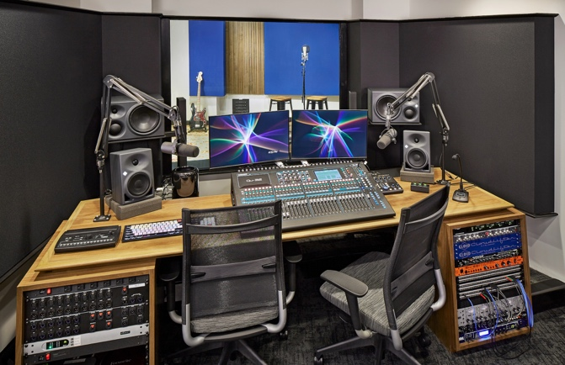
Stitcher has employed the Neumann KH 120 two-way studio monitors in its studio and edit suites, and one studio also includes a pair of Neumann KH 310 three-way monitors. System specifications for the new studio were made on the recommendation of Romina Larregina, Partner, Director of Production at WSDG.

Listen up
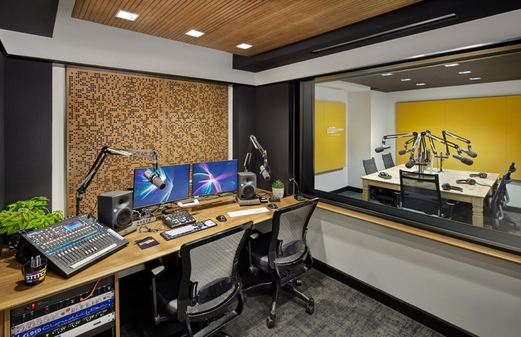
John DeLore, Senior Production Manager at Stitcher, says that podcasting studios share many similarities with traditional recording studios, including a primary need to accurately capture and reproduce the human voice. “But the main difference is that in most of our sessions we're recording only voices,” he says. “Therefore, since there are fewer instruments competing for the listener’s attention, we have to be attuned to every nuance of the voice coming through.”

While some podcasts can entail a simple stack of two or three mono voice tracks, DeLore says that more complicated sessions can run upwards of 20 or 30 tracks, which might include sound design, ambient sounds, field recordings, interview tape, and archival audio in addition to in-studio host tracking. This means that the monitoring environments must be equipped to handle complex mixing tasks in addition to routine tracking and editing: “In these cases, we need maximum clarity and frequency range to make sure all the information is coming through clearly, and that all the scoring and sound design is sculpted around the voice.”

Neumann KH 120: Punching above its weight class
For the in-studio Stitcher team, a ‘typical’ production process might include capturing the interview or the host. Then the team will assemble other content where required — such as clips, sound design and music. Once the mixing process arrives, the engineer will dive into the finer points of EQ, compression, noise reduction, and achieving satisfactory balance among all tracks.

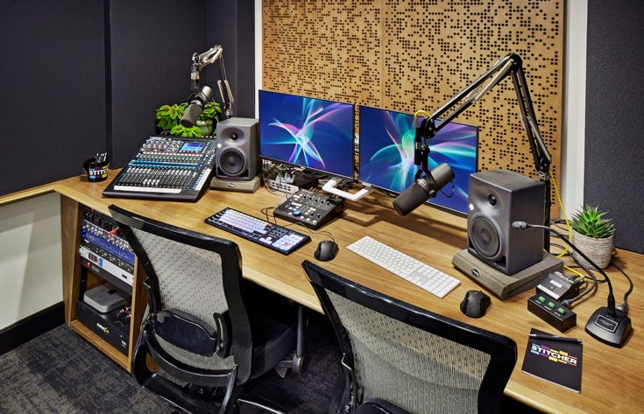
So far, says DeLore, the Neumann monitors have delivered: “The KH 120s have been working really great for us and have been able to deliver more than enough low frequency response for our tracking and mixing needs. What we hear is a clear reproduction of our signal chain, with no additional coloring or overcompensation. This is important, because we need these recordings and these mixes to translate to several possible playback scenarios, such as car stereos, ear buds, or built-in laptop speakers.”

Meantime, a pair of Neumann KH 310 three-way monitors in one of its larger studios has served as a perfect complement to the KH 120s: “Because we want to record bands in that room, the extra firepower of the 310s was a good fit,” DeLore says. “Also, the 310s are designed to provide a wider sweet spot, which is ideal for podcasts which can have production teams of 4-5 people who need to all sit in the studio and be able to hear the same mix.”

“The decision to go with the Neumann monitoring systems was made after several discussions with the client,” commented Romina Larregina. “The equipment size and frequency range worked perfectly for the room sizes we were working with. Once the system was in place, the frequency response was calibrated to customize each of the control rooms to obtain the most accurate sounding environment possible.”

While the completed podcasts will typically be consumed as compressed MP3 files through listening platforms such as Stitcher’s own podcast-listening app, Apple Podcasts, Spotify and Pandora, the Stitcher production team has to be attentive to the overall quality throughout the entire process. “Our mission at Stitcher is to take even the simplest shows and make sure they sound optimal — so having clear, accurate and consistent monitoring across all our rooms is of utmost importance,” says DeLore.

Photo credits: John Muggenborg, www.johnmuggenborg.com.

Link for photo and text material:
https://www.neumann.com/exchange/Neumann-Stitcher.zip

About Neumann
Georg Neumann GmbH, known as “Neumann.Berlin”, is the world’s leading manufacturer of studio microphones and the creator of recording legends including the U 47, M 49, U 67 and U 87. Founded in 1928, the company has been recognized with numerous international awards for its technological innovations. Since 2010, Neumann.Berlin has expanded its expertise in electro-acoustic transducer design to also include the studio monitor market, mainly targeting TV and radio broadcasting, recording, and audio productions. The first Neumann studio headphone was introduced at the beginning of 2019. The company manufactures its microphones in Germany, while its monitors are built in Ireland. Georg Neumann GmbH has been part of the Sennheiser Group since 1991, and is represented worldwide by the Sennheiser network of subsidiaries and long-standing trading partners. More information at www.neumann.com.

Press Contact USA: Global Press Contact:
Jeff Touzeau Andreas Sablotny
jeff@hummingbirdmedia.com andreas.sablotny@neumann.com
+1 (914) 602-2913 +49 (030) 4177 24 –19

