For more information, please contact Marta de Paco
On +34 670 780 664 or email press@comunicahair.com

Important:
These images are only available for editorial content.
Credits must be included.
Notification of their publication is expected.

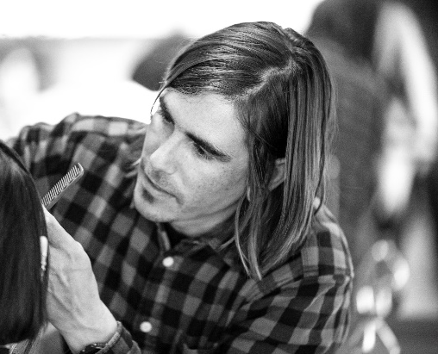
IMANOL OLIVER
OLIVER ESTILISMO
GEOMETRIC 4 Collection

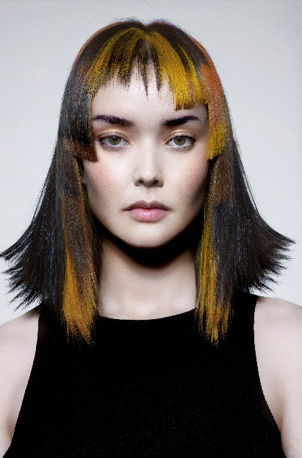
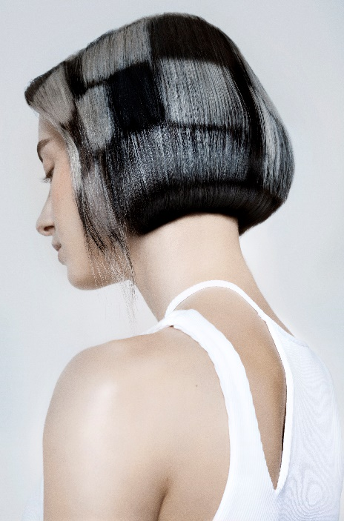
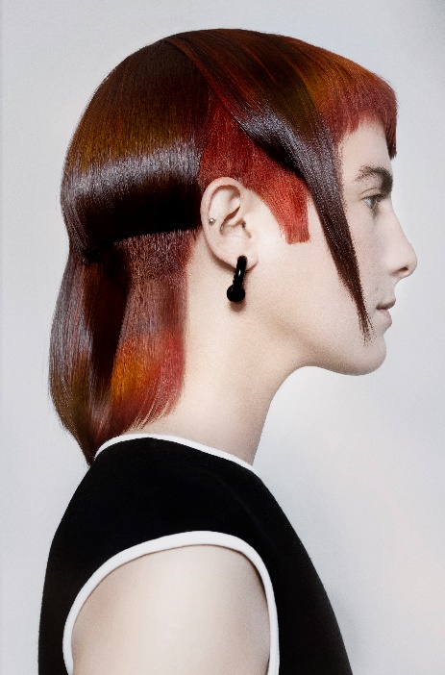

Hair: Imanol Oliver @imanol___oliver
Hair Instagram: Oliver Estilismo @oliverestilismo
Hair Assistant: Genesis Bastidas @genesisbastidasperez_
Estefanía Pérez @fannyladel97
Mari Conesa @mariconesa87
Photography: David Arnal @davidarnalteam
MUA: José Méndez @makeupbyjose_mdz
Styling: Imanol Oliver @imanol___oliver | Mari Conesa @mariconesa87
Models: Mª Dolores Martínez @emedemede
Sara Muñoz @sar.rvi
Susana Martínez @susanamarlo
Isabel Sáez @isabel_saez66 (agencia @monroemodels)
IMANOL OLIVER
OLIVER ESTILISMO
GEOMETRIC 4 Collection

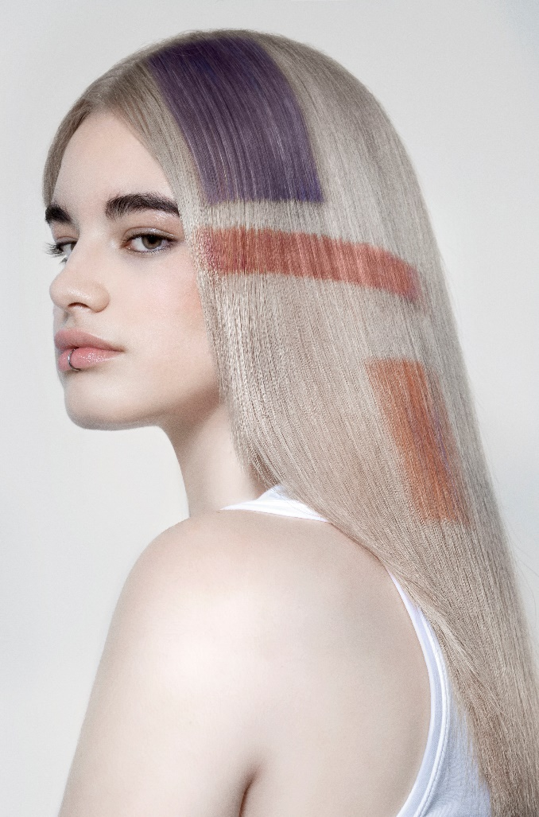

The collection is inspired by the Bauhaus artistic movement. Hence, the role of geometry, surprising angles, and clean and pure lines become the protagonists. The contours are drawn with the haircuts and the treatment of the silhouettes, but also through the geometric figures and the colors stamped on the hair. All this results in a new dimension of shapes and tones.

