**Dustin Fleetwood Crafts Cinematic Magic**

**with Sound Devices**

*Production Sound Mixer on contributing to a professional film community and choosing rock-solid gear for Louisiana weather*

**NEW ORLEANS, LA, MAY 1, 2024 – Over the past decade, the state of Louisiana has increasingly become a popular destination for Film and TV production crews. *Netflix, AppleTV, Amazon,* and *Disney* are but a few of the many studios filming productions that have leveraged the state’s rapidly evolving production infrastructure and unique local flavor in service of creative and cost-effective filmmaking.** [**Dustin Fleetwood, CAS**](https://www.imdb.com/name/nm1982993/) **is a homegrown sound professional thriving in Louisiana’s film industry. He has quickly become a go-to Production Sound Mixer for some of the major production studios that film in Louisiana. Renowned Film Directors such as: Richard Linklater (*School of Rock, Dazed & Confused, Hit Man*) and legendary Director and Writer from the Scorsese ensemble, Paul Schrader (*Taxi Driver, Raging Bull, Master Gardener*), personally hired Dustin Fleetwood. To ensure that he and his crew that he calls, “Sound Fleet”, are operating at the highest possible levels of quality and efficiency for those productions, Fleetwood made the Sound Devices Scorpio a key element in their production sound workflow.**

**Contributing his expertise to the local film community.**

Fleetwood initially gained his experience in a recording studio as an assistant engineer. He recorded songs for Grammy Lifetime achievement winner Leo Nocentelli, and local New Orleans artists. Fleetwood would occasionally freelance as a FOH Engineer in various venues mixing live sound. He later moved to California to train in Burbank, for post-production sound with Joel Krantz as his instructor. Krantz has written several key training books on Pro tools for sound in music and film. While in training, he was hired to mix live sound for the late and iconic Director Gary Marshall’s Falcon Theatre. “I decided to return home when the film industry was booming and started working as a sound utility and boom operator when opportunities presented themselves.” Fleetwood worked for several years for other mixers and started building his own sound cart. He saw the opportunity to take an active hand in becoming a Production Sound Mixer full time, and he joined the I.A.T.S.E. Local 478 Union. “I would hire and train film students from local colleges and non-college individuals from training programs who I later helped join I.A.T.S.E. You don't have to have a college degree to work in the film industry and thrive. The infrastructure really started to build up and more shows and films decided to shoot in and around New Orleans, and needed crew”, he explained. “I couldn’t have imagined sustaining a career in production here when I was just out of high school, but word got out in the industry that New Orleans had a lot to offer film productions — in terms of the character of the city, the locations, as well as the tax incentives.”

“I realized as this was happening that there was a real chance for me to work in sound on films back home, without living in California.”

Upon his return to Louisiana, Fleetwood made a name for himself based on his work ethic and versatility as an audio professional. He became a member of Cinema Audio Society. “It became very important to me, being a Louisiana native, to not only prove that I can do the work just as well here, but also to prove to others from here that they can do it too,” he said. Fleetwood recently Co-Executive Produced a short film entitled “Revival,” Directed by his wife Wendy Fleetwood. “We hired local film professionals and students to work on the film. The strikes have been very hard on the local film community, and getting a paycheck to work on this film was a relief for a lot of the crew.”

“I was always looking for ways to give back, and in doing that, we’ve helped contribute to the growth and survival of the film community professionals here in a genuine way.”

**Sound decisions for a seamless workflow**

As a Production Sound Mixer, Fleetwood is very conscious of the role he has in ensuring the authenticity of the scene. His experience in various areas of sound has informed how attuned he is to the talent in the moment, and ensuring that their performances are captured perfectly, regardless of how adversarial the mixing situation might be. “The way actors perform is heavily influenced by the situations they are in — how the scene feels, what the backdrop is like, how they are responding to the elements in the environment,” he explained. “Capturing that perfectly during the take is the most important part of my job. There are also many subtle sonic textures that are utterly unique to these locations that you want to ensure you have so it all feels real.”

“You need your gear to be utterly rock solid in those situations, which is why I’ve always used Sound Devices.”

**Advancing to digital**

Fleetwood met with Chris Alix, VP of Engineering at Sound Devices in New Orleans. “I was honored to have had the opportunity to work in-person with Chris and personally test the Sound Devices A20-Nexus, along with the A20-Mini and A20-TX, as well as NexLink. Chris and I performed various range tests comparing other competitors to Sound Devices. However, there was no comparison; Sound Devices outperformed and was much more feature rich than its competitors. Chris Alix is a programming genius and I was impressed by the way he listened to my suggestions for enhancements and the challenges we deal with daily on set.

“I initially started with the Sound Devices 664 and MixPre-10T. So, I am looking forward to the future of sound technology. Sound Devices works well with the humid climate of Louisiana and has never failed me.” Fleetwood upgraded to the Scorpio just ahead of his work on *The Burial*, starring Tommy Lee Jones and Jamie Fox. “I needed that Sound Devices reliability with a higher track count on *The Burial;* we had as many as 14 people in the same scene,” he said. “The Scorpio had just come out and it immediately felt familiar to me. There was no learning curve from my time on the 664 and MixPre-10T, so I was able to put it to work right away.”

“I’ve used other brands, but Sound Devices are always intuitive and easy to work with. You need that when you’re in the position that I’m in where every second counts. You don’t want to miss anything because you were messing with your gear and I never have to worry about that with the Scorpio.”

Fleetwood currently operates a cart with both his Scorpio and MixPre-10T running in tandem, enabling him to easily record multiple backups as well as uploading takes to Frame.io for post-production. The seamlessness of his workflow allows him to focus entirely on capturing perfect takes, no matter what may happen in a scene.

“When the filming wraps and the movie is about to be released, I get excited, especially when hearing the sound mix on the big screen. It’s an amazing experience and there is nothing like it.”

For more information about Dustin Fleetwood, please click below:

[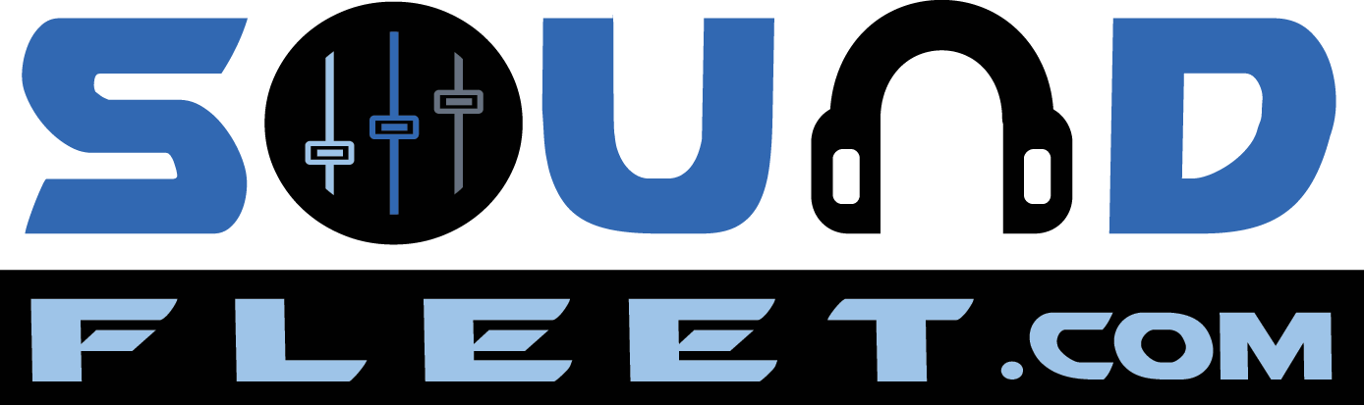](http://www.soundfleet.com) [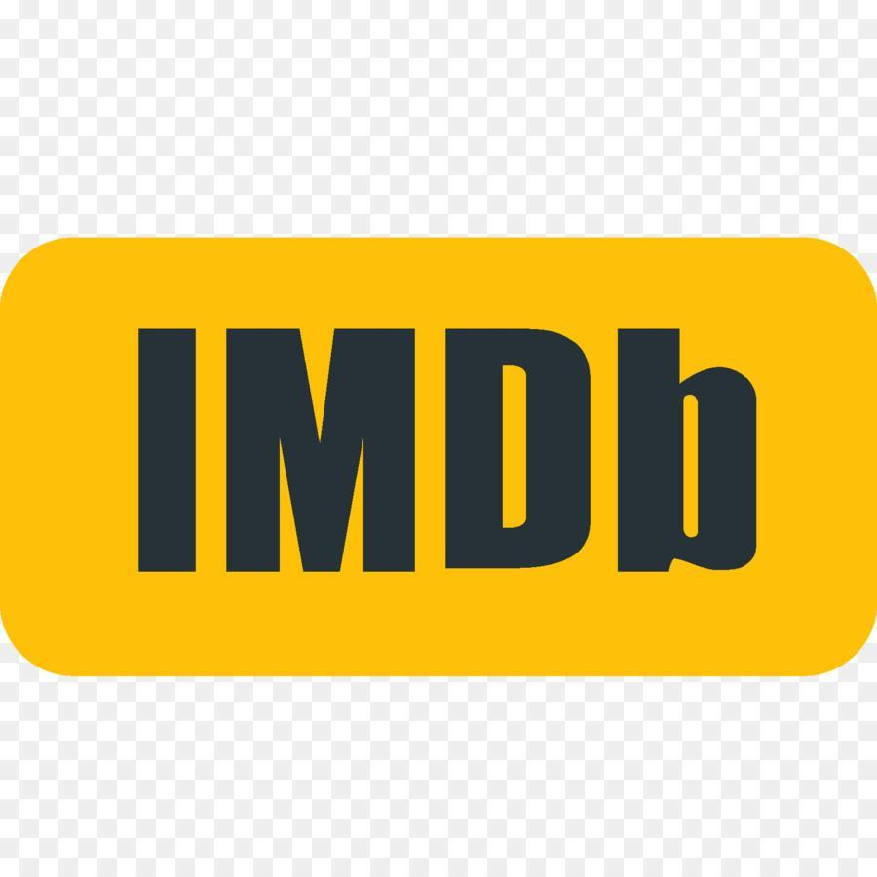](https://www.imdb.com/name/nm1982993/?ref_=fn_al_nm_1) [](https://www.instagram.com/soundfleet/).

**About Sound Devices:**

For more than 25 years, Sound Devices has created premier audio equipment that helps sound professionals capture superior audio. The company's products have been used for an array of applications, from award-winning feature films and television shows, to live events, houses of worship, and educational applications. Sound Devices designs, assembles, and supports its products at their Reedsburg, Wisconsin, headquarters and their Madison, Wisconsin, and Rickmansworth, UK, offices.

For more information, visit [www.sounddevices.com](http://www.sounddevices.com/).

###