

bettergamingagency.prowly.com

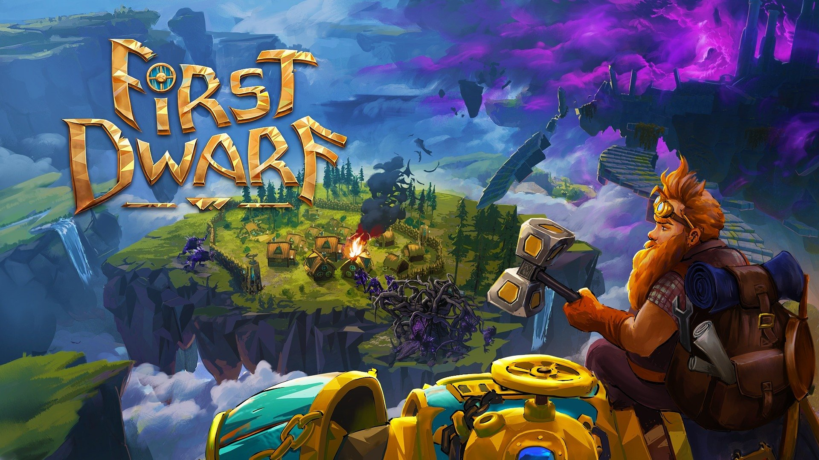

Dwarven mech test drive! First Dwarf shows off gameplay and invites for playtests

The developers at Star Drifters invite players to the world of Driftland - a magical realm set on floating islands above a desolated globe. The studio has presented 15 minutes of gameplay from First Dwarf and has launched open playtests for everyone. Head to the title’s Steam page to sign up for free.

Watch 15 minutes of gameplay from First Dwarf here

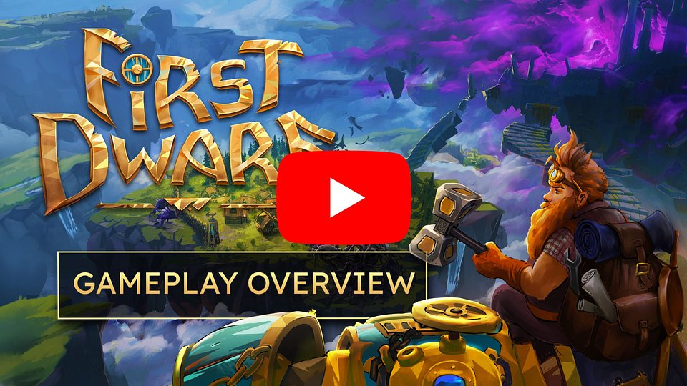
https://www.youtube.com/watch?v=k_3QfJYCJM4

Players can now test the unique mix of survival, colony management, tower defense, and action RPG which First Dwarf offers. Star Drifters invites everyone to open playtests on Steam. Just go to the game’s Steam page and request access! The dwarves need you!

Survival, colony management, tower defense, action RPG - how does it work?

In First Dwarf, players become Tru— a dwarven explorer who sets out to build colonies on the floating islands of Driftland. Shipwrecked Tru must prepare for the dangers of the sky-high land, building defenses and infrastructure for the future colonists. Fortunately, with dwarven engineering skills, he can repair and pilot a powerful mech, which proves itself in combat, gathering resources and building. With various upgrades, this pinnacle of fantasy tech will eventually become the ultimate exploration machine. The mech's offensive arsenal will also come in handy, as the uncharted lands are inhabited by mysterious creatures hostile to the dwarven newcomers.

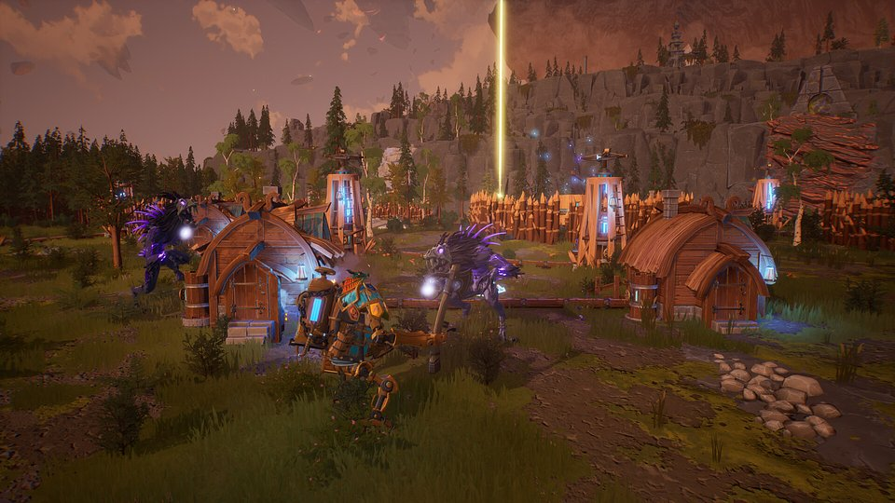

But the gigantic mech is not enough to uncover all the mysteries of Driftland. Ragna, a she-dragon, is a playable companion who aids Tru in his quest. Her small size, ability to fly, and breathe fire make her a great addition to the dwarven skills of the protagonist. The game can be played in co-op (split screen and online) with each protagonist doing their job.

Building a colony and managing the settlers is another part of Tru’s job. With tower defense mechanisms, the settlement can be prepared for the worst. But it’s not all about survival —Tru will have to balance and fulfill the needs of new inhabitants, providing them with resources, shelter, and entertainment to boost their happiness. Only a prosperous society will allow our protagonist to pursue his own personal goal—discovering what evil taints these lands and what happened to the previous dwarven expeditions, including the one led by his father.

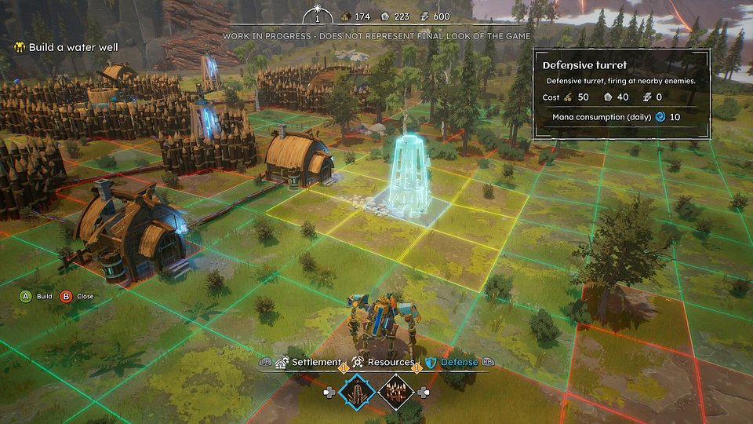

Game features:

⚒️ Control dwarf Tru, pilot the powerful mech and fly with Ragna the Dragon, each with their own skills to upgrade
⚒️ Build, optimize and look after your colonies
⚒️ Upgrade, craft and discover new structures, technologies, tools and weapons
⚒️ Fight Tainted enemies by engaging in close combat and by building defensive turrets and walls in advance, preparing not only for monster waves, but also natural disasters
⚒️ Heal the Tainted animals or purge the island of them - the choice is yours
⚒️ Unveil the hidden secrets of Driftland and learn the truth about Tru’s father’s past
⚒️ Embark on an adventure alone or with a friend in co-op assist mode

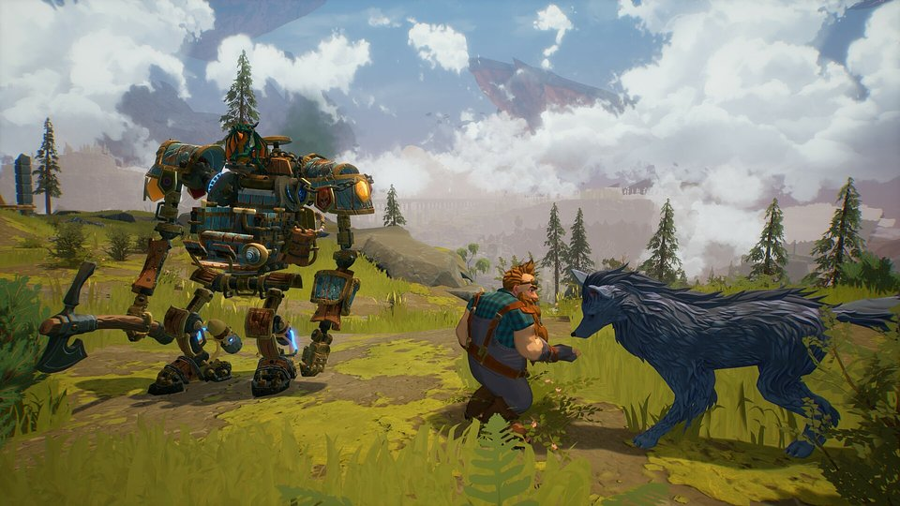

First Dwarf is coming to PC, PlayStation5, Xbox Series X|S and Nintendo Switch later this year.

You can find the game’s presskit here.

About Star Drifters:Star Drifters is an independent game development studio based in Warsaw, Poland. The company was founded in 2014 by two industry veterans: Michal Sokolski and Krzysztof Jakubowski. During a nearly two-decades-long career, they’ve worked on numerous titles for all major gaming platforms and gained extensive experience in game development and management.Starting in 2020, after Kuba Wójcik joined the team, the second area of the studio’s activity has been the selective incubation of independent games and teams behind them. The scope of support is individually tailored and covers areas from production, design, and positioning through financing to the sale of the final product.Star Drifters’ mission is to create engaging, challenging, and highly replayable games that will remain in players’ memories for a long time.



Jakub Smolak
PR Specialist at better. gaming agency
jakub.smolak@bettergaming.pro
Twitter

