For immediate distribution

BAE Audio Announces R53 Channelstrip, Package Deal

Customers can get 19” rack unit free with purchase of three BAE 500-series modules

North Hollywood, CA, October 31, 2019 – BAE Audio, the Hollywood-based manufacturer of authentic vintage-style preamps and compressors has announced the newest edition to its family of best-in-class recording studio equipment: The R53 Channel Strip. The 19” rack unit holds three 500-series modules, allowing engineers with traditional rack systems to utilize these modules in their regular setup as well as link them in order to use all three as a channel strip. In addition to making the new rack unit available, BAE is also offering a package deal where anyone who purchases three of BAE’s celebrated 500-series modules, as long as the purchase includes at least one EQ module and one compressor module, will receive an R53 free of charge. 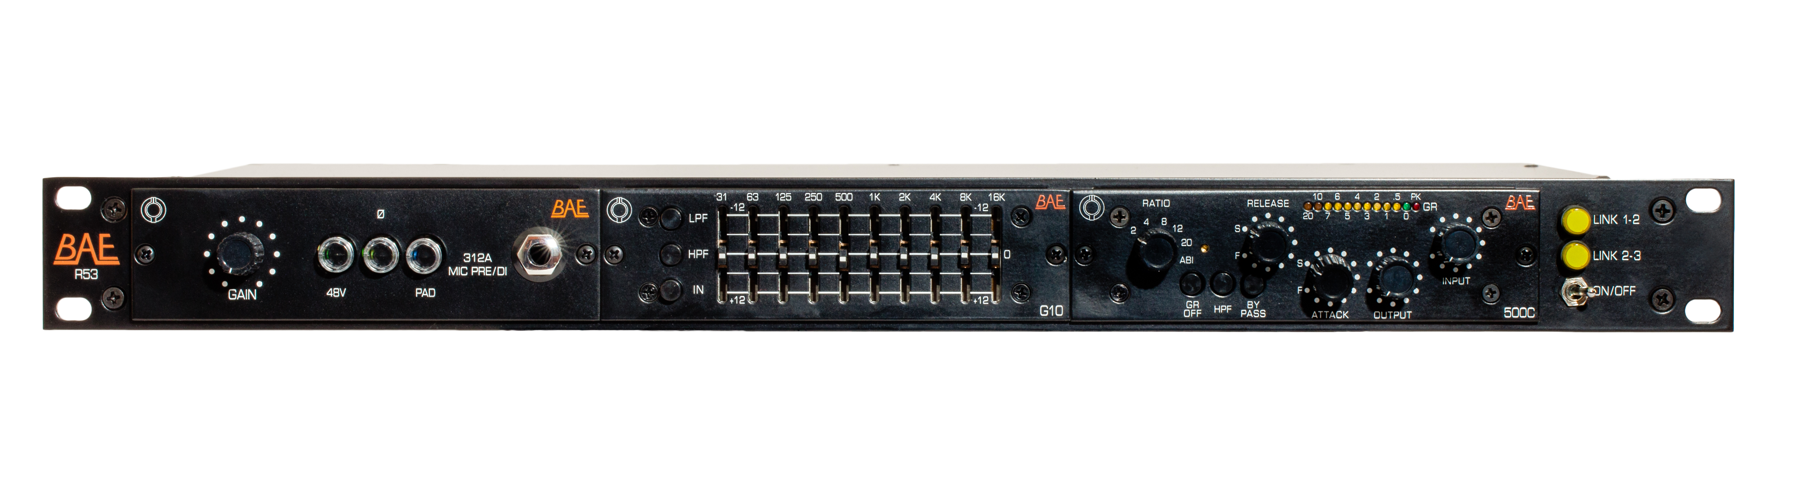
“The R53 is a great solution for anyone looking to link our 500-series modules within a traditional 19” rack setup,” said Mark Loughman, President of BAE Audio. “We’ve spared no expense in ensuring that the unit has solid steel construction, a robust power supply, and is easily serviceable, meaning that it will be an essential part of anyone’s recording studio for a long time to come.”
Modules eligible for the promotion include:
- BAE 312A 500-Series Mic Pre
- BAE G10 500-Series 10-Band Graphic EQ
- BAE 500C 500-Series FET Compressor
- BAE 73MPL 500-Series Mic Pre
- BAE 73EQL 500-Series EQ
The R53 is available now at a price of $500 USD. For more information on the R53 and BAE’s line of 500-series modules, please visit http://www.baeaudio.com
About BAE Audio
BAE Audio is a U.S.-based manufacturer of high-end microphone preamp and equalizers, all of which are faithful to vintage designs of the seventies and before. The company is committed to the vintage philosophy of hand wiring and hand soldering all of its components to achieve a high quality and authentically vintage sound. For more information on BAE Audio, please visit our website at www.baeaudio.com.

Media contact
Jeff Touzeau
Public Relations
Hummingbird Media
+1 (914) 602 2913
jeff@hummingbirdmedia.com

