Local Press Contact:
Jayne Feldman
BRAVE Public Relations
404.233.3993
jfeldman@emailbrave.com

FOR IMMEDIATE RELEASE
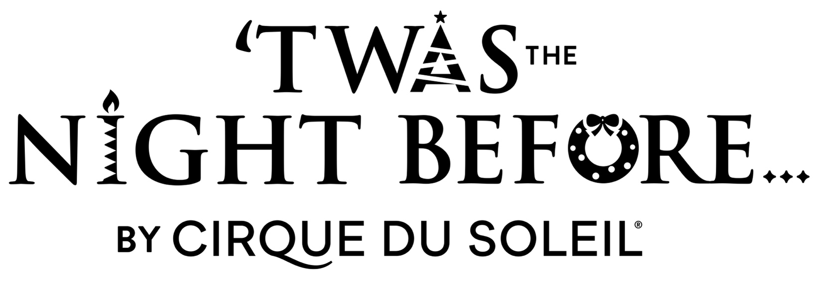

‘Twas the Night Before by Cirque du Soleil – Cirque du Soleil’s
first Christmas show – is coming to Atlanta

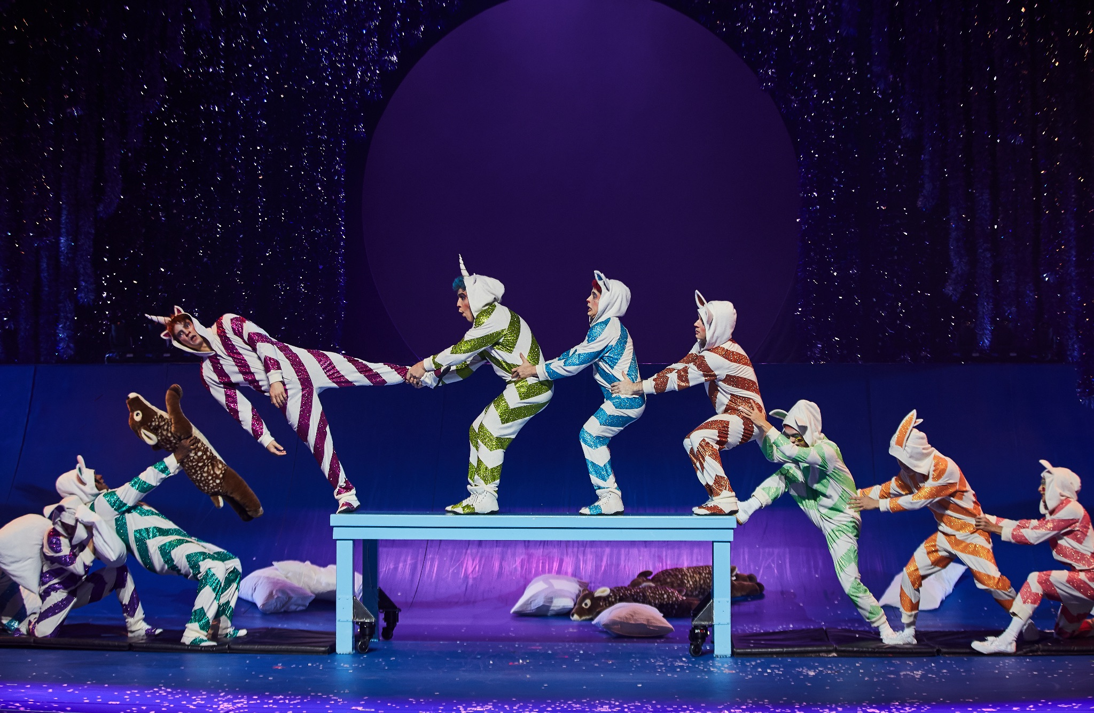

Performances begin on Friday, Nov. 29 and play through Sunday, Dec. 15 at the Fox Theatre

ATLANTA (JULY 16, 2024) – Cirque du Soleil and Regions Bank Broadway in Atlanta announced today that tickets for ‘Twas the Night Before by Cirque du Soleil will go on sale to the public on Thursday, July 25 at 10 a.m. ‘Twas the Night Before by Cirque du Soleil will be the first Cirque du Soleil show to premiere on the Fox Theatre stage from Friday, Nov. 29 for a limited engagement of two weeks through Sunday, Dec. 15. For exact days and times, visit broadwayinatlanta.com.

Beginning Thursday, July 25, tickets will be available at the Fox Theatre box office at 660 Peachtree Street NE, by visiting foxtheatre.org/twas or by calling 855-285-8499. Group orders of 10 or more may be placed by contacting sales@foxtheatre.org.Tickets are now available online to Cirque Club members. Cirque Club membership is free and benefits includes access to advance tickets, special offers and exclusive behind the scenes information. To join, go to www.cirqueclub.com.

TICKET INFORMATION
Tickets for ‘Twas the Night Before… by Cirque du Soleil are now available online to Cirque Club members through July 24, 2024. Cirque Club membership is free and benefits includes access to advance tickets, special offers and exclusive behind the scenes information. To join, go to www.cirqueclub.com. Tickets for the general public will be available starting on July 25, 2024 at foxtheatre.org/twas.

ABOUT ‘TWAS THE NIGHT BEFORE BY CIRQUE DU SOLEIL

‘Twas the Night Before… is Cirque du Soleil’s first Christmas show, based on the classic poem “A Visit from St. Nicholas” by Clement Clarke Moore. Memorable lines from this cherished classic inspired Cirque du Soleil’s story about a jaded young girl who rediscovers the magic of Christmas. A festive flurry of love and cheer created especially for families, ‘Twas the Night Before… features thrilling acrobatics performed by a cast of 26 artists sailing from all over the world, lovable characters and a soundtrack including Christmas favorites re-invented by Cirque du Soleil.'Twas the Night Before… is inspired by the joy of giving and the wonder of the holiday season, with something for everyone in the family to enjoy.

For more information, visit www.cirquedusoleil.com/twas-the-night-before

Downloadable Press Kit, Photos, Trailer & B-Roll: https://media.cirquedusoleil.com/portals/bi93dsg2/TWASPRPortal

ABOUT CIRQUE DU SOLEIL ENTERTAINMENT GROUP
Cirque du Soleil Entertainment Group is a world leader in live entertainment. Building on four decades of pushing the boundaries of the imagination, the Company brings its creative approach to a large variety of entertainment forms, such as multimedia productions, immersive experiences, and special events. Cirque du Soleil Entertainment Group celebrates 40 years of defying reality, defining entertainment, and illuminating the world through art and creativity. Since its creation in 1984, more than 400 million people have been inspired on 6 continents and 86 countries. The Canadian company now employs more than 4000 employees, including 1200 artists from 80 different nationalities.

For more information about Cirque du Soleil Entertainment Group, please visit cirquedusoleil.com.
Follow #TWASCirque and #cirquedusoleil on social media: Facebook | Twitter | Instagram | YouTube

The Atlanta engagement of ‘Twas the Night Before by Cirque du Soleil is presented by arrangement with Regions Bank Broadway in Atlanta as a part of the 2024/2025 Regions Bank Broadway in Atlanta season.

###

About Broadway in Atlanta

The John Gore Organization is the leading presenter, distributor, and marketer of Broadway theater worldwide. Under the leadership of 20-time Tony-winning theater producer and owner John Gore, its family of companies includes Broadway Across America, Broadway.com, The Broadway Channel, BroadwayBox.com, Group Sales Box Office and Broadway Brands. The company presents shows in 48 cities across North America as well as on Broadway, Off-Broadway, London’s West End, Japan, and China. It has won Tony Awards in every producing category as well as numerous other Drama League, Drama Desk and Olivier Awards. The John Gore Organization is committed to supporting theater access and education programs that introduce Broadway to the next generation of audiences and theater professionals.

Broadway Across America (BAA) is part of the John Gore Organization family of companies, which includes Broadway.com, The Broadway Channel, BroadwayBox.com, Group Sales Box Office, and Broadway Brands. Led by 22-time Tony-winning theater producer John Gore (Owner & CEO), BAA is the foremost presenter of first-class touring productions in North America, operating in 48 markets with over 400,000 subscribers. Presentations include Disney’s The Lion King, Wicked, The Book of Mormon, and Hamilton. Current productions include &Juliet, Hadestown, Hamilton, Hell’s Kitchen, MJ: The Musical, Moulin Rouge! The Musical, The Outsiders and Stereophonic.

