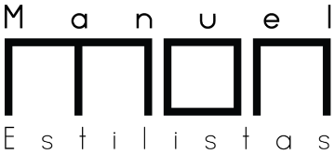
MARÍA MONTES

Manuel Mon Estilistas

In the beginning, what motivated Maria Montes to enter the world of hairdressing was her frustration regarding the world of image. In 2004 she began training at an intermediate level. This in turn led her to obtain an internship as a student at Manuel Mon Estilistas towards the end of 2005. Following that she undertook a professional course in personal decorative aesthetics. Maria completed the whole of her training in Asturias.
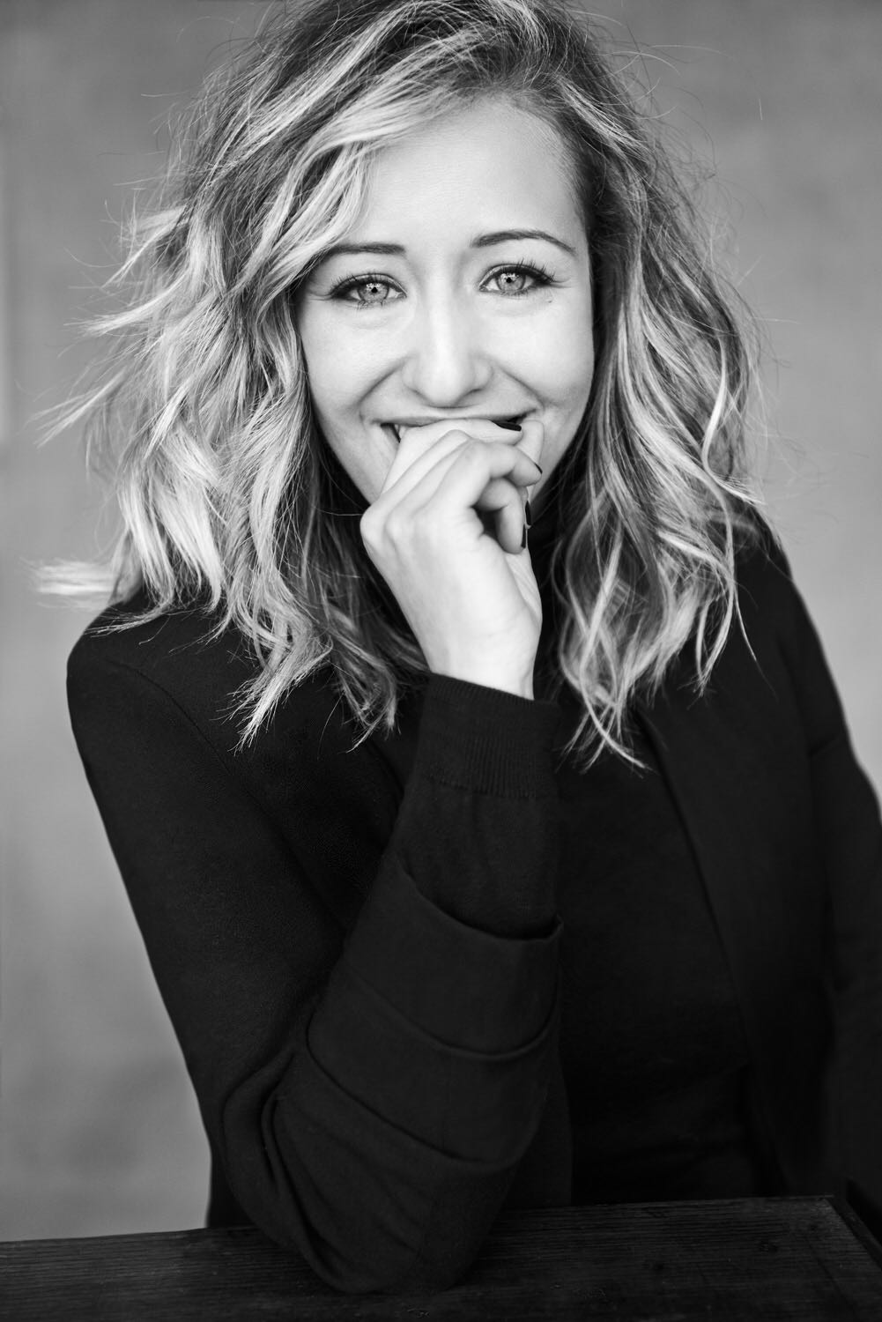
María is a restless soul and she frequently attends numerous symposiums, courses and trainings in order to keep herself informed concerning the latest in hairdressing and aesthetics. In addition, over the years she has earned her place as an instructor, collaborating regularly with Manuel Mon in his training sessions, which are held all over Spain. María’s work also extends beyond the salon, having attended national and international galas and hairdressing events. These experiences have enabled her to gain a much broader view of the professional world in which she works.
Working with the photographer Bernardo Baragaño, María has achieved, regarding the publishing world, a global vision of what is and is expected from an image, both in hairdressing and aesthetics. Along with her team, she has collaborated as a stylist with firms such as Mónica Cordera, Zaitegui and Style Aristos.
In 2016 María achieved her first notable recognition when she was awarded Newcomer Hairdresser at the Creative Hairdressing Awards by Club Figaro. Inspired by the dreamlike mythology of Asturias, her collection was given the fairy name ‘XANAS’. In 2018, María was riding a wave of adulation which every professional in the hairdressing sector dreams of.

MARÍA MONTES

Manuel Mon Estilistas

Not only was she nominated as a finalist in the Style Master Awards organized by Revlon Professional, she went onto to win the award and was proclaimed ‘Country Winner (Spain)’. Subsequently María was selected as one of nine international finalists competing at the grand final in Barcelona. However, the dream did not end there as after dazzling everyone with her much lauded and valued collection, she was then rewarded with the top prize in the contest, the ‘Global Winner’, which recognised María as one of the best hairdressers in the world. For her, this recognition provided her with the incentive to continue working and creating fashion collections where beauty meets technique and the global image.

