**Introducing iFi’s Hip-Dac 3 Stealth Edition**

*A Limited Edition available exclusively through Gramophone*

**Southport, UK, October 4, 2024*—*** [**iFi audio**](https://ifi-audio.com/) **announces a limited edition of their iconic hip-flask-shaped DAC/headphone amplifier, the hip-dac 3 Stealth, with Gramophone. After introducing the hip-dac line in 2019, it has become one of iFi’s most popular DACs, awarded for its portability, hi-res specs, design, richly detailed sound and affordability. The latest iteration, cloaked in a stealthy matte black finish with matching hardware, delivers upgrades and refinements making it the perfect companion for audio and tech enthusiasts who want to step up their audio during commutes, travel or everyday use with up to 12 hours of playtime. The hip-dac 3 Stealth is now available exclusively through** [**Gramophone**](https://skybygramophone.com/products/ifi-audio-hip-dac-3-portable-usb-dac-headphone-amplifier-black-stealth)**, a family-owned company that provides the highest quality home and video equipment to their customers, for $199 USD.**

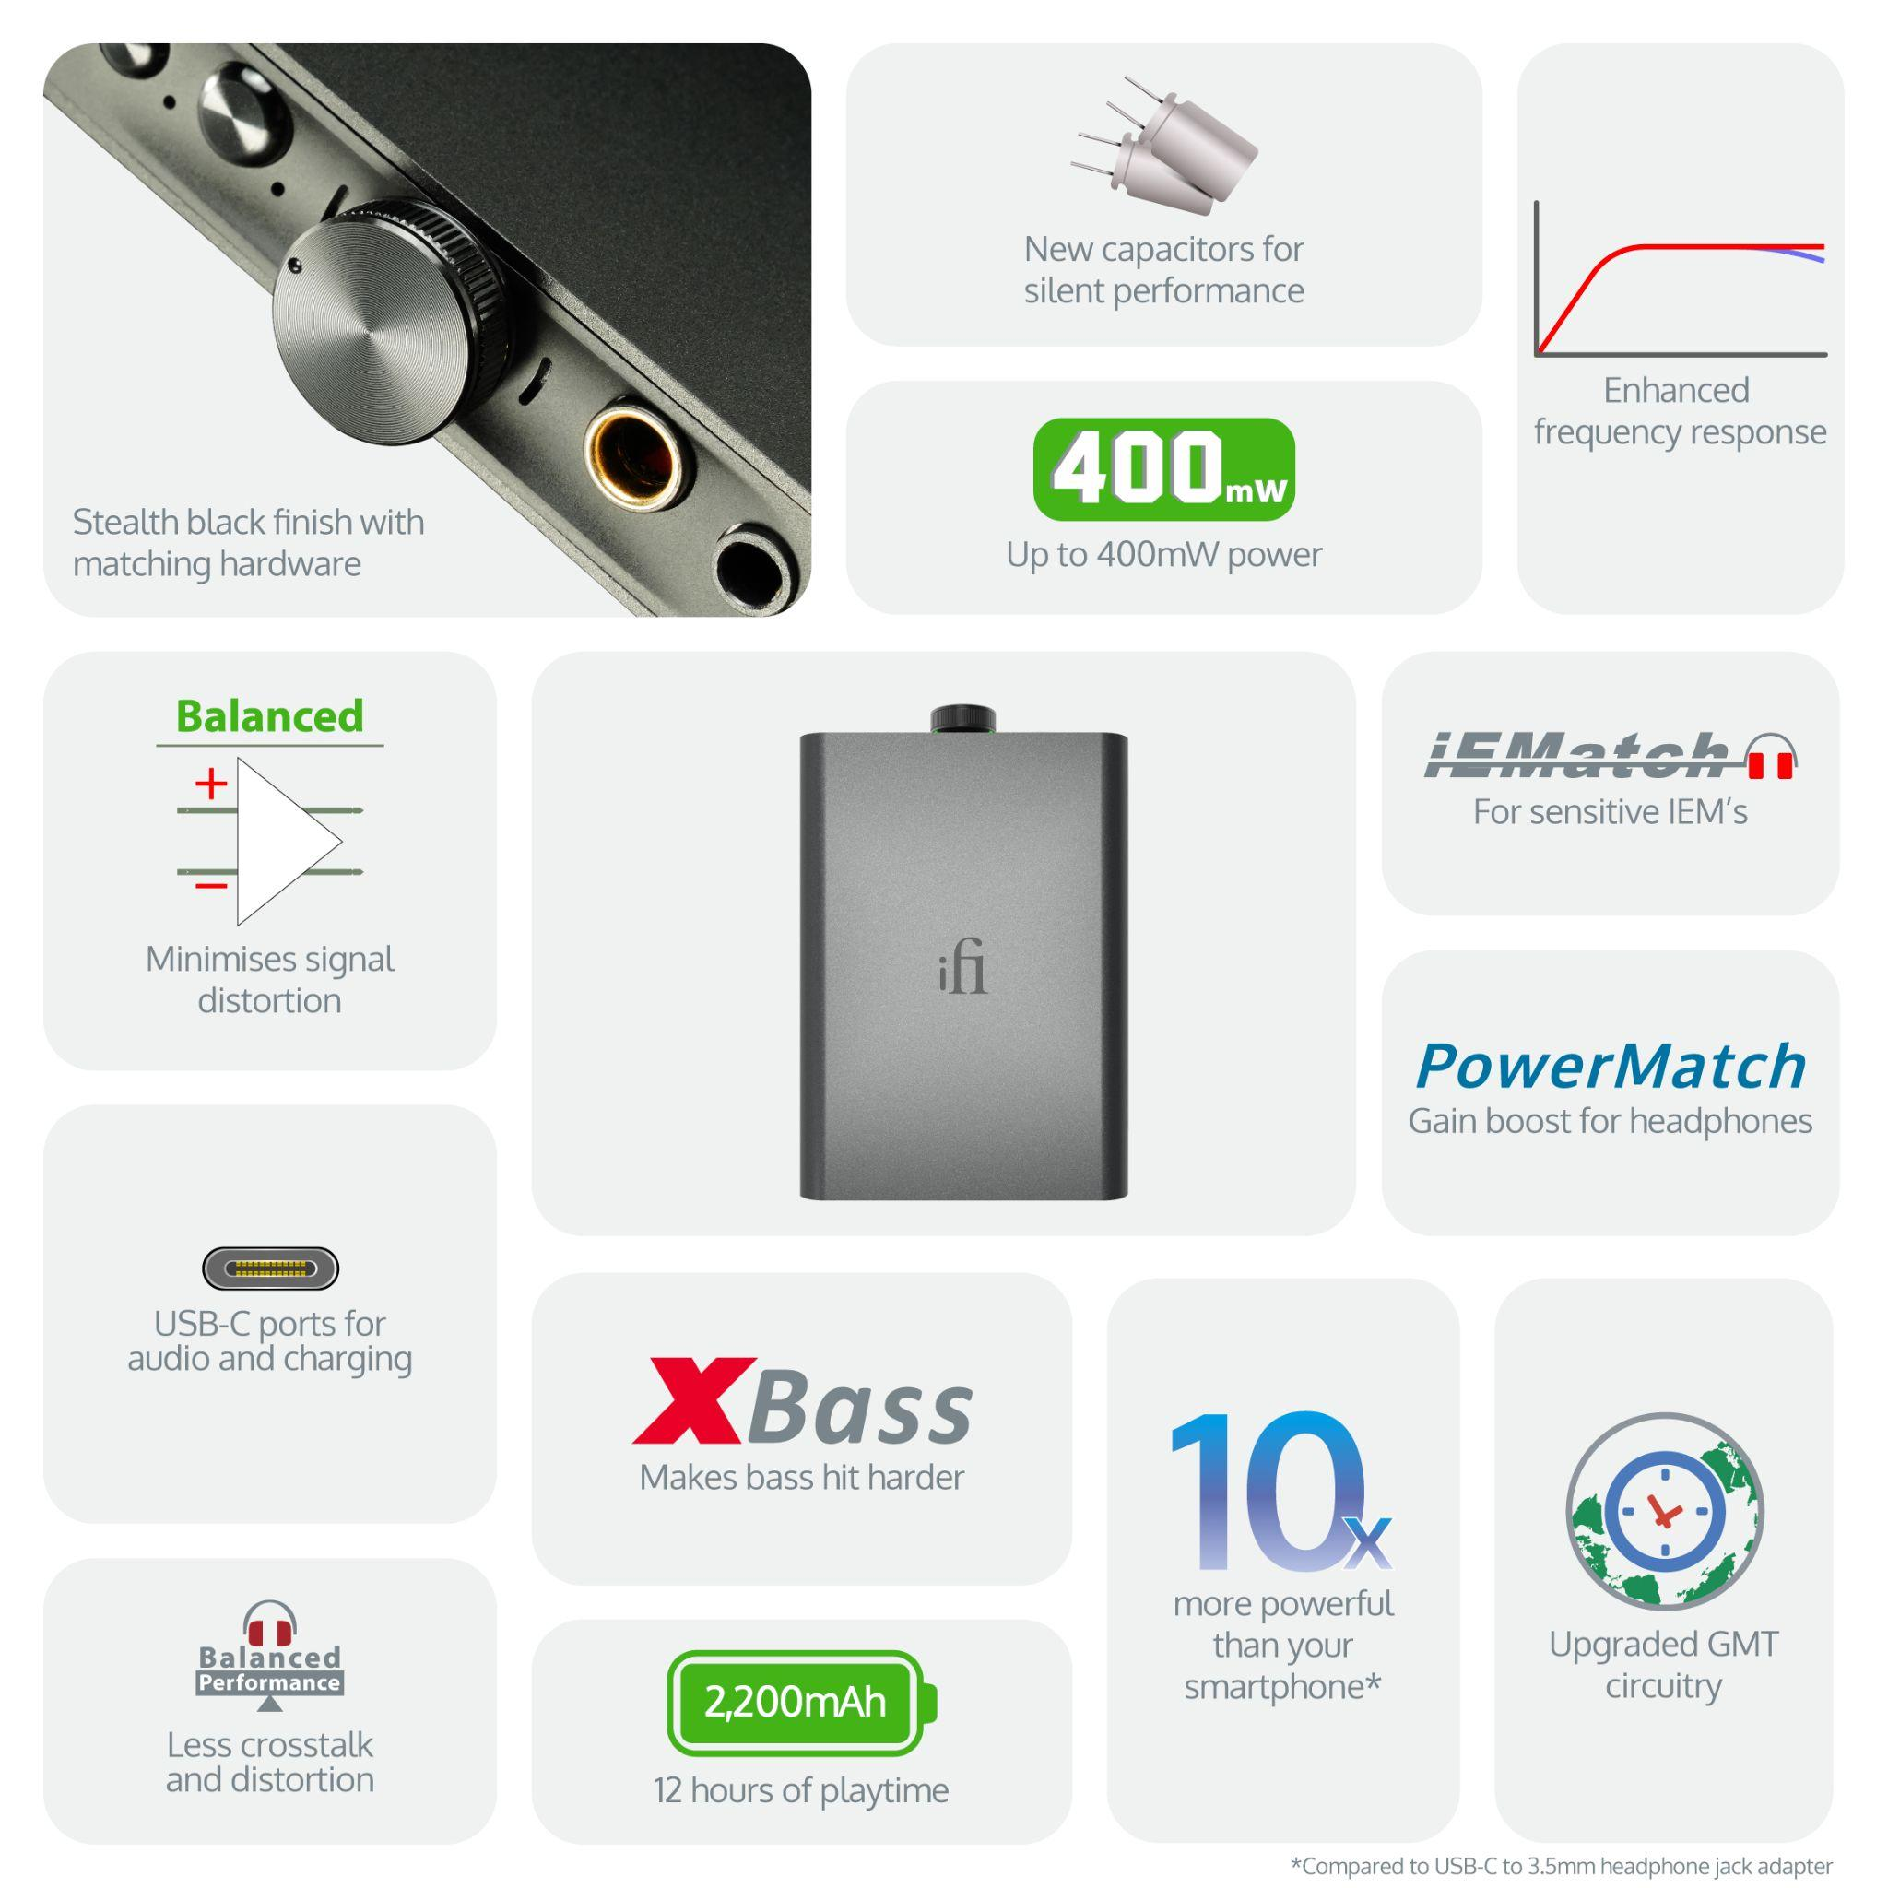

**Whisper-Quiet Upgrades**

The new Stealth Black colorway envelops revised components for quieter power supply operation, as well as the previously implemented ‘True Balanced’ circuit design, new capacitors for enhanced frequency response, and updated ‘GMT’ clock circuitry with a new oscillator to reduce phase noise. All components work together to collectively minimize signal distortion more effectively than in any previous version, ultimately delivering a purer sound to headphones.

The hip-dac 3 Stealth maintains the features and improvements of its multi-award-winning predecessor, like the tried-and-true Burr-Brown chipset for its natural-sounding musicality and True Native architecture. The design allows DSD and PCM audio date to remain ‘bit-perfect’ through separate pathways. Combined with custom iFi circuitry the hip-dac 3 Stealth delivers excellent sound quality across all digital audio formats supporting PCM (Pulse Code Modulation) up to 384kHz, DSD (Direct Stream Digital) up to 256 and full MQA decoding.

**Sleek, sophisticated & stealthy**

The compact device measures 102 x 70 x 14mm with a weight of 135g, delivering ten times more power than a laptop or smartphone and immersing the user into their favorite music without distracting noise or interference. Through PowerMatch users can optimize the hip-dac 3 Stealth to match the headphone’s impedance and sensitivity for peak performance. With XBass, an analogue circuit designed to restore the lost bass response of open-back headphones, achieves a more accurate reproduction of the original music. There is even an IEMatch Switch for sensitive IEMs that fine-tunes the output level, ensuring a perfect match with the amp. Like the hip-dac 3, the Stealth model is future-proofed with 2 USB-C ports. This simplifies cable management and allows one port for audio and the other for charging. Also included is a 3.5mm S-Balanced output for minimized crosstalk and distortion, plus a 4.4mm Balanced output for balanced headphones further leveraging the devices’ differential circuit design.   
  
To purchase this stealthy, perfect portable companion please visit <https://skybygramophone.com/products/ifi-audio-hip-dac-3-portable-usb-dac-headphone-amplifier-black-stealth>.

For more information about iFi Audio and their offerings please visit, [www.ifi-audio.com](http://www.ifi-audio.com).

**Specifications**

|  |  |
| --- | --- |
| **hip dac3-Stealth** | |
| **Input** | USB-C |
| **Formats supported** | DSD256, PCM 384kHz, MQA Decoder |
| **DAC** | Bit-Perfect DSD & DXD DAC by Burr Brown |
| **Headphone Outputs** | |
| Balanced | 4.4mm |
| S-BAL | 3.5mm |
| **Power Output (RMS)** | |
| Balanced | 400mW @ 32Ω; 6.3V @ 600Ω |
| S-BAL | 280mW @ 32Ω; 3.2V @ 600Ω |
| **Output Impedance** | |
| Balanced | ≤1Ω ; With iEMatch engaged: ≤4.5Ω |
| S-BAL | ≤1Ω ; With iEMatch engaged: ≤4.5Ω |
| **SNR** | |
| Balanced | <109dB(A) @ 0dBFS |
| S-BAL | <103dB(A) @ 0dBFS |
| **DNR** | |
| Balanced | <109dB(A) |
| S-BAL | <103dB(A) |
| **THD + N** | |
| Balanced | <0.006% (360mW/2.0V @ 600Ω) |
| S-BAL | <0.01% (100mW/1.27V @ 16Ω) |
| **Frequency Response** | 20Hz - 45kHz (-3dB) |
| **Power Consumption** | <2W idle, 4W max |
| **Battery** | Lithium-polymer 2200mAh approx. 8 hours |
| **Power System** | Charging via USB-C, BC V1.2 compliant up to 1000mA charging current |
| **Dimensions** | 102 x 70 x 14 mm (4.0" x 2.8" x 0.6") |
| **Net weight** | 135 g (0.30 lbs) |
| **Limited Warranty** | 12 months* |
| *12 months typical or as permitted/required by local reseller laws | |
| **Specifications are subject to change without notice. | |

**Contact**

Shelby Coppola  
Hummingbird Media  
Public Relations  
shelby@hummigbirdmedia.com

**About iFi**

iFi is the sister-brand of Abbingdon Music Research (AMR) and is headquartered in Southport, UK. The two brands respectively design and manufacture portable, desktop and lifestyle audio products and high-end hi-fi components. Combined in-house hardware and software development teams and a ‘music first’ approach enable iFi and AMR to create advanced audio products that deliver new levels of design, functionality and performance at their respective price points. Since iFi’s formation in 2012, its products have earned many awards around the world, helping it to become one of the fastest-growing brands in its field.

[www.ifi-audio.com](http://www.ifi-audio.com)