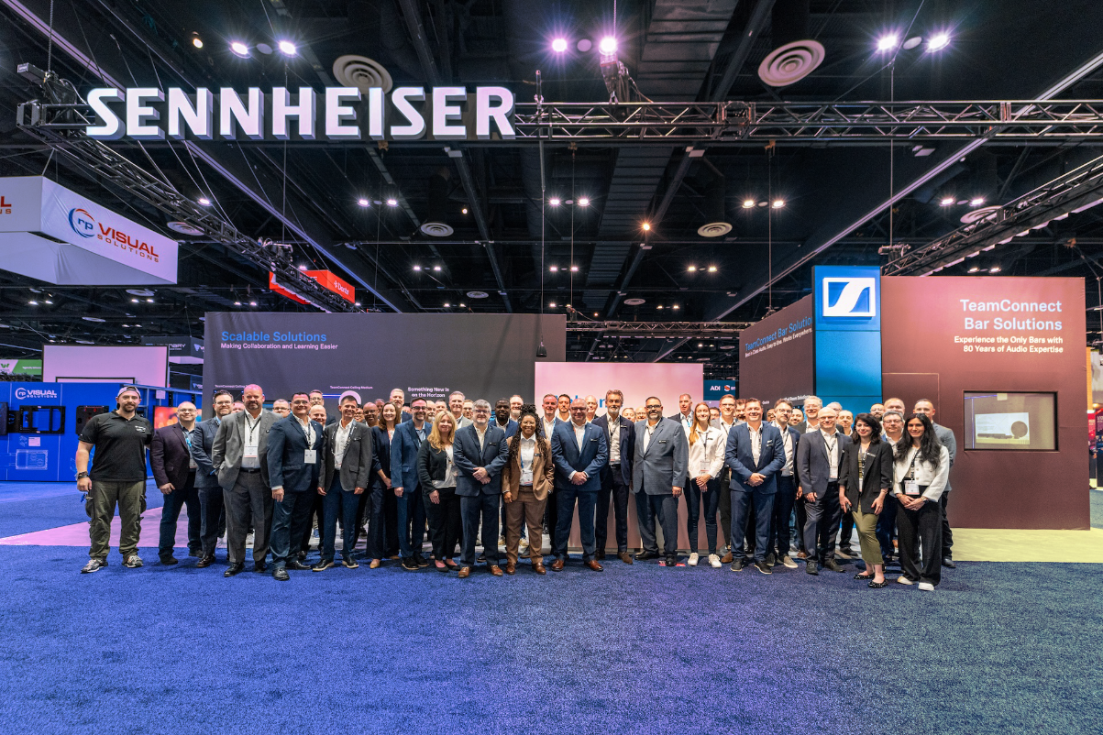
Sennheiser to Unveil Next Generation of Collaboration and Wireless Audio Solutions at InfoComm 2026
Lineup to Include Expansion of DeviceHub Platform, New TeamConnect Innovations, Updates to the Spectera Wireless Ecosystem, and More

LAS VEGAS — June 4, 2026 — Sennheiser, the first choice for advanced audio technology that makes collaboration and learning easier, will bring its most ambitious InfoComm showcase yet to Las Vegas, June 13-19, 2026. Visitors to booth C5313 at the Las Vegas Convention Center will find a full slate of product demonstrations spanning the company’s latest business communication and wireless audio innovations. At the center of this year’s exhibit is the newest TeamConnect Ceiling solution, expansion of the DeviceHub cloud management platform, new partner integration capabilities, Spectera updates and the return of Sennheiser’s popular partner scavenger hunt.

“InfoComm 2026 represents a significant moment for Sennheiser and for the AV industry broadly,” said David Missall, Insights Manager Consultants and Technical Application Engineer Manager, Sennheiser. “From cloud-based device intelligence to new hardware that redefines what’s possible in flexible collaboration spaces, we’re arriving in Las Vegas with solutions that address where the market is heading—not just where it is today. We look forward to welcoming customers, integrators, and partners to the booth for hands-on time with these innovations.”
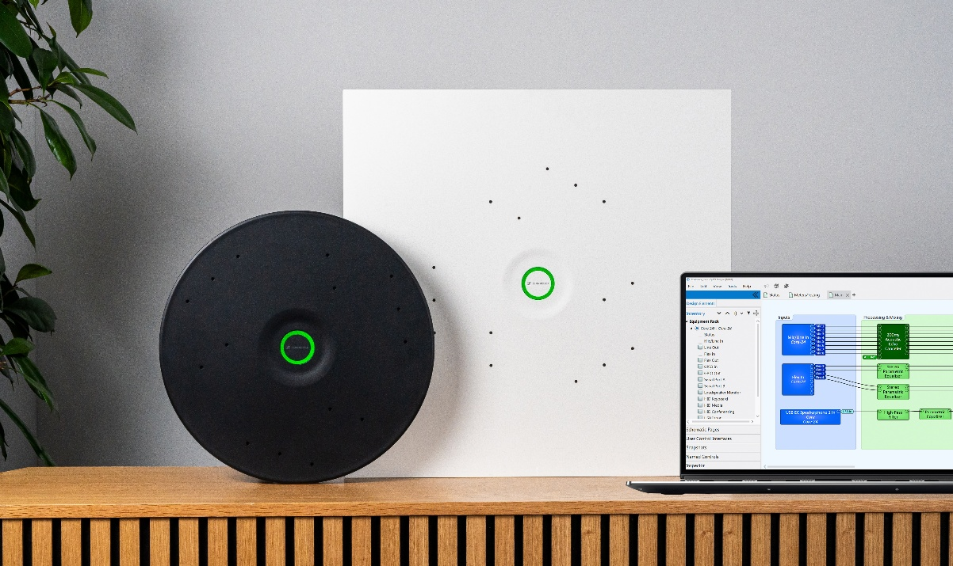
The New TeamConnect Ceiling Medium Plus
Building on the success of the TeamConnect Ceiling portfolio, Sennheiser will debut the TeamConnect Ceiling M Plus (TCC M Plus), a new ceiling microphone designed to deliver simplicity of use and clarity of sound, combining streamlined deployment with consistently clear, natural speech for every participant in the room. The solution combines trusted Sennheiser audio performance with a new generation of features designed to reduce deployment effort, simplify system configuration, and support scalable AV environments.

One of the new key capabilities included with TCC M Plus is PartnerLink, Sennheiser’s integration feature designed to simplify how microphones are configured within leading AV platforms. The first implementation, co-developed through close engineering collaboration between Sennheiser and Q-SYS™, enables the TCC M Plus to be directly configured within Q-SYS Designer Software. PartnerLink is built as a scalable framework intended to extend to additional platforms over time.
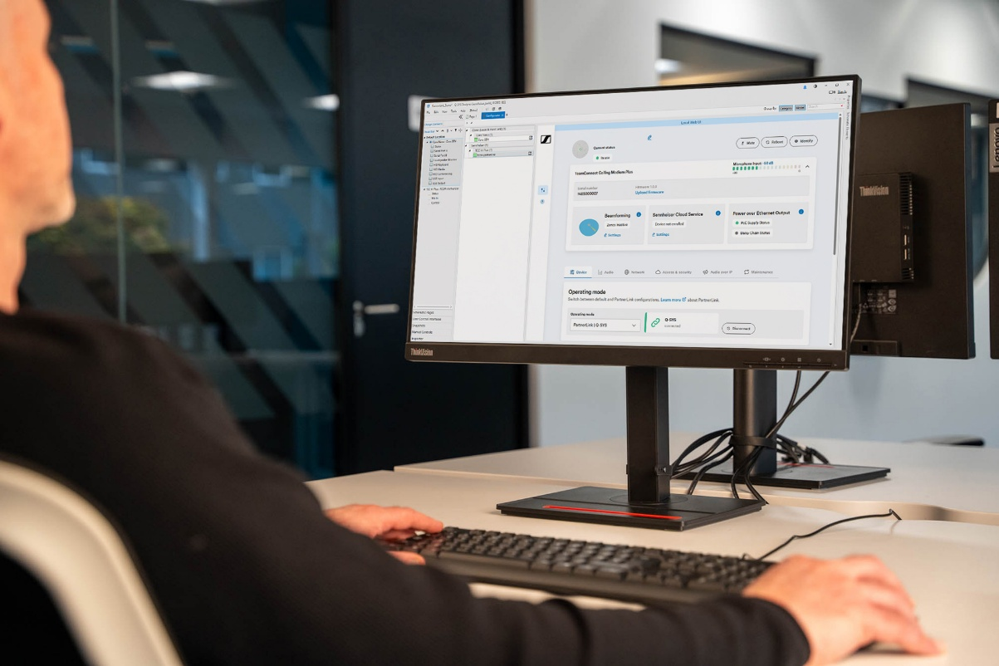
Beyond PartnerLink, TCC M Plus continues Sennheiser’s established approach to interoperability, supporting multiple integration methods to suit different system designs and customer requirements. This flexibility allows organizations to standardize on Sennheiser audio while choosing the platforms and architectures that best meet their needs.

DeviceHub
Launched earlier this year, DeviceHub gives AV and IT teams a secure, browser-based environment to monitor, configure, and manage Sennheiser devices across enterprise, education, and corporate deployments from any location. At the show, Sennheiser will showcase expanded capabilities — including support for the TCC M Plus — that reflect real-world feedback from early adopters, demonstrating how the platform has evolved from initial launch into a living ecosystem that anticipates the needs of distributed, multi-site installations.

With DeviceHub, organizations no longer rely on on-site troubleshooting or room-by-room oversight. Remote monitoring, configuration, and management across multiple locations provide the visibility needed to proactively manage device estates and simplify operations at scale. As deployments grow, DeviceHub provides a centralized platform that helps organizations maintain consistency, reduce operational overhead, and efficiently manage devices across distributed environments.

Spectera
Sennheiser will also showcase updates to the multi-award winning Spectera platform, the world’s first wideband, bidirectional wireless ecosystem for microphones, in-ear monitoring, and control data within a single RF channel. Following its Best of Show recognition at NAB 2026 from Mix Magazine, Spectera has continued to gain momentum across live production and professional AV markets. Attendees can experience live demonstrations of the complete ecosystem.


Partner Innovations and Scavenger Hunt
Attendees will be able to explore collaborations with leading AV platform partners demonstrating how Sennheiser audio operates within the broader control, management, and deployment workflows customers depend on.

On the show floor, visitors will find featured showcases with key integrations including Barco ClickShare Hub, Crestron intelligent audio solutions, Pleneo intelligent meeting room kits, and TCC M Plus with Q-SYS. Sennheiser will also be represented at a further 15 partner booths, giving visitors a practical look at how its audio solutions connect into the platforms and workflows shaping today’s collaboration spaces

Sennheiser’s popular partner scavenger hunt also returns at InfoComm 2026. InfoComm attendees can participate by completing the following steps:

- Download the Scavify app from the Apple App Store or Google Play
- Search for IC26 and enter the Hunt
- Complete the Q&A challenges to get started, then continue the Hunt by visiting partner booths and completing QR, photo and video challenges to earn points
- Visit the Sennheiser booth reception (C5313) at any point after completing the Q&A challenges to collect your Sennheiser socks
As attendees explore the partner ecosystem, they can earn points through challenges across the show floor for the chance to win prizes from Sennheiser and participating technology partners.

More information about Sennheiser at InfoComm 2026 can be found at sennheiser.com/en-us/events/infocomm.

###

About the Sennheiser Group
Building the future of audio and creating unique sound experiences for our customers - this is the aspiration that unites the employees of the Sennheiser Group worldwide. The independent, family-owned company Sennheiser was founded in 1945. Today, it is managed in the third generation by Dr. Andreas Sennheiser and is one of the leading manufacturers in the field of professional audio technology.

sennheiser.com | neumann.com | merging.com

Sennheiser Contact
Daniella Kohan
Communications Manager – Americas & ANZ
(860) 598-7420
daniella.kohan@sennheiser.com

Agency Contact
Peter Schuyler
InGear
(917) 496-8970
peter@ingearpr.com

