PERFECT SOUND FOR YOUR HOLIDAY SEASON

Wedemark, XXXXX, 2019 – Traditional carols, festive pop songs and movie classics like “Home Alone” and “Miracle on 34th Street”: Music and movies are as much part of the holiday experience as gingerbread houses and twinkling lights on trees. Put on the right song or movie and you’ll instantly be in the right mood for the holidays and ready for a bit of Christmas shopping for your friends and family. This year why not kill two birds with one stone and make music and movies your inspiration: Delight your loved ones with a pair of brilliant Sennheiser headphones or the extraordinary AMBEO Soundbar to make sure they can enjoy their favorite Christmas songs and movies to the fullest. No matter how discerning the music or movie lovers on your gift list are, audio specialist Sennheiser is sure to have the perfect present that will make their holidays sound even more special.

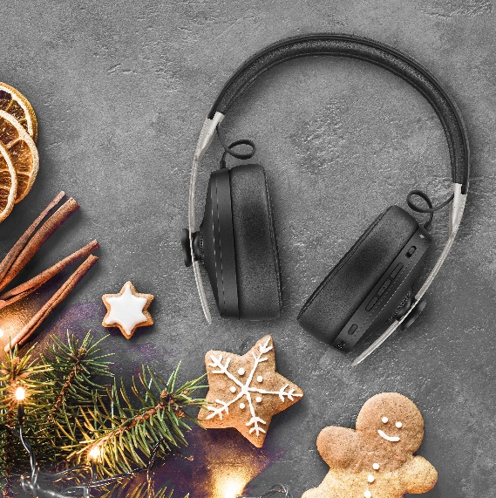
Perfectly in tune with Christmas
MOMENTUM WIRELESS
+ Smart features such as Auto On/Off and Smart Pause ensure you never miss a beat of your favorite holiday song
+ Superior sound: reproduces the balanced depth and precision of a studio recording
+ Three Active Noise Cancellation modes and Transparent Hearing function
+ A touch of indulgence: genuine, soft leather on the earpads and headband
+ One-touch access to voice assistants
+ Almost impossible to misplace thanks to the integrated Tile Bluetooth tracker
MSRP: 399 EUR
https://en-de.sennheiser.com/momentumwireless

Style and sound icon
MOMENTUM TRUE WIRELESS
+ Exceptional sound performance
+ Transparent Hearing feature for optional improved situational awareness
+ Intuitive touch interface and direct access to smart assistants
+ Pure design featuring metallic details on the outer face and a stylish fabric-wrapped case
+ 4-hour battery life that can be extended to up to 12 hours via the compact case with integrated power bank
MSRP: 299 EUR
https://en-de.sennheiser.com/truewireless-details

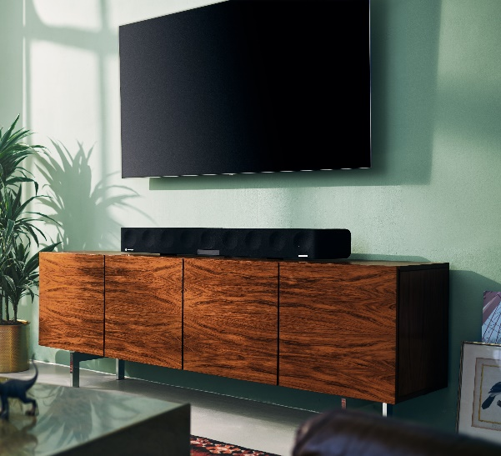
Incredible 3D sound in your living room
AMBEO SOUNDBAR
+ Experience your favorite Christmas movie like never before
+ Delivers the immersive “as-if-there” feeling of a 5.1.4 speaker system and incredibly powerful bass, without the need for a subwoofer
+ Automated room calibration tailors the sound to your room and preferred seating position – placing you in the center of the action
+ As well as supporting 3D audio formats like Dolby Atmos, MPEG-H and DTS:X, the soundbar’s Upmix Technology recreates stereo and 5.1 content as a thrilling 3D sound experience.
MSRP: 2,499 EUR
https://en-de.sennheiser.com/ambeo-soundbar

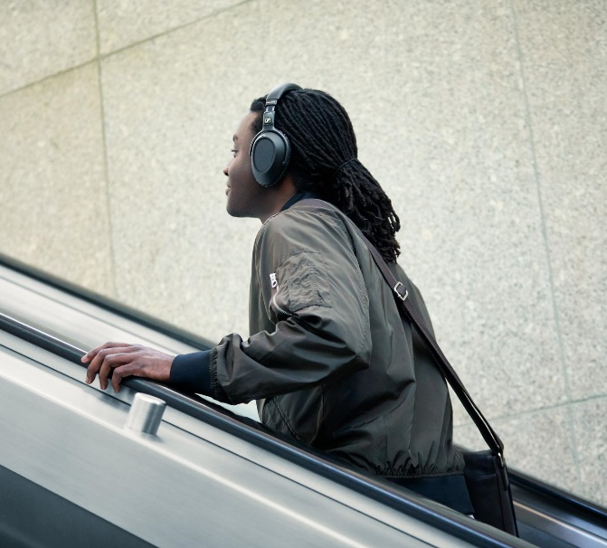
For the frequent traveller
PXC 550-II WIRELESS
+ Wireless headphones created for a smart and sophisticated travel experience – perfect when coming home for the holidays
+ Undisturbed, superior sound in any environment with adaptive noise cancellation
+ Intuitive operation via touch pad
+ Convenient one-touch access to voice assistants
+ Travels the world on a single charge: up to 20 hours of battery life with Bluetooth and ANC switched on, and up to 30 hours when using ANC and a wired connection
MSRP: 349 EUR, available from November

https://en-de.sennheiser.com/pxc-550-ii

The images accompanying this press release can be accessed here: https://sennheiser-brandzone.com/c/1543/k7zEPeNr

About Sennheiser
Shaping the future of audio and creating unique sound experiences for customers – this aim unites Sennheiser employees and partners worldwide. Founded in 1945, Sennheiser is one of the world’s leading manufacturers of headphones, loudspeakers, microphones and wireless transmission systems. Since 2013, Sennheiser has been managed by Daniel Sennheiser and Dr. Andreas Sennheiser, the third generation of the family to run the company. In 2018, the Sennheiser Group generated turnover totaling €710.7 million. www.sennheiser.com

Global Press Contact
Sennheiser electronic GmbH & Co. KG
Jacqueline Gusmag
Communications Manager Consumer
T: +49 (0)5130 600-1540
jacqueline.gusmag@sennheiser.com

