Longines Spirit Zulu Time

REFERENCE NUMBERS

L3.802.5.53.2

L3.802.5.53.6

L3.802.5.53.9

CALIBRE

Longines exclusive self-winding movement, L844.4, COSC certified

With silicon balance-spring and magnetic resistant

11½ lines, 21 jewels, 25'200 vibrations per hours

Power reserve of approximately 72 hours

FUNCTIONS

Hours, minutes, seconds and date aperture at 6 o’clock

24 hours hand with time zone mechanism

CASE

∅ 39 mm, 13,50 mm thickness

Lug-to-lug: 21 mm

Round, stainless steel

Sapphire domed glass with multi-layered anti-reflective coating on both sides

Screw in crown in yellow gold

Case back with 6 screws

Bidirectional rotating bezel in yellow gold with chocolate brown ceramic insert

Engraved 24-hour scale with lacquered numbers and Super-LumiNova® triangle

DIAL

Anthracite sandblasted, applied Arabic numerals,

Super-LumiNova® old radium

HANDS

Gilt polished, Super-LumiNova® old radium

GMT hand: black and gilt polished

WATER-RESISTANCE

To 10 bar (100 meters)

BRACELET/STRAP

Brown leather strap with folding buckle and micro adjustment

system, with interchangeable system

Stainless steel bracelet with double safety folding clasp and

push-piece opening mechanism, with interchangeable system

Brown NATO strap

*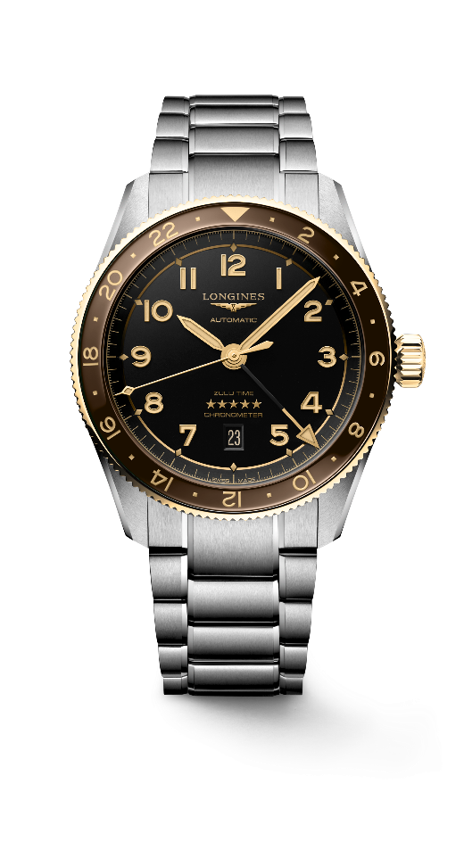*

*L3.802.5.53.6*