The Sennheiser Group at NAB 2023
Experience the latest audio tools for production and studio

Wedemark, March 2023 – NAB Visitors are invited to experience the combined power of four brands at booth No. C5217: Sennheiser, Neumann, Dear Reality and Merging Technologies will showcase their full range of audio solutions for video production, sound design, recording, and more to equip professionals of all levels, from social media creators to audio mixers for film and television.

Sennheiser
Besides its full range of mics for camera use, Sennheiser will showcase its EW-DX and Digital 6000 wireless microphone systems and also debut its latest wireless audio system, designed specifically for film makers, high-profile content creators and broadcasters. The product portfolio on show is rounded off by the company’s broadcast headsets. Attendees will also have the chance to listen live to Emmy-nominated foley artist Sanaa Kelley and head mixer Arno Stephanian – captured by Sennheiser’s world-class shotgun microphones.

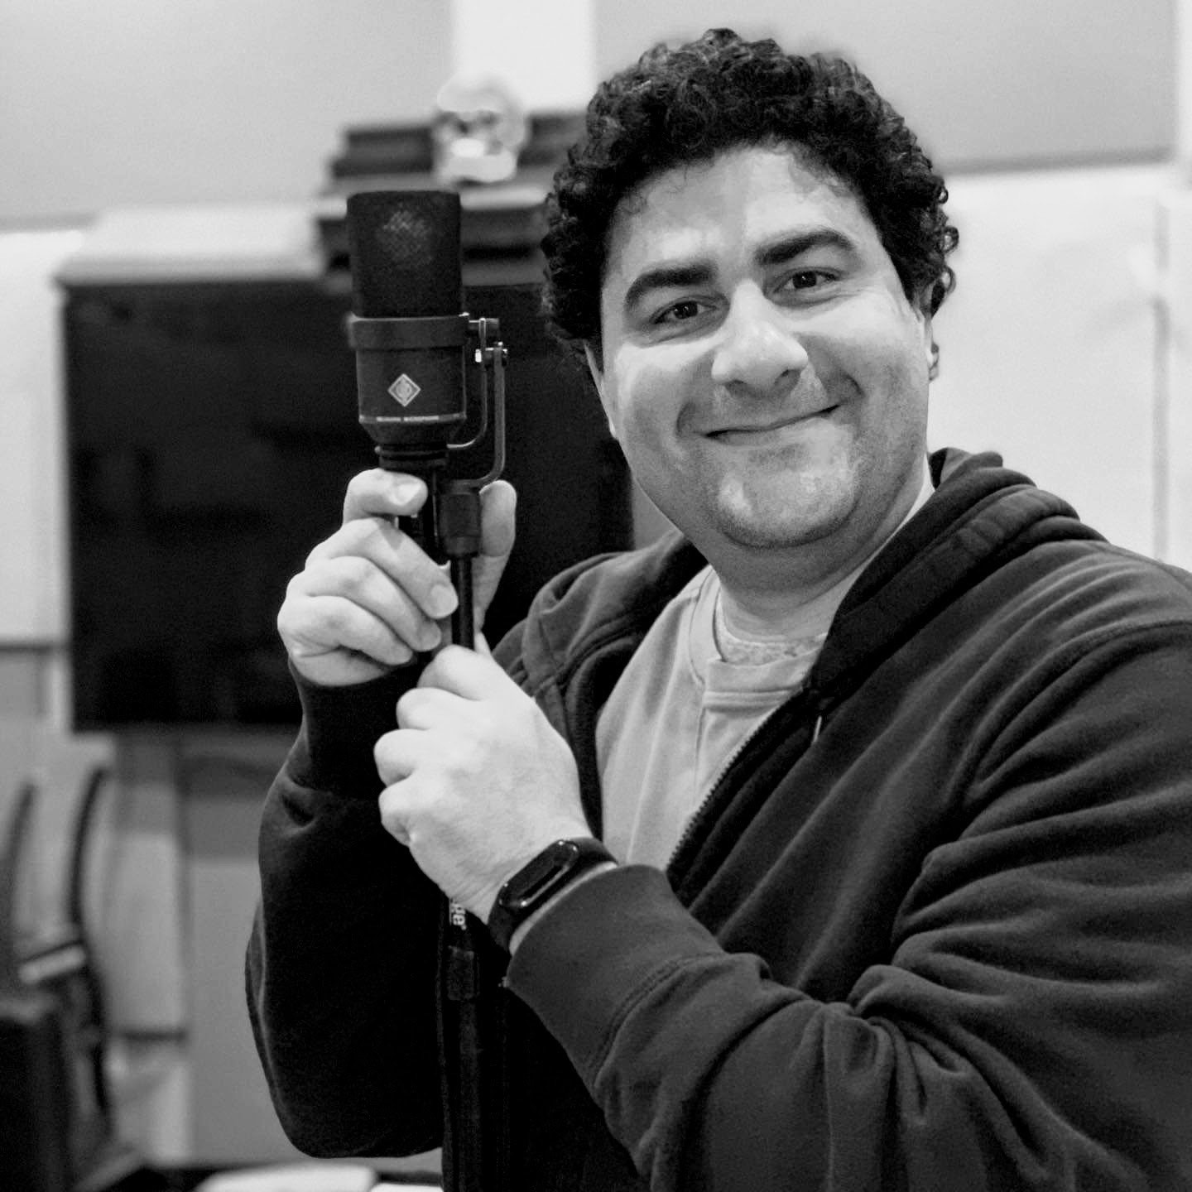
Sanaa Kelley, founder of Reel Foley Sound, and Arno Stephanian, head mixer, will captivate visitors with their art

The ProLabs team, meanwhile, will be demoing the exciting capabilities of its AMBEO 2-Channel Spatial Audio renderer, which, working from immersive and 5.1 formats, creates a fantastically spatial soundscape for listeners on a stereo system.

Wireless Multichannel Audio Systems (WMAS) – A technology revolution for large wireless microphone set-ups
On Tuesday April 18th, Joe Ciaudelli, Director of Spectrum & Innovation, will speak about this exciting new wireless technology in demo room # N114LMR at 10:00 a.m., 11:30 a.m. 2:30 p.m. and 4 p.m.

Wireless Multichannel Audio Systems (WMAS) will revolutionize large wireless microphone and monitoring configurations. Compared to today’s conventional link-based approach, where each audio channel transmits on a dedicated, unique narrowband radio frequency (RF) carrier, WMAS multiplexes audio channels onto a single wideband RF carrier. This allows more audio channels to be packed within a small block of RF spectrum, such as a vacant TV channel. It also allows more spectrum reuse because the required separate distance is shorter between a WMAS and another user operating on the same RF channel.

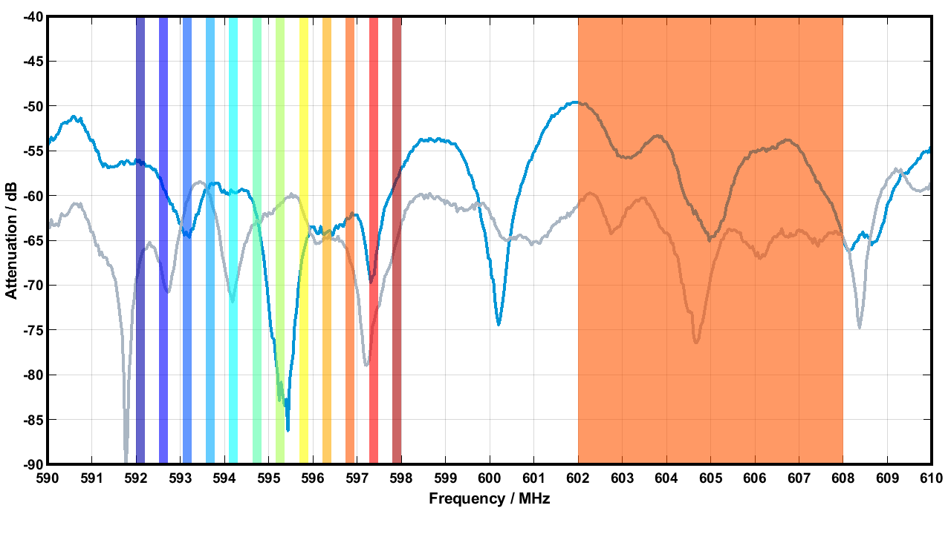 | Operating principle of Wireless Multi-Channel Audio Systems. Instead of individual 200 kHz bandwidths as in narrowband transmission (left-hand side), the technology uses time slots in a 6 or 8 MHz wide window (right-hand side). More information at sennheiser.com/wmas
This is particularly beneficial for multi-studio production facilities, mega-sporting events such as the Olympics, theme parks, school campuses, or densely packed theater districts such as Broadway, West End or Las Vegas.

Neumann.Berlin
Neumann’s studio microphones and monitors are firm favorites with studios and broadcasters the world over. Active listening stations with Neumann headphones will allow visitors to listen to the most popular mic models, while an immersive set-up will impressively demo KH 80 and brand-new KH 120 II monitors.

Dear Reality
Dear Reality will demonstrate spatial productions with an extended immersion using the dearVR PRO spatializer. Visitors can listen to these multi-channel productions with Neumann headphones and the dearVR MONITOR virtual immersive mix room plugin.

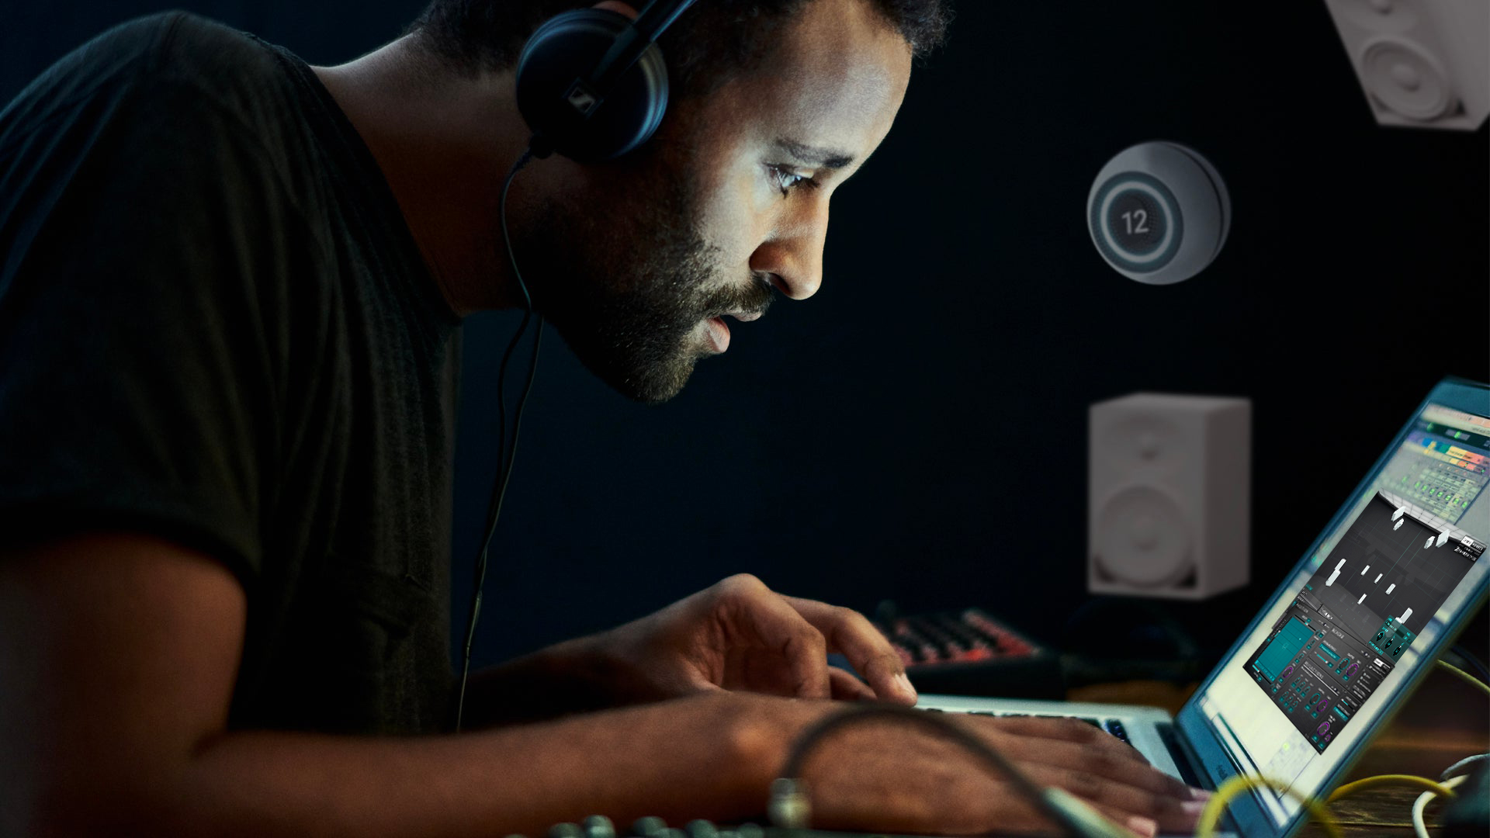 | Intuitively spatialize your tracks and monitor your immersive mixes everywhere with dearVR PRO and dearVR MONITOR

Merging Technologies
In addition to their own booth (C4517), Merging Technologies will be present at the Sennheiser Group booth and demo their world-class audio interfaces. Their Anubis and Hapi solutions are part of the active demonstrations at the group’s booth.

Equipment loans
During the show, content creators, journalists and freelance reporters can try some of Sennheiser’s audio for video solutions for a day. They should simply come to the booth to collect a mic or headphone, leave an ID and return the gear at the end of the day.

Visit the Sennheiser Group at NAB, Central Hall, booth No. C5217.

(Ends)
The images accompanying this media release can be downloaded here.

About the Sennheiser Group

Building the future of audio and creating unique sound experiences for our customers - this is the aspiration that unites the employees of the Sennheiser Group worldwide. The independent family-owned company Sennheiser was founded in 1945. Today, it is managed in the third generation by Dr. Andreas Sennheiser and Daniel Sennheiser, and is one of the leading manufacturers in the field of professional audio technology. Within the Sennheiser Group are Georg Neumann GmbH (Berlin, Germany), manufacturer of studio-grade audio equipment; Dear Reality GmbH (Düsseldorf, Germany), known for its binaural, Ambisonics, and multichannel encoders with realistic room virtualization; and Merging Technologies SA (Puidoux, Switzerland), specialist in high-resolution digital audio recording systems.
sennheiser.com | neumann.com | dear-reality.com | merging.com

