SpeechLine Digital Wireless
New multi-channel receiver sets the standard for network-enabled AV equipment

Wedemark/Amsterdam, 11 February 2020 – In today’s corporate and higher education environments, it’s often small IT teams that look after huge AV set-ups, taking care of many rooms and even more microphones that are spread over large campuses. To make their task easier – and expand its offer of network-enabled AV equipment – Sennheiser is launching the SpeechLine Multi-Channel Receiver. The IT-friendly receiver will be available from Q2 2020 as a two-channel or four-channel version.

“The SpeechLine Multi-Channel Receiver is part of Sennheiser’s wide offering for higher education facilities and corporations. It adds a compact, IT-friendly receiver with maximum connectivity and easy control to the SpeechLine Digital Wireless series,” said Michael Altemark, Portfolio Manager at Sennheiser. “The receiver ensures perfect IT integration, ease of use and seamless workflows.”

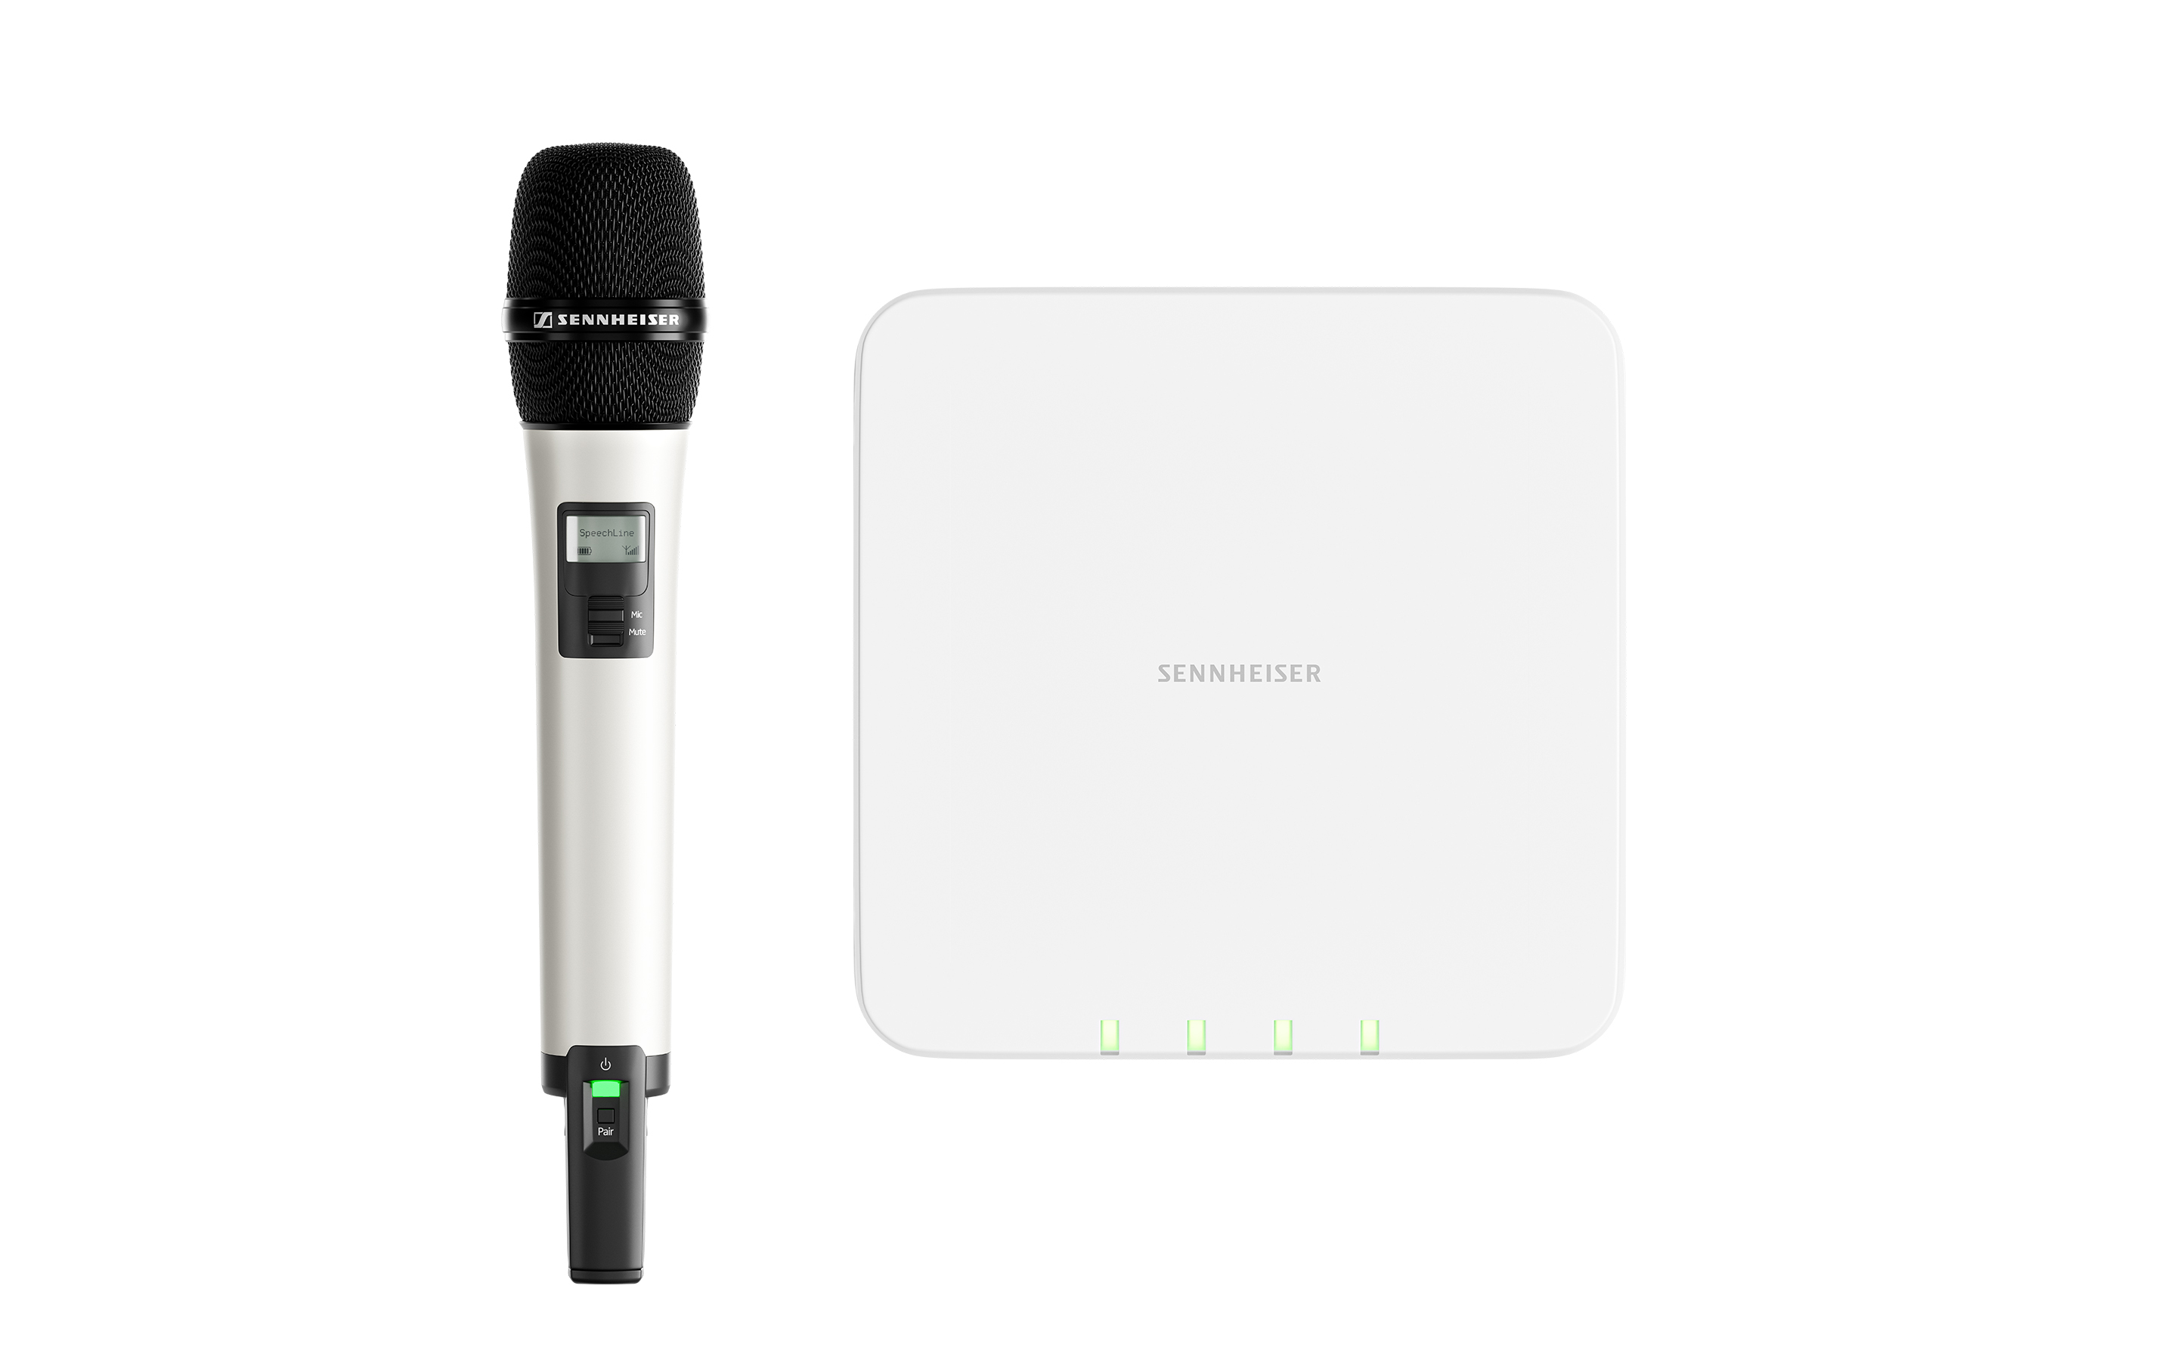 | The new multi-channel microphone receiver for Sennheiser’s SpeechLine Digital Wireless series is a perfect match for modern IT infrastructures.  It ensures easy integration, uses license-free 1.9 GHz technology and can be centrally software controlled through Sennheiser Control Cockpit

All-in-one solution
Offering the same uncompromising RF performance as all SpeechLine Digital Wireless devices, the new multi-channel receiver accommodates up to four receiving channels and an auto-mixer – no additional antenna is needed, and only one cable is required for PoE, control data and the Dante stream for which redundant sockets are provided. A 3-pin terminal connector is available for infrastructures that need an analog output. The multi-channel receiver complies with common network security standards.
Rear view of the SpeechLine Multi-Channel Receiver with connection options and wall mount | 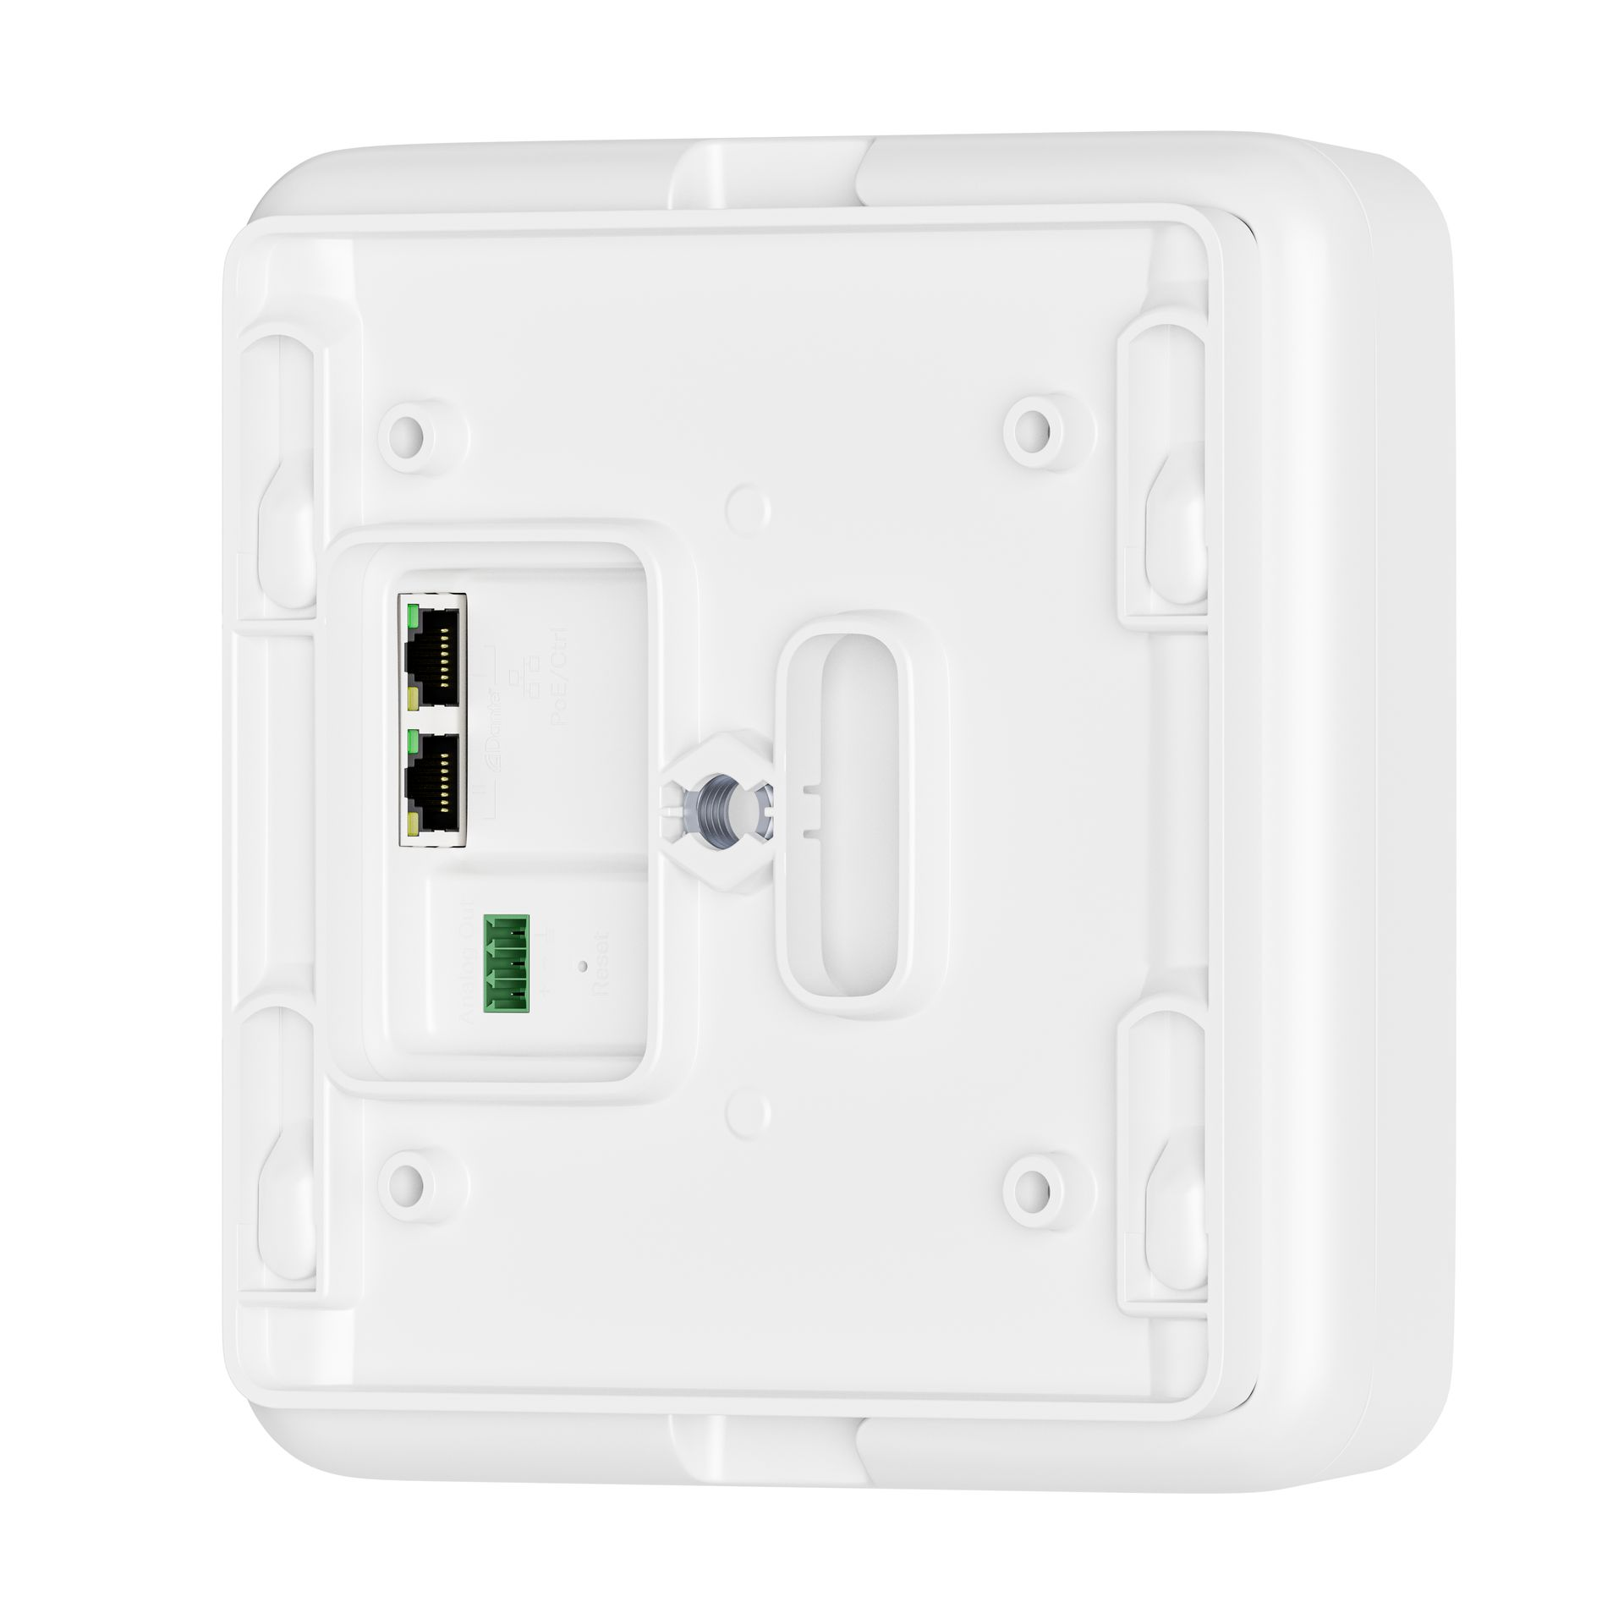

The SpeechLine Multi-Channel Receiver can be unobtrusively wall- or ceiling-mounted using the included wall-mount adapter. For a quick on-site check, the receiver features status LEDs for the audio channels, otherwise it is configured and controlled via the convenient Sennheiser Control Cockpit software or via Sennheiser’s open SSC protocol for third-party solutions.

For lecturers and speakers, SpeechLine offers a choice of wireless handheld, headset, lavalier or even boundary and table microphones, ensuring that they can feel at ease with their favorite type of microphone.

A universal tool for education and business environments
Sennheiser Control Cockpit has been designed to make the daily routines and workflows associated with the use of wireless microphones in corporate and campus settings far easier. The software allows centralized remote control, monitoring and maintenance of campus- and company-wide audio installations from anywhere in a network.

For example, battery management will become a breeze for the IT staff – the software allows them to filter for low batteries or to activate push messages to their (mobile) devices. The software also helps to identify potential issues that an end user may encounter, enabling IT staff to remotely check the operating status of each microphone on the campus or in a company.

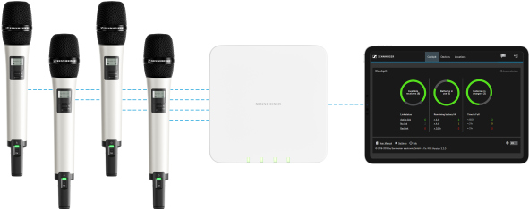 | The Sennheiser Control Cockpit software makes system set-up, control and monitoring a breeze

Besides SpeechLine Digital Wireless, the software also supports evolution wireless G3 and G4 as well as the TeamConnect Ceiling 2 microphone.

Multi-room mode and 1.9 GHz transmission
With SpeechLine Digital Wireless, an infinite number of microphone links can be implemented at a university or a corporate campus. This is made possible by the system’s multi-room mode, which allows to select the transmission power in accordance with the room size, ensuring optimum audio transmission everywhere on campus.

SpeechLine Digital Wireless works in the license-free 1.9 GHz range, and features both auto-frequency management and auto-interference management. The system uses advanced 256-bit AES encryption to ensure data integrity.

Technical Data
Number of channels: 2 or 4
PoE: yes
External control: yes
Dante: yes, redundant (two ports)
Assignment of RJ 45 connectors: 1: PoE, Control, Dante (primary); 2: Dante (secondary)
Analog out: yes
Stand-alone operation: yes
Dimensions: 180 x 180 x 45 mm
Weight: approx. 600 g
Vesa mount: yes, Vesa 100

The images accompanying this press release can be accessed here: https://sennheiser-brandzone.com/c/181/zVT7pZcQ.

About Sennheiser
Shaping the future of audio and creating unique sound experiences for customers – this aim unites Sennheiser employees and partners worldwide. Founded in 1945, Sennheiser is one of the world’s leading manufacturers of headphones, loudspeakers, microphones and wireless transmission systems. Since 2013, Sennheiser has been managed by Daniel Sennheiser and Dr. Andreas Sennheiser, the third generation of the family to run the company. In 2018, the Sennheiser Group generated turnover totaling €710.7 million. www.sennheiser.com

Local Press Contacts

Sarah James Maik Robbe
sarahj@gasolinemedia.com maik.robbe@sennheiser.com
+44 (0) 1483 223333 +44 (0) 7393 462484

