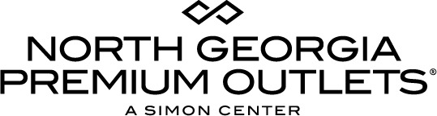

For more information:
McKenzie Riley
BRAVE Public Relations
mriley@emailbrave.com
404.233.3993
FOR IMMEDIATE RELEASE

North Georgia Premium Outlets welcomes Johnathan Andrews as General Manager

Dawsonville, Ga. (August 17, 2018) – Simon, a global leader in the ownership of premier shopping, dining, entertainment and mixed-use destinations, announced today the appointment of Johnathan Andrews as General Manager of North Georgia Premium Outlets. Andrews, who arrives with special experience in retail management has spent nearly a decade in the retail industry, including experience with brands like Fossil, Aéropostale and Abercrombie & Fitch. He previously held the General Manager position at Clinton Crossing Premium Outlets in Connecticut and served as the Assistant General Manager at Charlotte Premium Outlets in North Carolina.

“It’s an honor to join the extraordinary team at North Georgia Premium Outlets. I am excited to invest my energy into this shopping and tourism destination,” said Andrews. “I look forward to continuing Simon’s vision for North Georgia Premium Outlets and its contributions to the Dawsonville community!”

As General Manager, Andrews will be responsible for leasing operations at the center, including working with current and prospective businesses on their presence in the center and reviewing lease transactions. In addition, he will also oversee the center’s marketing development and daily operations.

North Georgia Premium Outlets
North Georgia Premium Outlets is a leader in the most sought-after outlet retail located north of Atlanta in Dawsonville, Ga. The over 481,000 square-foot outlet shopping center features enormous savings up to 65 percent off every day at 140 stores including Ann Taylor, Burberry, Cole Haan, Gap Outlet, J. Crew, Kate Spade New York, Nike Factory Store, The North Face, Pottery Barn Outlet, Restoration Hardware, Saks Fifth Avenue OFF 5TH, The North Face, UGG Australia, Vera Bradley, Vince Camuto, Williams-Sonoma and more. For a map and store listings, as well as directions, events and tourism resources, visit www.premiumoutlets.com/NorthGeorgia.

###

