For more information, please contact Marta de Paco
On +34 670 780 664 or email press@comunicahair.com

Important:
These images are only available for editorial content.
Credits must be included.
Notification of their publication is expected.

PELSYNERA
UNDERWATER Collection

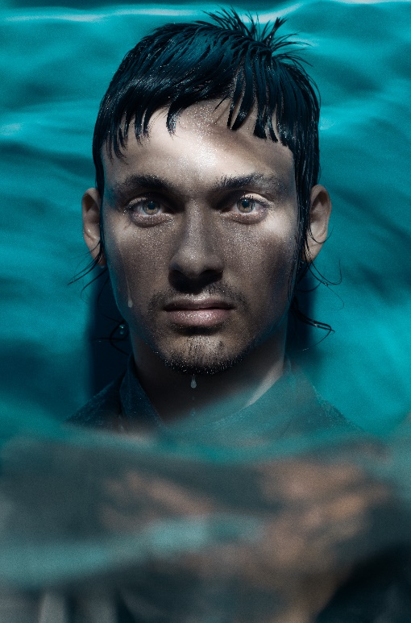
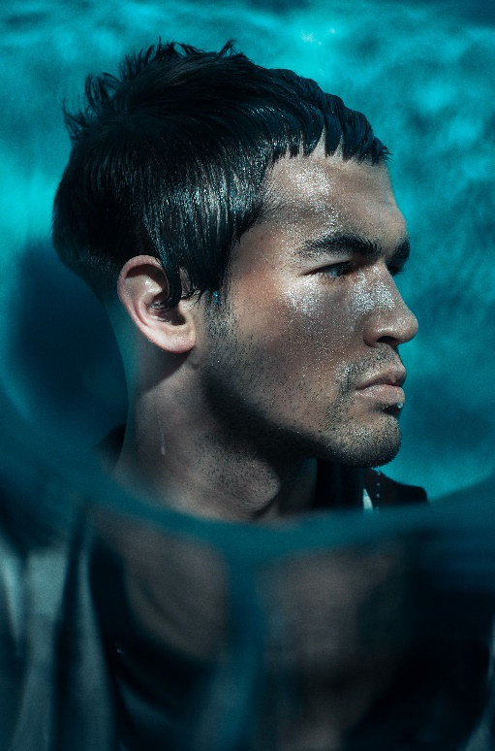
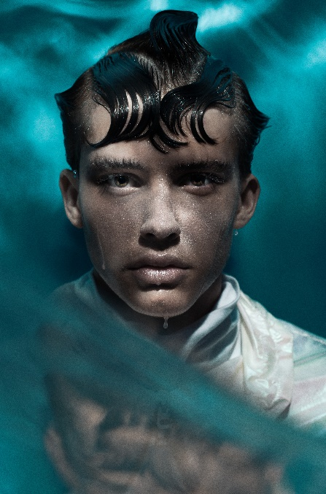

Hair: Pelsynera
Instagram @Pelsynera
Photographer: David Arnal
Instagram @Davidarnal
MUA: De_maria
MUA Instagram @de_maria
Styling: Pelsynera
Instagram @Pelsynera
Video: El hombre orquesta

PELSYNERA
UNDERWATER Collection

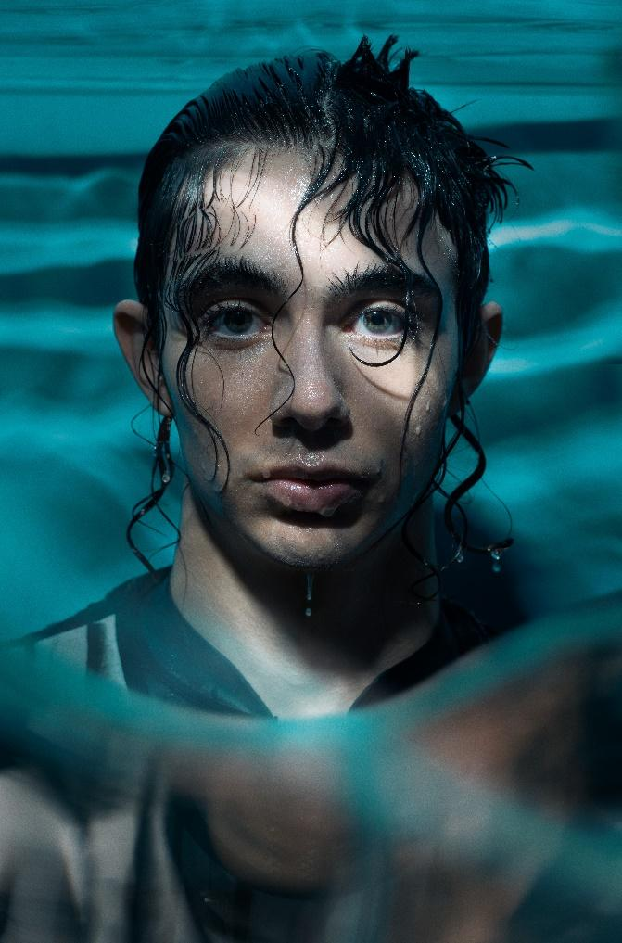

The sea leads us on winding paths through its transparent currents, it embraces us with its deep blue, and it envelops us in its sacred dance.
The hair gathers with its flexibility the language of its movement with waves that sway to the rhythm of the sea waves. Imperfectly perfect, they connect us with an ancient essence that is renewed every time we immerse ourselves. The hair is the swing of its whims, the reflection of a humidity that connects us with the mystery of life.

