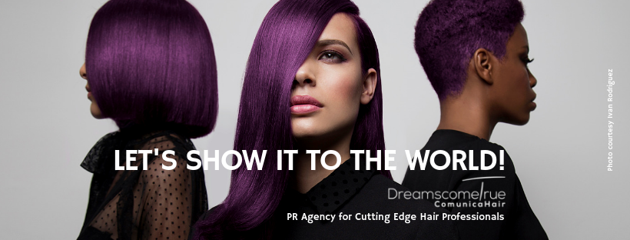
Specialised PR Agency for Cutting Edge Hair Professionals.
Creative Hairdressers are our clients.

For more information, please contact Marta de Paco
On +34670780664 or email press@dreamscometrue.es

Important:
These images are only available for editorial content.
Credits must be included.
Notification of their publication is expected.

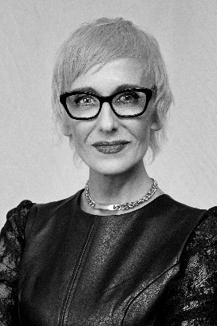
FELICITAS HAIR
WHY NOT Collection

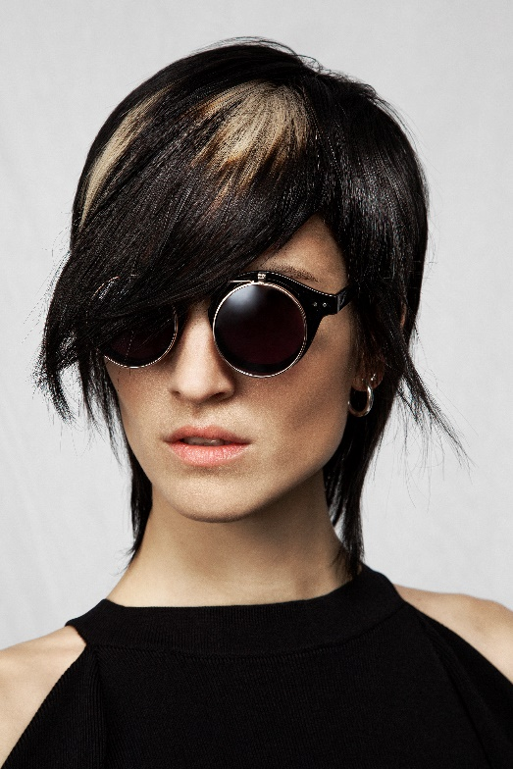
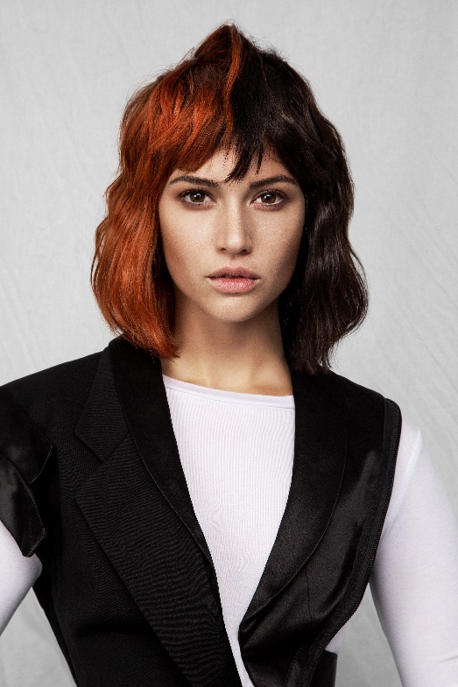
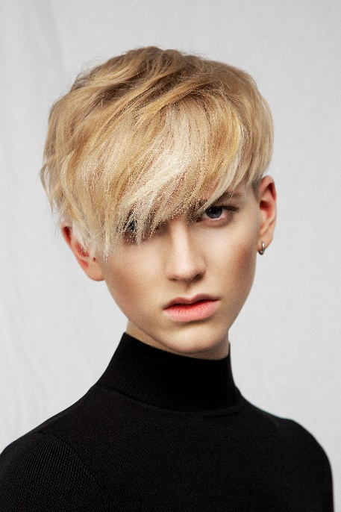

Hair: Felicitas Ordás @ Felicitas Hair
Hair Instagram @felicitashair
Photography: Esteban Roca Instagram @esteban_roca_photo
Make-up: Kuki Giménez Instagram @kukigimenezp
Styling: Visori Fashionart Instagram @visorifashionartstudio
Models: Zoa, Miriam, Sandra, Margo, Bianca y Elliot
Products: Revlon Professional Instagram: @revlonprofessional_es
Video: Josep Oriol Carrasco
Music: Keco Pujol Instagram: @madeinblack
Catalog Design: Magda Obara

FELICITAS HAIR
WHY NOT Collection

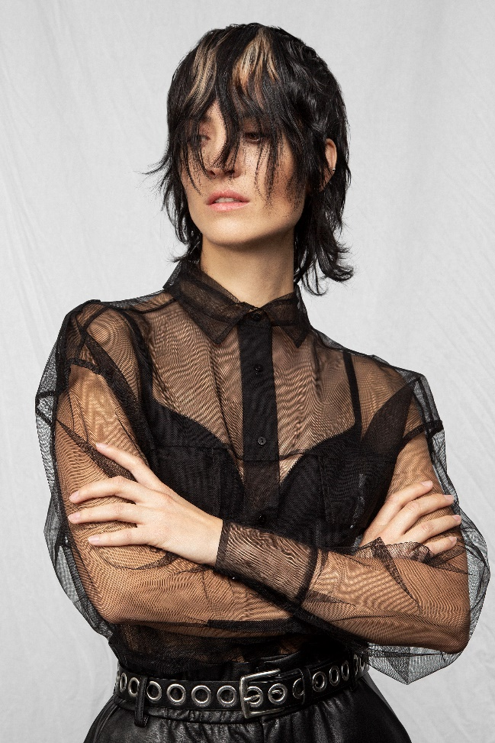

Why not is an exercise of freedom, it’s following the footsteps of one's own principles, those that arise away from limitations and labels and that are the result of a different way of living.
Inspired by the 90s, a decade full of important events such as the fall of the Berlin Wall, the appearance of Internet and the arrival of the end of the millennium, her images recall the nonconformity of the time. Textures are light-hearted, tones combine unexpectedly, and haircuts defy the pre-established aesthetic. It’s a rupture that aspires to create a new order in which only daring is possible.

