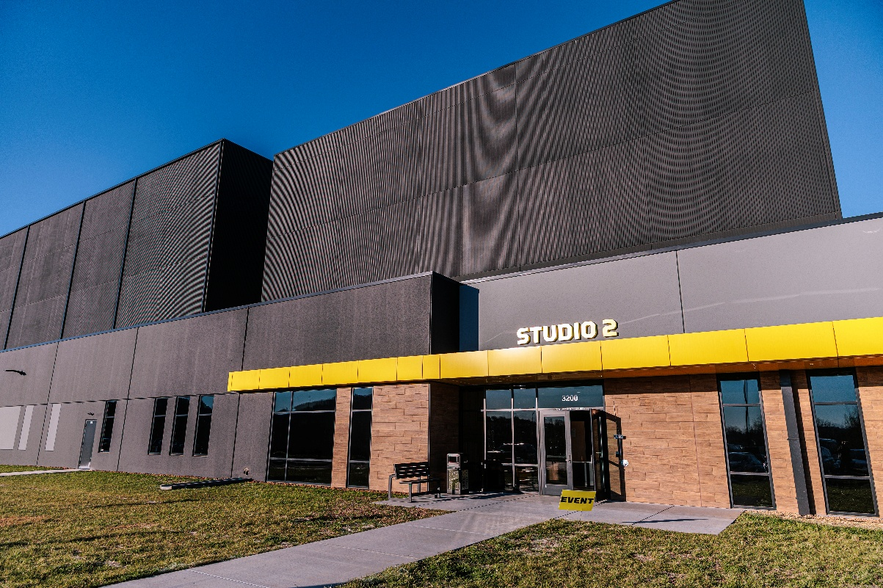

Sennheiser to Relocate American Headquarters to Rock Nashville
Global professional audio manufacturer partners with the Tennessee Department of Economic and Community Development for American HQ relocation
Nashville, Tennessee, March 4, 2026 —Sennheiser Group, Tennessee Gov. Bill Lee, Deputy Gov. and Department of Economic and Community Development Commissioner Stuart C. McWhorter announced today that Sennheiser plans to move its Americas Regional Hub to Rock Nashville.
The project represents the creation of at least 25 jobs and an investment of $2.5 million into the Tennessee economy. This marks the first company to partner with the Tennessee Department of Economic and Community Development (TNECD) to locate within the Rock Nashville facility.

“Establishing our Americas Regional Hub in Nashville – and now, more specifically, within Rock Nashville – feels like a natural and exciting next step for Sennheiser. Nashville is a place where creativity, culture and community come together, and it is already home to so many of the artists, engineers and industry partners who inspire our work every day. By opening our office at Rock Nashville, we’re not simply expanding our presence in the Americas; we’re creating a welcoming, collaborative space designed to spark new ideas, bring us closer to our customers and support our long-term growth across the region.” – Francine Seles, Director of Operations,
Americas, Sennheiser

Founded in 1945 in Wennebostel, Germany, Sennheiser has been a leading professional audio manufacturer building the future of audio for more than 80 years. The company is also home to the iconic Neumann.Berlin brand. Today, the Sennheiser Group employs more than 2,000 people and operates on multiple continents across the globe.


The new Nashville headquarters will expand its local presence, creating opportunities for talented professionals to support its evolving operations.

“There is no city in the U.S. better suited for Sennheiser than Nashville. With its rich music and entertainment heritage, Music City offers both the skilled workforce and creative atmosphere a company like Sennheiser needs to thrive. Tennessee is defined by iconic brands like Sennheiser, especially in the entertainment industry, and this project will benefit Tennesseans across our state for years to come.” – Gov. Bill Lee

As Sennheiser establishes its new hub in Nashville, the company will expand its local presence, creating opportunities for talented professionals to support its evolving operations. While certain customer-facing teams will be office-based to offer more in-person touchpoints with clients, other functions will continue in hybrid and remote roles across the U.S. and Canada. This builds on Sennheiser’s already robust and effective setup in the Americas, where many remote employees are strategically based in key markets across the region.


Rock Nashville is a dynamic, 600,000-square-foot production campus offering purpose-designed rehearsal studios and industry-driven initiatives.

Nashville’s thriving music and entertainment ecosystem and strong business environment make it an ideal home for the next chapter of Sennheiser’s growth. The relocation will embed the company’s brands, Sennheiser and Neumann, in a city celebrated worldwide for its musical heritage and creative energy.

“Nashville is known for its vibrant music industry, and Rock Nashville is proud to be a growing part of that. Our goal is to bring together the leaders who make today’s shows so spectacular. The Sennheiser Group is known worldwide for their commitment to excellence within live entertainment. We are honored to have their company as part of our campus community as we enter a new phase for Nashville productions.” - Andrea Shirk, CEO & President of Rock Lititz / Rock Nashville

“This project locating in Rock Nashville marks the beginning of a new era for entertainment companies across Tennessee or looking to come to Tennessee. Music and entertainment represent a major aspect of Nashville’s economy and culture, and we’re thrilled that Sennheiser has chosen to join this booming ecosystem. Thank you to Sennheiser leadership for choosing Tennessee, and we look forward to seeing all the success that follows today’s announcement.” – Deputy Gov. and TNECD Commissioner Stuart C. McWhorter

“We are excited to welcome Sennheiser to Nashville. Working in partnership with the Tennessee Department of Economic and Community Development, the Nashville Area Chamber of Commerce, Nashville Electric Service and the Metropolitan Government of Nashville and Davidson County furthers our shared commitment to fostering economic growth in the region. Sennheiser’s establishment here represents investment and the creation of job opportunities for the communities we serve. TVA is proud to support companies that contribute to the prosperity and vibrancy of our region.” – Heidi Smith, Vice President of Economic Development, TVA

“Sennheiser’s decision to relocate to Nashville is a strategic win for our city’s live music and production industry. Their partnership with us strengthens our global reputation as Music City while bringing new investment and good-paying jobs to our community. Nashville continues to be the right place for companies rooted in sound, creativity and growth.” – Sen. Charlane Oliver (D-Nashville)

“In the short time that Rock Nashville has been open, it's become a mecca for local musicians and a boon to North Nashville. Now, this new investment of over $2 million by a company as powerful and prominent as Sennheiser is in the audio industry will only enhance both. I'm excited and looking forward to continued growth at the Rock Nashville campus and the company being a great community partner.” – Rep. Vincent Dixie (D-Nashville)

For more information about Sennheiser, visit ​ www.sennheiser.com.

###

About the Sennheiser Group
Building the future of audio and creating unique sound experiences for our customers - this is the aspiration that unites the employees of the Sennheiser Group worldwide. The independent, family-owned company Sennheiser was founded in 1945. Today, it is managed in the third generation by Dr. Andreas Sennheiser and is one of the leading manufacturers in the field of professional audio technology.

sennheiser.com | neumann.com | merging.com

About the Tennessee Department of Economic and Community Development (TNECD) TNECD is the state's primary agency committed to fostering economic growth through job creation and community development. By attracting new corporate investment and facilitating the growth of existing businesses, the department works to strengthen Tennessee's competitive landscape. Additionally, TNECD strives to increase the economic prosperity for all Tennesseans by providing grants to communities statewide, helping them to become vibrant,
business-friendly environments where companies can flourish. For more information, visit us at tnecd.com. Join the conversation on Twitter, Instagram, LinkedIn, Facebook and YouTube.

Sennheiser Contact
Daniella Kohan
Communications Manager – Americas & ANZ
(860) 598-7420
daniella.kohan@sennheiser.com

TNECD Contact
Chris O’Brien
Public Information Officer
(615) 934-5879
Chris.OBrien@tn.gov

