For immediate distribution

Hardcore Guitarist, Recording Engineer Neil Westfall ‘Rocks on’ with Flock Audio’s PATCH System
‘The PATCH System totally changes the way I use outboard gear’

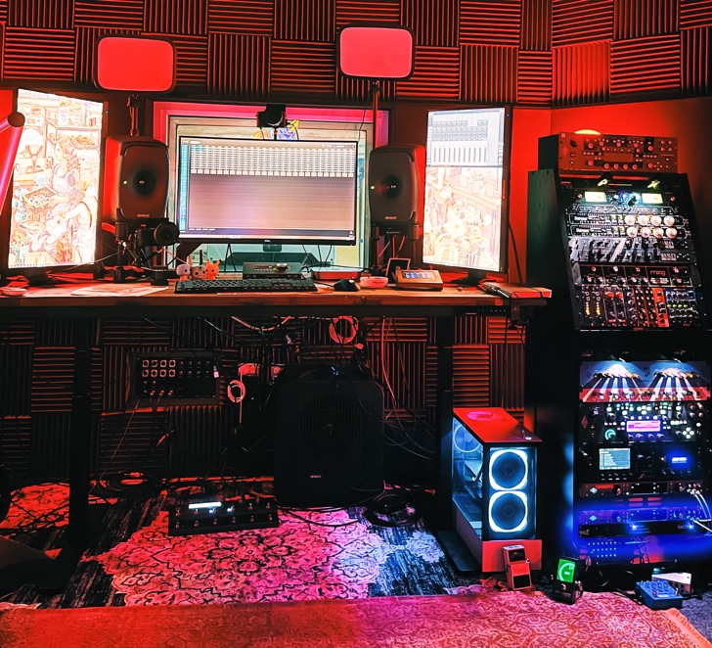
WINTER PARK, FLORIDA — October 26, 2021 —As a founding member and guitarist of hardcore band A Day to Remember, Neil Westfall has spent a lot of time in the recording studio over his bands’ 18 years. In 2018, he founded his own studio, The Unicorn Room, in Winter Park, Florida’s The Audio Compound. There, he does a lot of the writing sessions for ADTR as well as records other Orlando-area bands. Six months ago, he was looking for a solution that allowed him to ‘cut the cord’ on traditional patchbays, and installed Flock Audio’s revolutionary digitally controlled patchbay routing solution, the PATCH System, in his studio.
Westfall's 'The Unicorn Room' Studio
“Because I do a lot of production work on my own, I’ve found using the PATCH System simultaneously with outboard gear while doing multiple takes to be a huge time saver,” Westfall said. “It really changes the way you use outboard gear. Sometimes you get a new piece of gear, and it’s not as amazing and you think it’s going to be. With the PATCH System, it totally blew my mind.”
Clean & Clear Workspace
At The Unicorn Room, Westfall works with a wide range of local artists and friends’ bands as well as completes his own demoing and writing. The projects he works on run the full gamut of musical genres — from pop to punk.
“I’ve done recording sessions with hardcore band Body Snatcher, Orlando-based rock band Nidus Expire, as well as done a bunch of writing sessions for myself and ADTR,” he explained, adding that the PATCH easy-to-use system makes recording a breeze.
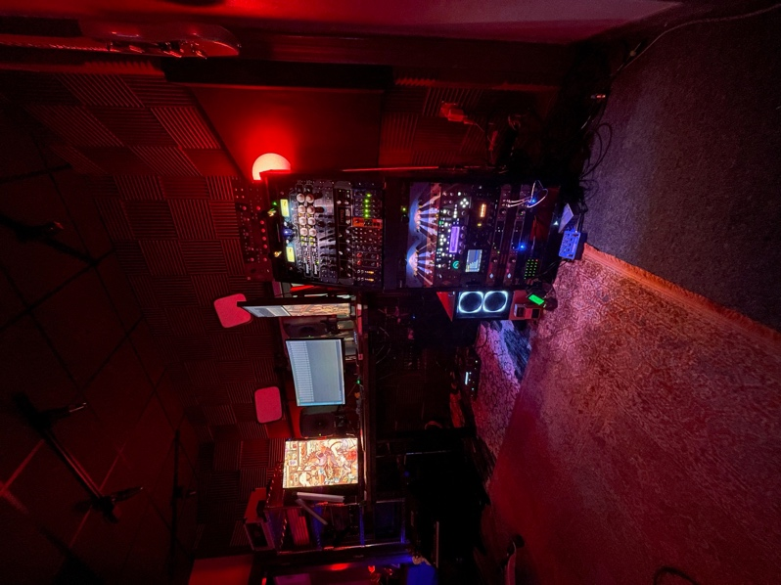
“It’s so clean,” he said. “When you have sessions with someone, you need things to happen quickly, and the PATCH System makes everything so easy and so fast so you can focus on being creative and not worried about being tied up with patching.”
Sampling different sounds with ease is key for Westfall while working live in the studio with a band.
“Being able to sample many different sounds by multing the signal down and running it through several different chains to be able to be like, ‘OK, this is the sound,’ without having to patch something else is just amazing,” he said.
Besides maintaining a creative mindset through quicker patching, Westfall said having his patching done digitally through the PATCH System makes for a cleaner studio in general.
“It sounds funny but having a good, clean workspace area allows me to not stress and focus just on the recording process,” he said.
Looking Ahead
With their sixth studio album ‘You’re Welcome’ out earlier this year, Westfall said he can’t wait to use the PATCH System on A Day to Remember’s future releases.
“Our latest album is really experimental — we used a lot of different gear in the studio, including tons of synths and a massive outboard gear collection we brought in from LA,” Westfall said. “I absolutely cannot wait to use the PATCH system on everything we record with ADTR in the future.”
For more on Flock Audio, visit: flockaudio.com.

About Flock Audio
Flock Audio Inc. is a pro-audio manufacturer based in Kelowna, British Columbia, Canada, founded in 2017. The company is best known for its PATCH System Series, which is a digitally controlled, 100% analog patchbay routing solution for professional audio environments. For more information on Flock Audio and its products, please visit the company website at: http://www.flockaudio.com.
Media Contact:
Jeff Touzeau
Public Relations
Hummingbird Media
+1 (914) 602-2913
jeff@hummingbirdmedia.com

