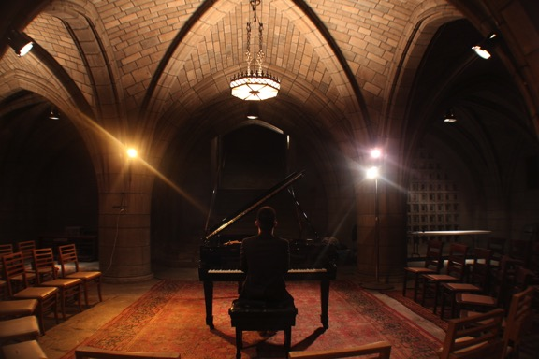
The Crypt Sessions 2016 Season

Presented by Unison Media and the Church of the Intercession, sponsored by Yamaha

Unison Media and the Church of the Intercession, Harlem, are excited to announce the first full season of the The Crypt Sessions, sponsored by Yamaha Pianos.

The performances will take place in the magnificent Crypt Chapel of the Church of the Intercession, Harlem, and will feature an extraordinary lineup of artists: Alexandre Tharaud, Matt Haimovitz, The Attacca Quartet, Christina & Michelle Naughton, Gregg Kallor, Di Wu & Adrian Daurov, and Haskell Small.

The Crypt Sessions began last year with performances by pianist/composer Conrad Tao and Lawrence Brownlee,

Concerts include a complimentary wine & cheese reception from 7-8PM.
2016 Crypt Sessions

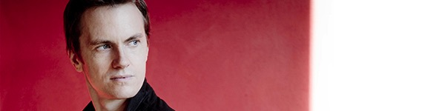

Alexandre Tharaud
April 4, 2016, 8PM

The Long Version: Internationally-renowned French pianist Alexandre Tharaud will perform Bach’s towering Goldberg Variations, one of the most technically-demanding, transcendent works ever written. Tharaud’s recent recording of the piece was among the New York Times‘ “Best Recordings of 2015,” and he performed the work by candlelight shortly after the ISIS shootings in Paris.

The Short Version: An intimate, intense evening with one of today’s greatest pianists.
Get Tickets

Haskell Small
May 10, 2016, 8PM

The Long Version: Pianist/composer Haskell Small performs works by Pärt, Beethoven, Hovhaness and himself before delving into Tavener’s Pratirupa, giving the New York premiere of a work which attempts to “reflect the most beautiful, the Divine Presence which resides in every human being.” Small, known for his “devotion to subtle beauty” and his “shattering performances,” brings his quiet focus to the Crypt in this special program.

The Short Version: A program of music that reaches for the heavens without forgetting all that makes us human.
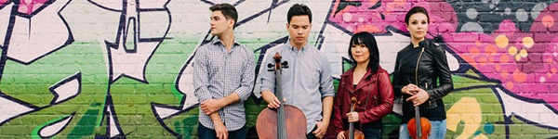

The Attacca Quartet
June 8, 2016, 8PM

The Long Version: One of chamber music’s brightest voices, the Attacca Quartet perform with a sense of commitment and maturity far beyond their years. For the Crypt, they will perform Haydn’s great masterwork The Seven Last Words of Christ on the Cross, arranged for quartet by Andrew Yee and the Attacca themselves. The work is an extended meditation on the final moments of life.

The Short Version: Four young stars perform a work that could not be more perfectly suited to the Crypt space.Get Tickets

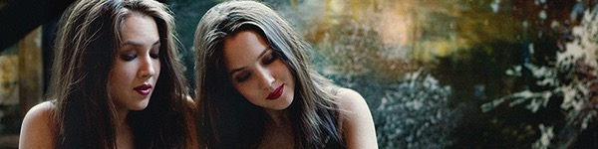

Christina & Michelle Naughton
August 25, 2016, 8PM

The Long Version: The beautiful, talented young twin sister piano duo Christina and Michelle Naughton bring their near-telepathic talents to the Crypt, performing one of the most staggering works ever written: Messiaen’s haunting, gripping, wrenching Visions de l’Amen.

The Short Version: Just don’t miss this one.
Get Tickets

Matt Haimovitz
September 23, 2016, 8PM

The Long Version: Cellist Matt Haimovitz is, quite simply, one of the greatest and most utterly individual performers of his generation. Dissatisfied with the standard classical music scene, he broke off and followed his own muse, performing Bach’s immortal cello suites in bars and clubs around the country. Now he brings these moving, solitary works to the Crypt, accompanied by newly-commissioned pieces by Philip Glass, Vijay Iyer and more.

The Short Version: One of the greatest cellists in the world will take you on a journey through a fusion of old and new works.
Get Tickets

Gregg Kallor
October 26, 2016, 8PM

The Long Version: When you’re pianist/composer Gregg Kallor, instead of celebrating Halloween with a $5 mask and one too many Kit Kats, you give the world premiere of your new musical rendition of Edgar Allen Poe’s The Tell-tale Heart for piano and mezzo-soprano-slash-rockstar Elizabeth Pojanowski. A collaboration with On Site Opera, the The Tell-tale Heart features a semi-staging setup by the always-awesome director Sarah Meyers, whom you might know from a little place called The Metropolitan f-ing Opera. Oh, and if you’re Gregg then you also perform your cello sonata as well with cello superstar Joshua Roman, just for good measure.

The Short Version: The perfect way to end the 2016 season and enjoy the work of one of NYC’s fastest-rising musical talents.
Get Tickets

