CX Plus Special Edition True Wireless: Superior Sound. No Compromise
Sennheiser’s new Special Design Edition earbuds deliver premium sound with Active Noise Cancellation

Sydney, Australia, 21 March, 2022 – When it comes to true wireless listening, superior sound and great wearing comfort are essential. Sennheiser’s new Special Design Edition has a new brushed matte surface which gives the CX Plus True Wireless a unique look. The earbuds offer a thrilling, high-quality listening experience with Active Noise Cancellation, effortless smart interaction, and a sleek refreshed design for supremely comfortable all-day enjoyment.

The superior sound of Sennheiser’s CX Plus SE True Wireless earbuds is a world apart – at an accessible price point. This is made possible thanks to the clarity of its German-engineered TrueResponse transducer, an acoustic system that brings audiophile technology to everyday listening. Developed for the audio specialist’s premium earbuds, this bespoke acoustic system delivers high-fidelity stereo sound with deep basses, natural mids and clear, detailed treble.
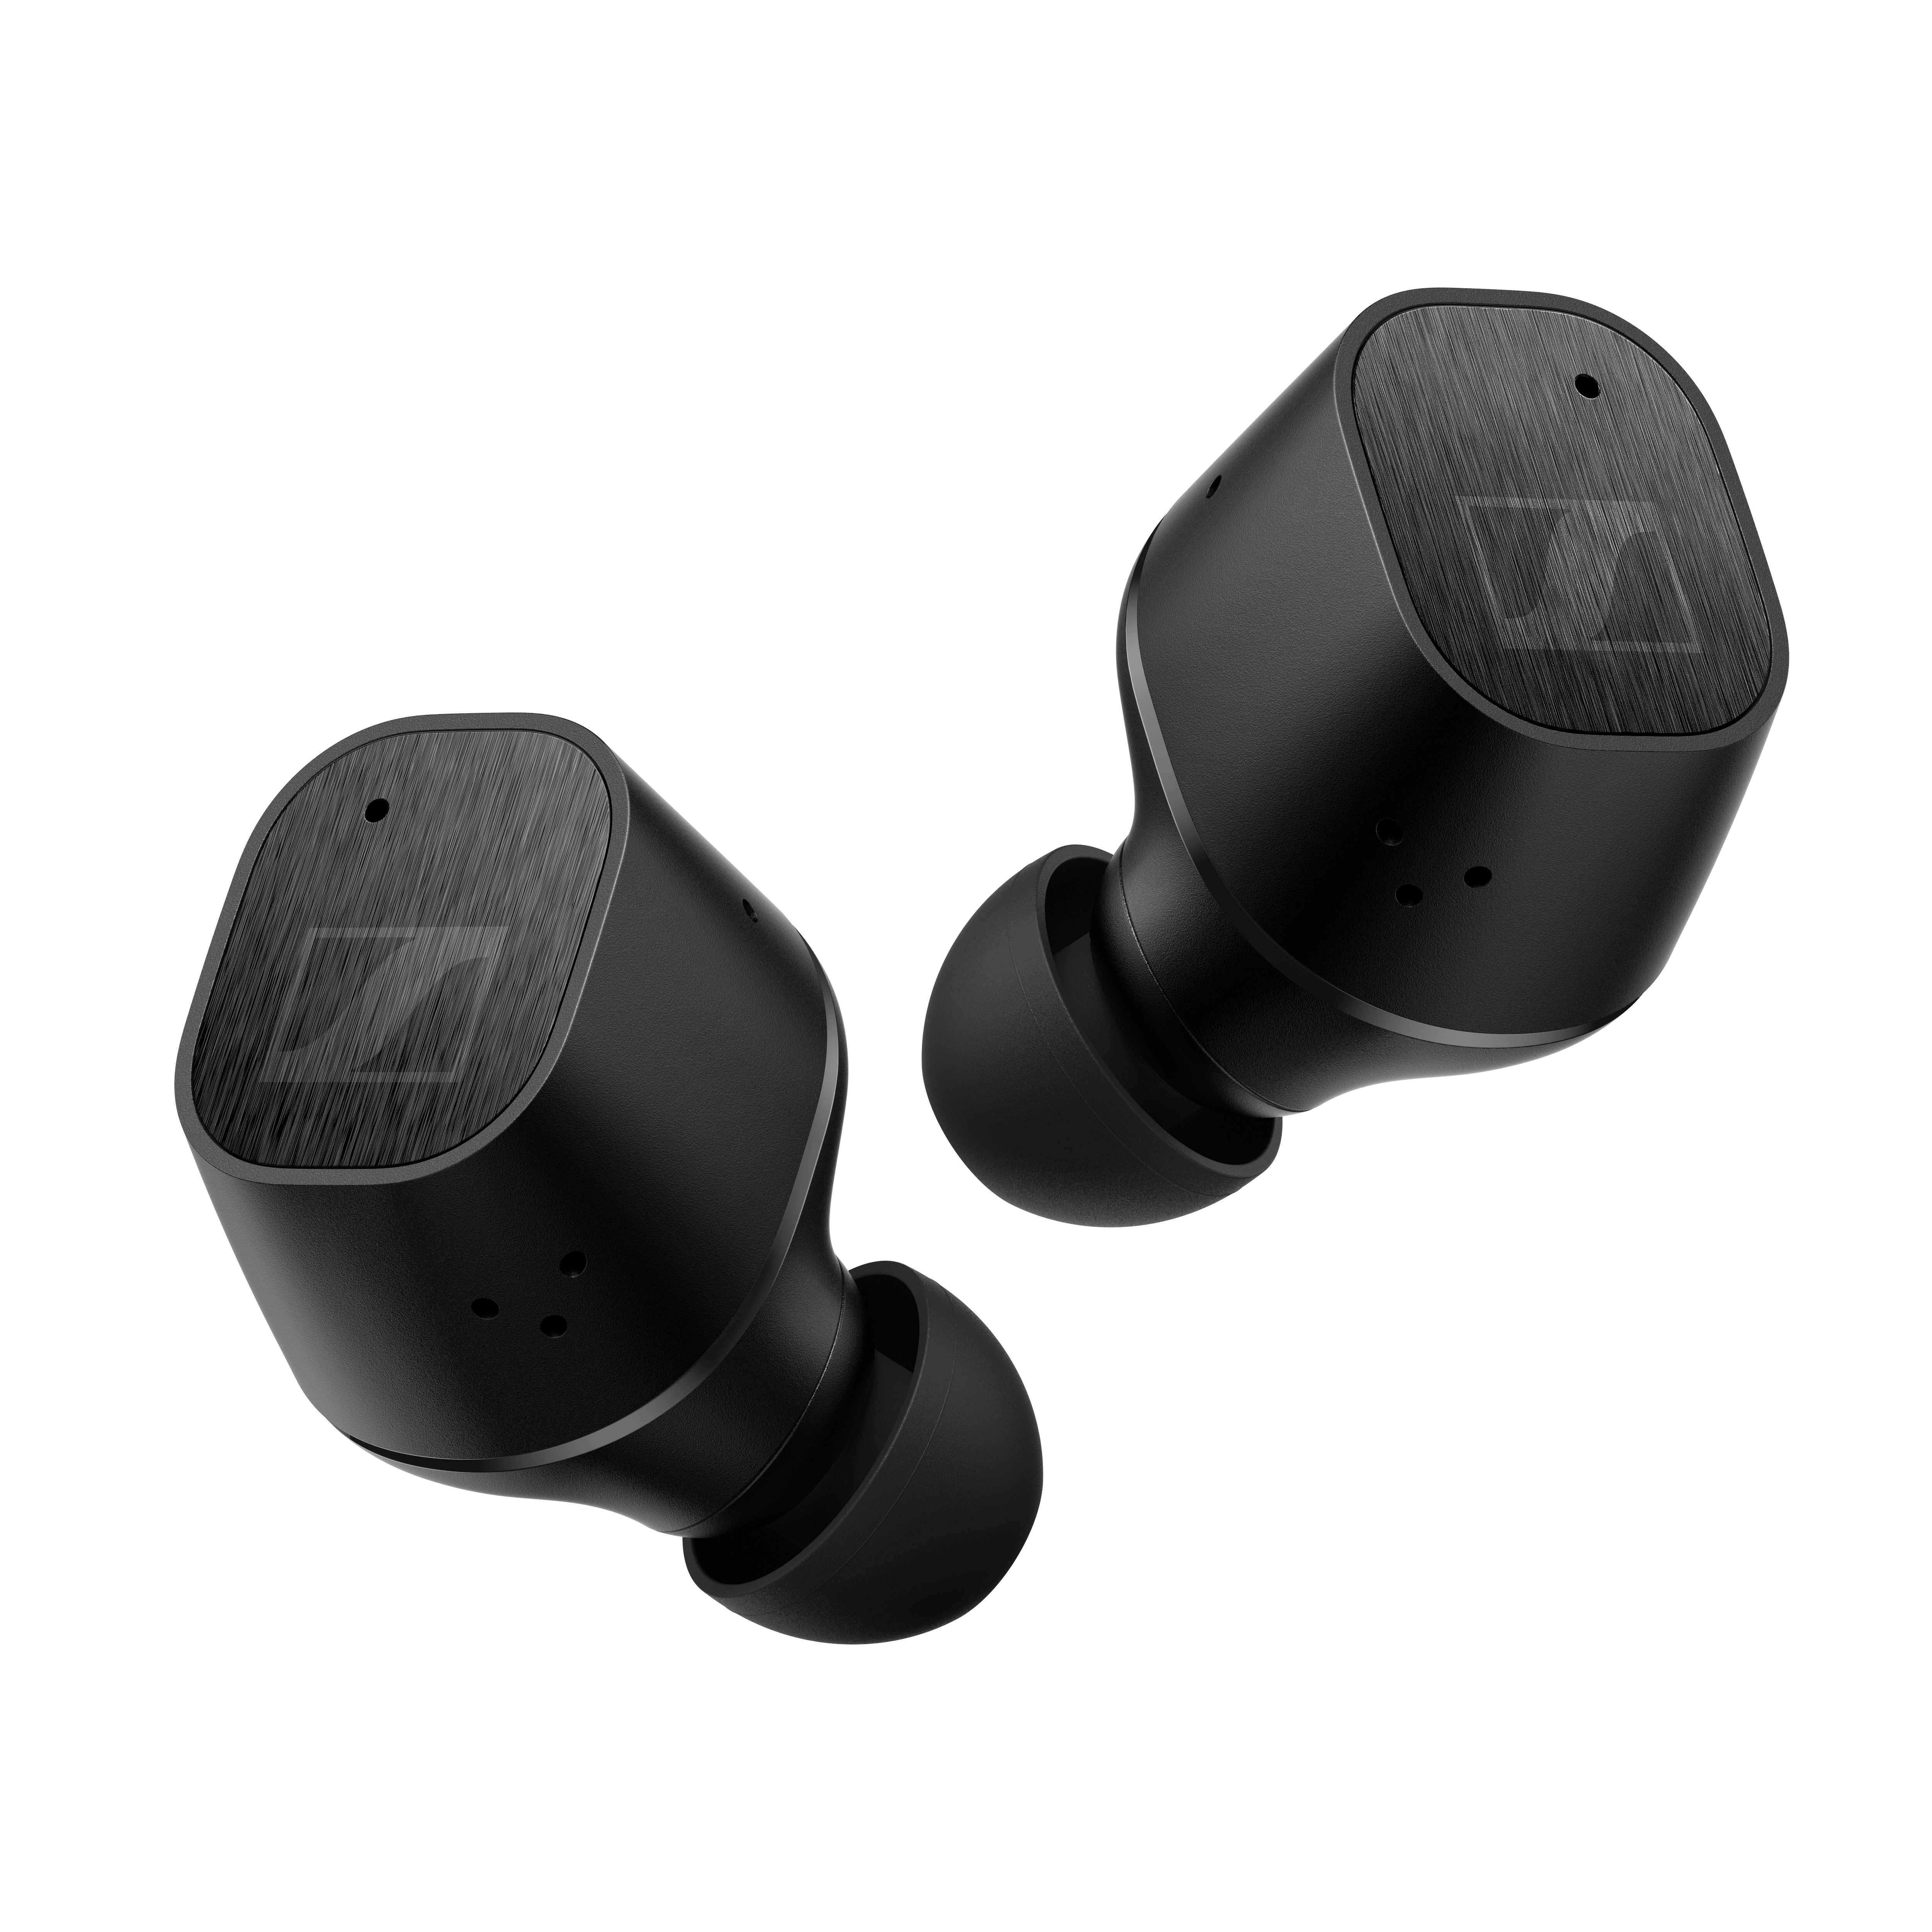

The Active Noise Cancellation function ensures that listeners do not miss a note, allowing them to experience all the clarity, detail and thrilling bass without distractions – even in noisier environments. Meanwhile, the Transparent Mode feature makes it easy to focus on external sounds when desired without the need to remove the earbuds. This feature is particularly useful in letting outside sound in, so users are more aware of their surroundings.

Everyday life, simplified
Thanks to the customisable touch controls, every interaction, touch, and moment shared with the CX Plus SE True Wireless can be conducted effortlessly. Users can even tailor bespoke commands to ensure that controlling audio, calls and accessing voice assistants is both convenient and intuitive. Each earbud is equipped with a pair of dual mics that optimises speech for calls and voice assistant access to ensure crystal clear voice pick-up. The independent earbud use allows the right and left earbuds to be used individually or as a pair.

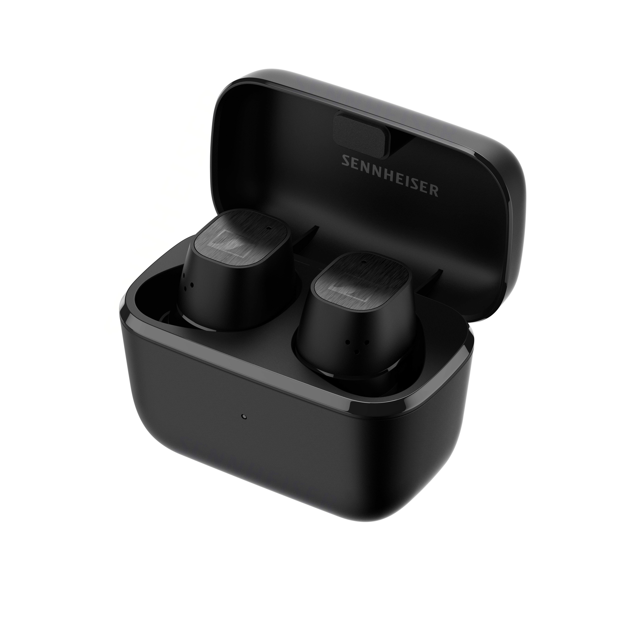
Designed for all-day enjoyment
The sleek, design of the CX Plus SE True Wireless guarantees fatigue-free all-day enjoyment. The compact earbuds securely fit in the ear canal, so they stay in place when listening on the move.

With IPX4 rated splash resistance, listeners can enjoy the CX Plus SE True Wireless wherever they go. And, as life doesn’t slow down, the CX Plus SE True Wireless is ready to keep pace with its long-lasting battery and portable charging case, providing an impressive 24 hours of playback time.

The CX Plus SE True Wireless is available in black from 1 April for $289.95 AUD / $309.95 NZD.

About the SENNHEISER Brand

We live and breathe audio. We are driven by the passion to create audio solutions that make a difference. Building the future of audio and bringing remarkable sound experiences to our customers – this is what the Sennheiser brand has represented for more than 75 years. While professional audio solutions such as microphones, meeting solutions, streaming technologies and monitoring systems are part of the business of Sennheiser electronic GmbH & Co. KG, the business with consumer devices such as headphones, soundbars and speech-enhanced hearables is operated by Sonova Holding AG under the license of Sennheiser.
www.sennheiser.com
www.sennheiser-hearing.com

Global Press Contact
Sennheiser Consumer Audio GmbH
Paul Hughes
Head of PR and Influencers
T +49 (0)162 2921 861
paul.hughes@sennheiser-ce.com

Local Press Contacts
Caitlin Todd
caitlin.todd@groundagency.com

Gabby Wallace
gabby.wallace@groundagency.com

