**MEDIA ALERT: RME DAC Line to Appear at CanJam 2022 in Chicago**

*The ADI-2 DAC FS and ADI-2 Pro FSR Black Edition will be available to demo at the RME Booth C8*

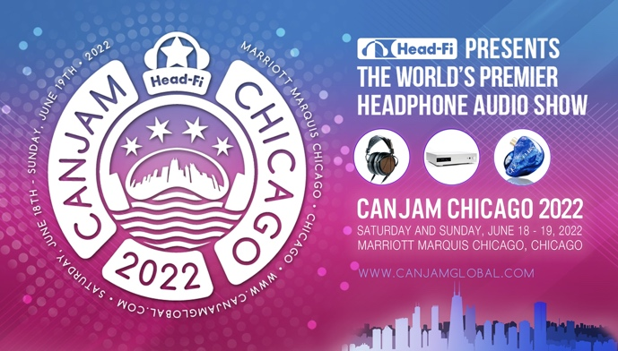**Chicago, IL, June 16, 2022 —** Leading German audio interface manufacturer [RME](https://www.rme-usa.com/) is excited to highlight two of their reference quality converters including the [ADI-2 DAC FS](https://www.rme-usa.com/adi-2-dac.html) and the [ADI-2 Pro FSR Black Edition](https://www.rme-usa.com/adi-2-pro-be.html) at the RME Booth during the [CanJam Chicago 2022](https://canjamglobal.com/shows/chicago2022/) show on June 18-19 presented by Head-Fi. The show will take place in the Marriot Marquis Hotel in Downtown Chicago.

The ADI-2 DAC FS is a compact and versatile USB D/A converter that offers one of the most advanced packages imaginable. The unit is equipped with a front panel control scheme offering unprecedented customization. Audio conversion is supported for PCM sample rates up to 768 kHz and DSD. Other key features include balanced & unbalanced analog outs, with an Extreme Power headphone output, super low noise IEM output, intelligent hybrid analog/digital level control, DSP-based signal processing for EQ and crossfeed, Class Compliant USB compatibility, and the latest SteadyClock FS jitter suppression technology from RME.

The ADI-2 Pro FS R Black Edition adds another separate ¼” output for headphones, even supporting balanced headphones to double the output power for challenging applications. 2 channels of analog input support audio capture at up to 768kHz for PCM, or DSD recording. Both models include IR remote control and AutoDark functions, making them equally useful in audio labs, recording studios and home Hi-Fi applications.

To learn more about these RME DAC’s, please visit Booth C8 during the CanJam Chicago 2022 show inside the Marriot Marquis Hotel located at 2121 S Prairie Ave in Chicago, Illinois.

For more on RME, visit[**rme-usa.com**](http://rme-usa.com/)

**About Synthax, Incorporated**  
Synthax Inc. is the exclusive USA distributor for RME digital audio solutions, Digigram broadcast audio systems, Appsys digital audio tools, Ferrofish advanced audio applications, myMix personal monitoring systems and ALVA cableware. We supply a nationwide network of dealers with these products for professional audio, broadcast, music industry, commercial audio, theater, military and government applications. For additional information, visit the company online at [http://www.synthax.com](http://www.synthax.com/).

**Media Contacts:**

Shelby Coppola

Public Relations

Hummingbird Media

+1 (203) 598- 8167

[shelby@hummingbirdmedia.com](mailto:shelby@hummingbirdmedia.com)

Jeff Touzeau

Public Relations

Hummingbird Media

+1 (914) 602 2913

[jeff@hummingbirdmedia.com](mailto:lipoff.alexis@gmail.com)