The festival season has never sounded better
Sennheiser’s MOMENTUM True Wireless is a great companion for your summer adventures

Wedemark, July 1, 2019 – As things heat up for the summer, it’s hard not to feel just that little bit more carefree and alive – especially if you have a hot ticket to one of the season’s sensational music festivals. Whether you’re Instagram-ready at Lollapalooza, feeling the heat and beats of Benicàssim or scaling the heights of Fuji Rock – festival season is all about letting go, getting down and being free. That’s why there’s no better festival accessory than Sennheiser’s MOMENTUM True Wireless ear buds.

When packing your festival bag, it’s important to be smart as well as stylish – remembering the essentials without getting weighed down. Thanks to their uncompromised sound performance, state-of-the-art technology and super desirable lightweight design, Sennheiser’s MOMENTUM True Wireless premium earbuds are the ideal ready-to-wear companion for your summer adventures.
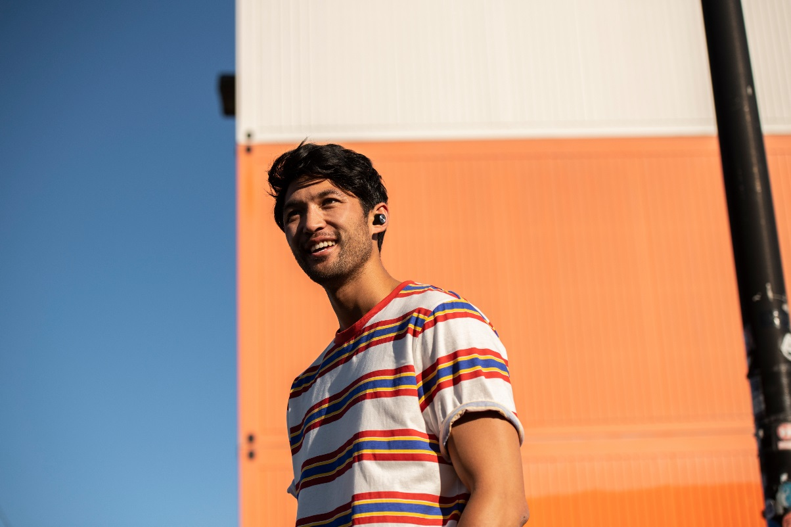

Truly wireless, lightweight and stylish: Sennheiser’s MOMENTUM True Wireless is a great companion for your festival summer.

Designed to be light and comfortable enough to wear all day, they’ll keep the music playing even when the last encores have faded. And thanks to their perfect ergonomic fit, wireless design and splash resistance, they keep you free to go with the flow. Even better, their easy-to-pocket compact charging case lets you extend their 4-hour battery life twice over so you can enjoy twelve hours of tunes – saving those precious power-up pit stops for your phone.

Need to catch up on the headliner’s greatest hits? Sennheiser’s audiophile driver technology helps to make the music you love sound even better. Want to find your friends? You can make and take calls with ease thanks to the earphones’ 2-mic-beamforming technology which optimizes voice pick-up for crystal clear phone calls and voice assistant interaction. Even better, the MOMENTUM True Wireless’ Transparent Hearing feature ensures you can be aware of your surroundings at a touch so you can dive back into the hustle and bustle of your festival summer whenever you want.

about Sennheiser
Shaping the future of audio and creating unique sound experiences for customers – this aim unites Sennheiser employees and partners worldwide. Founded in 1945, Sennheiser is one of the world’s leading manufacturers of headphones, loudspeakers, microphones and wireless transmission systems. Since 2013, Sennheiser has been managed by Daniel Sennheiser and Dr. Andreas Sennheiser, the third generation of the family to run the company. In 2018, the Sennheiser Group generated turnover totaling €710.7 million. www.sennheiser.com

Global Press Contact
Sennheiser electronic GmbH & Co. KG
Jacqueline Gusmag
Communications Manager Consumer
T: +49 (0)5130 600-1540
jacqueline.gusmag@sennheiser.com

