For more information, please contact Marta de Paco
On +34 670 780 664 or email press@comunicahair.com

Important:
These images are only available for editorial content.
Credits must be included.
Notification of their publication is expected.

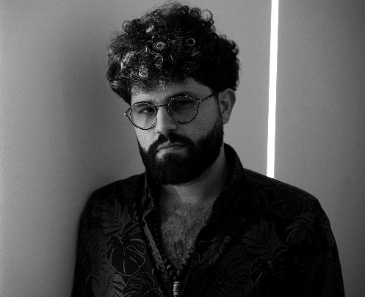
JAVIER GOMAR
GRAVITY Collection

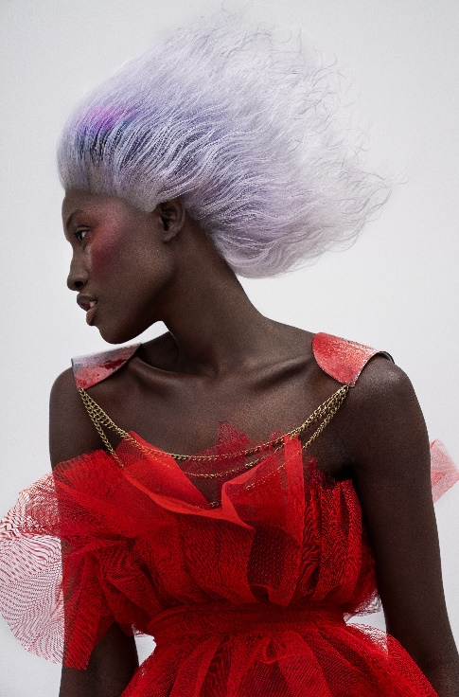
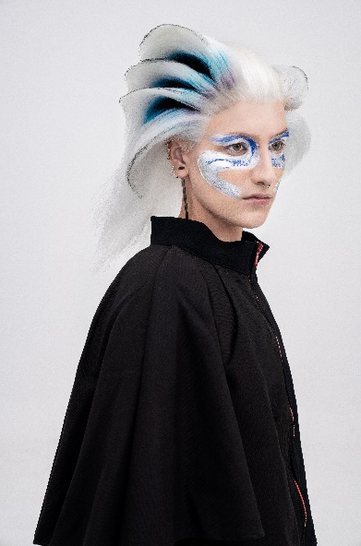
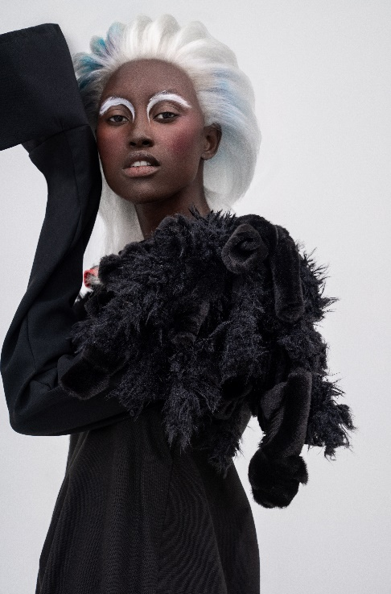

Hair: Javier Gomar @javiergomar4
Hair Assistant: Nestor Riera @nestorrierad
Laia Alborch @laia.alborch
Photography: David Arnal @davidarnalteam
MUA: Anna González @annagonzalezbeauty
Styling: Fabiola Ricci @fabiolariccifls
Designers: Fabiola Ricci @fabiolariccifls
Paula Catalá @paulakatana
Models: Aya @dji_aya
Barbara Jimena @_brrrs
Montse Zhu @zhumito
Video creator: David Arnal @davidarnalteam

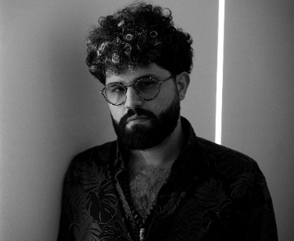
JAVIER GOMAR
GRAVITY Collection

"Gravity", Javier Gomar's second collection, is planned entirely on round angles and volumes. When planning that idea, he immediately came to mind the largest and most unreachable that surrounds us, the galaxy. His movements and hairstyles are inspired by the multiple celestial objects: simultaneous rings as if they were a satellite, but also the movements seen in an aurora borealis.
Colors refer to those found in the night sky, violets, and blues, combined with the purity of white and silver. And it is impossible to ignore the darkness that is the protagonist in some looks, or that is highlighted with details in others.
In this collection, hair floats and levitates, partly defying gravity, but without tricks or deception, thus making it a technical challenge. In addition, the natural movement of the hair is maintained and, in this case, the protagonist is the curly hair that continues to move, though without losing its unnatural position.

Rounded contours and shapes predominate to convey the lightness of a suspended volume. He wanted to create hair that levitated, like galactic circles, and also had movement. The volume is enlarged or decreased according to the desired visual search. For this collection, a wearable theme was sought. But also, a personal touch that would challenge hair to connect styling and avant-garde in a fine line, since the pieces of hair are complete, without additions.

Technically it is a step up from the previous collection, "Uprising". It is also more realistic and easier to wear, though with that unique touch of textures and color that make this work a creative mix that moves between the avant-garde and the commercial. A successful combination of colors, natural light, and cutting techniques from a masterful collection. "Gravity" tries to leave us the mind relaxed, as much as when we contemplate the sky at night.

This collection has been a personal challenge in which he has enjoyed throughout the entire process. The goal was to create a new vision of hairdressing. Also, an attempt to open it up and connect it to other disciplines and spaces such as art and fashion galleries.

