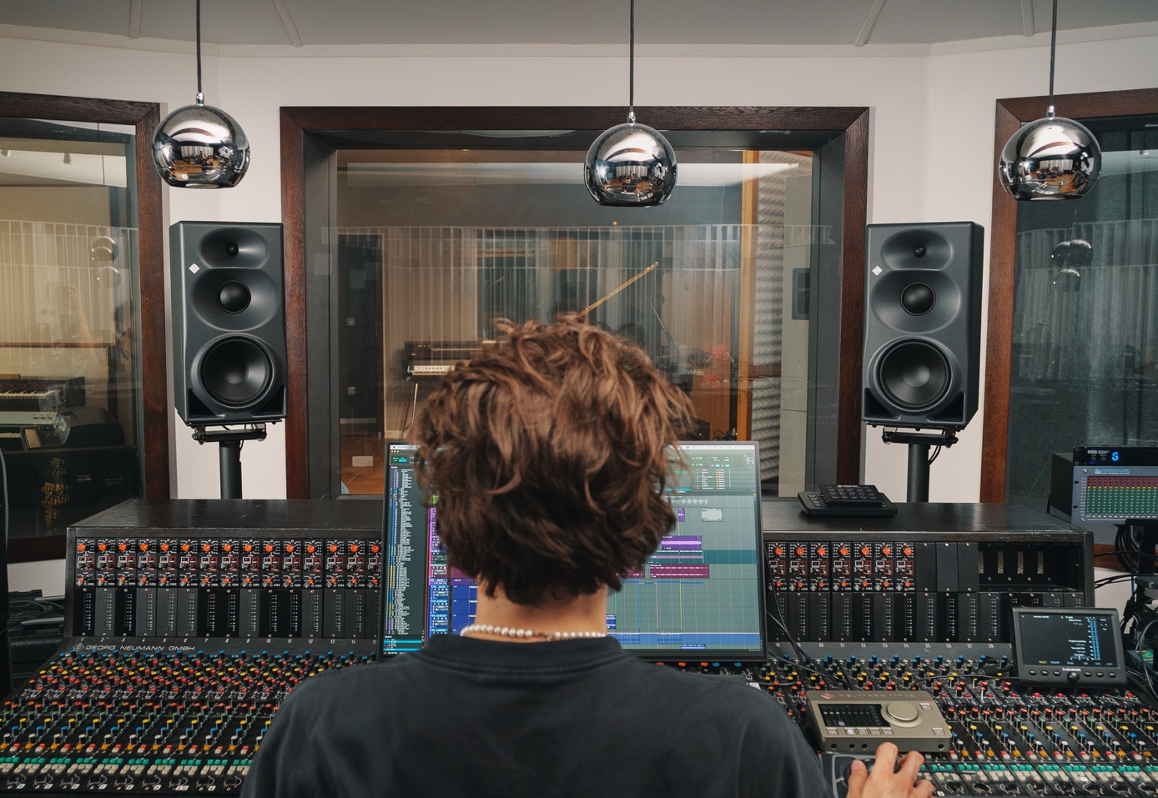
Neumann laajentaa kolmitiemonitorien valikoimaansa KH 310 II- ja KH 350 -malleilla
Kaksi monitoria, yksi laatustandardi
Neumann tuo markkinoille uuden sukupolven kolmitiestudiomonitorit KH 310 II:n ja täysin uuden KH 350:n. Yhdistämällä vuosikymmenten akustisen asiantuntemuksen tehokkaaseen DSP-alustaan ne tarjoavat poikkeuksellisen suorituskyvyn, saumattoman studiotyönkulun sekä sen tutun tarkkuuden, joka on tehnyt Neumannista ammattistudioiden vertailukohdan kautta maailman.
Lisää alla englanniksi.
Built on a shared platform of in-house designed drivers, powerful amplification, and advanced 32-bit DSP processing, the KH 310 II and KH 350 offer consistent sound with excellent translation while addressing different monitoring requirements. The KH 310 II advances one of the industry's leading studio references, while the KH 350 introduces a completely new full-range monitoring solution with exceptional low-end authority for larger listening environments and immersive rooms.
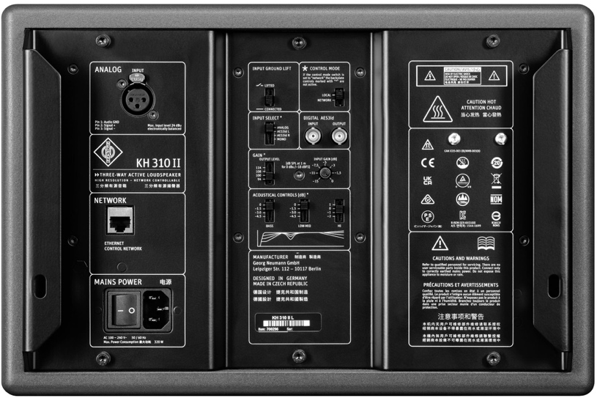
Both monitors offer seamless integration with Neumann’s state-of-the-art room correction solution MA 1 Automatic Monitor Alignment and feature analog as well as AES3 (coaxial) digital connectivity. They both combine the KH 310’s trusted midrange resolution with even lower distortion, almost doubled amplifier power, and even tighter tolerances for exceptional consistency. The result is razor-sharp imaging, predictable performance, and seamless integration across stereo, surround, and immersive audio applications.
“The KH 310 has earned an exceptional reputation among recording, mixing, and mastering engineers worldwide,” says Roman Kramer, Product Manager at Neumann. “With the KH 310 II, we worked long and hard to retain everything users love about the original while elevating performance in virtually every area. At the same time, the KH 350 opens new possibilities for engineers who need greater low-frequency authority and the flexibility to work confidently across both nearfield and midfield environments.”

Two Monitors, One Reference Standard
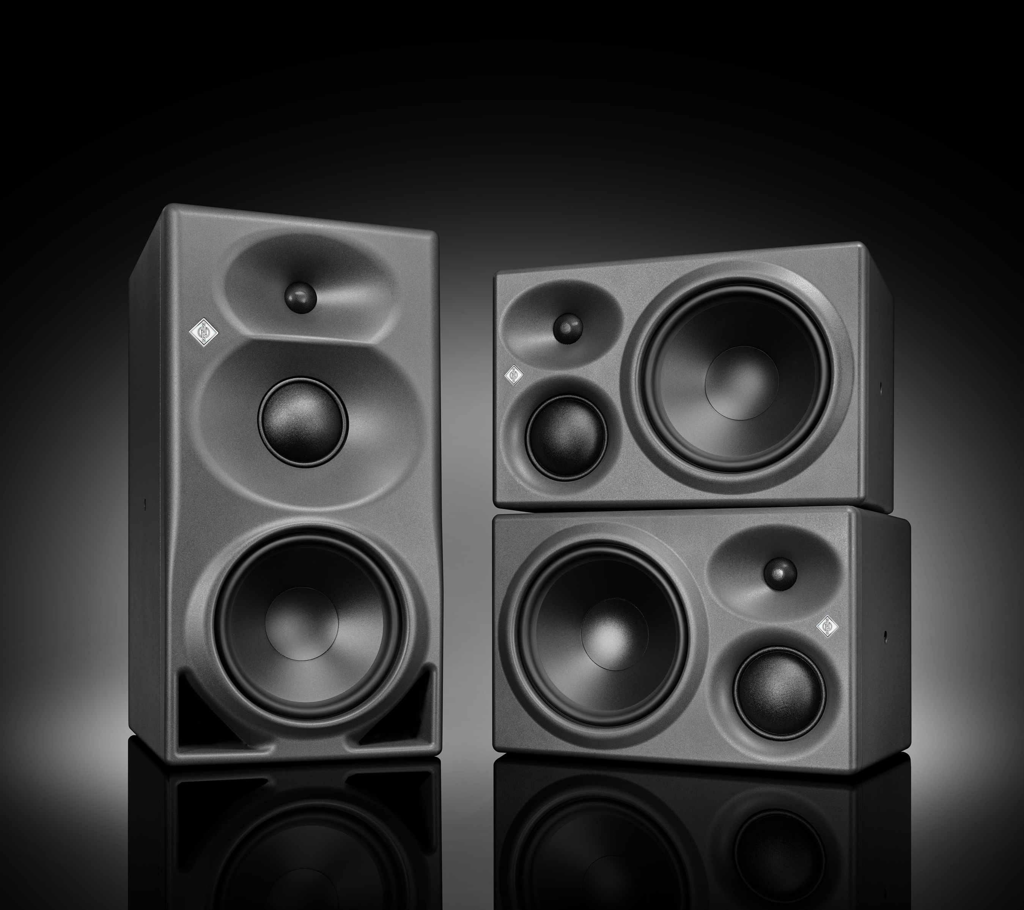
The KH 310 II and KH 350 share Neumann's renowned 3" soft-dome midrange driver, a precision 1" tweeter, an advanced 8.25" woofer, and powerful DSP processing. Together, these technologies deliver outstanding transparency, exceptional phase coherence, and the accuracy required for critical production decisions.
“The KH 310 II and KH 350 share the same acoustic DNA and commitment to truthful sound reproduction,” says Stephan Mauer, Product Management Director at Neumann. “Today's engineers work across a wide range of rooms, formats, and production styles. Our goal was to provide two solutions that deliver the same trusted reference standard while allowing users to choose the monitoring concept that best supports their workflow.”

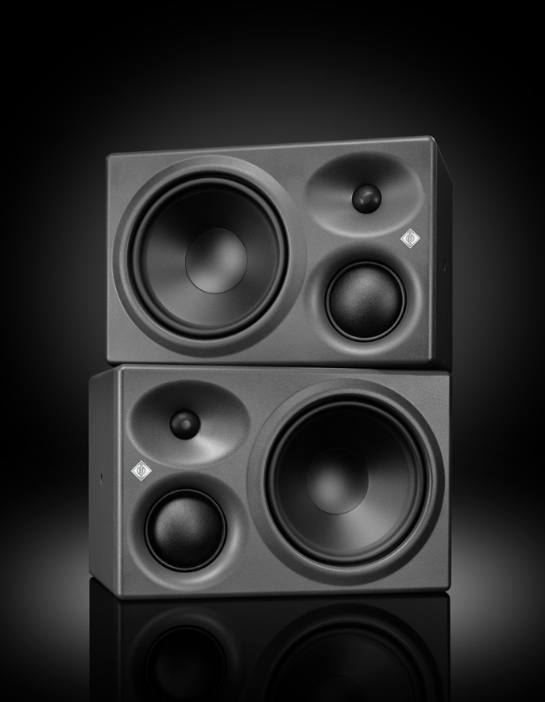
KH 310 II: The Reference, Refined
The KH 310 II builds upon the legacy of one of professional audio's most trusted studio monitors. The original KH 310 became a benchmark for accuracy, exceptional midrange clarity, and remarkably precise low-frequency reproduction.
The new KH 310 II retains the sealed-cabinet architecture that has long been prized for its fast transient response, low group delay, and precisely controlled bass reproduction. Neumann's celebrated 3" soft-dome midrange driver also remains unchanged, maintaining the natural tonal balance and vocal clarity that helped establish the KH 310's reputation.
At the same time, the system has been extensively re-engineered. A newly developed woofer, massively increased amplifier power, advanced DSP processing, improved linearity, and reduced distortion deliver a substantial performance upgrade. Despite offering 5 dB higher maximum SPL than its predecessor, the KH 310 II retains identical cabinet dimensions to allow for easy integration into existing studios and installations.
The result is a monitor that stays true to its heritage while setting new benchmarks in precision, consistency, and workflow integration.

KH 350: Full-Range Authority
The KH 350 introduces an entirely new monitoring option within the Neumann portfolio.
Designed for both nearfield and midfield applications, the KH 350 combines Neumann's proven midrange and high-frequency platform with a bass-reflex design engineered for deeper low-frequency extension, greater physical impact, and effortless full-range performance.
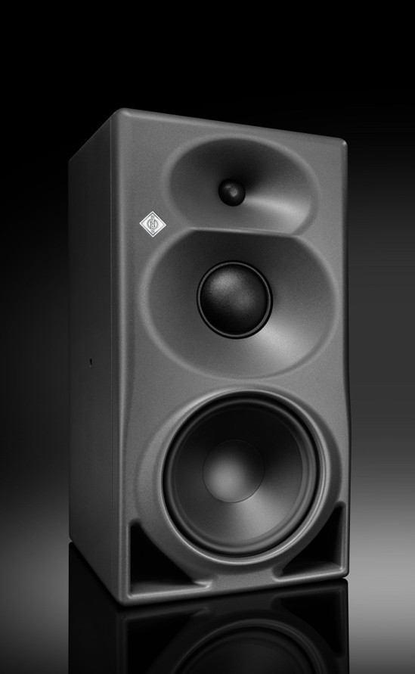
With a cabinet almost twice the size of the KH 310 II and a vertical speaker arrangement, the KH 350 is designed for larger listening environments requiring higher SPL capability and immersive mix rooms. Thanks to a large MMD waveguide, the KH 350 offers precise directivity control across its entire frequency range, which is key to stable imaging, reliable translation, and actual in-room performance. This also makes the KH 350 the perfect LCR and surround loudspeaker in immersive setups.
With low-frequency extension down to 27 Hz (±6 dB), increased output capability, and greater listening distance flexibility, the KH 350 delivers the scale and confidence required for modern music production, film scoring, post-production, broadcast, and immersive audio workflows.
Positioned between the KH 310 II and the flagship KH 420, the KH 350 creates a new option for engineers seeking deeper bass performance and a more versatile monitoring solution without compromising accuracy.

Next Generation 3-Way Monitoring
The introduction of the KH 310 II and KH 350 marks the latest step in the evolution of Neumann’s monitoring portfolio. All Neumann KH speakers follow the same design philosophy: highest linearity, lowest distortion, and perfect adaptability to the acoustic environment. This means that all KH line speakers may be combined in surround and immersive setups.
Neumann’s KH series continues the legacy of the German loudspeaker pioneer Klein + Hummel, whose monitoring solutions became a reference for broadcasters and recording studios across Europe. It was Klein + Hummel who invented the modern concept of powered studio monitors with active crossovers – as early as 1967 with the legendary OY 3-way monitor, the great-great-great-grandfather of today’s KH 310 II.

Key Features

Shared Features
- In-house designed custom drivers
- Exceptional midrange resolution thanks to dedicated 3" soft-dome driver
- Advanced precision with 32-bit DSP processing
- MA 1 Automatic Monitor Alignment compatibility
- Analog and AES3 coaxial (AES3id) digital connectivity
- 585 W amplifier power with high energy efficiency
- Consistent voicing across stereo, surround, and immersive setups
- Exceptional unit-to-unit consistency for precise imaging and multichannel installations

KH 310 II
- Sealed-cabinet design for exceptional transient accuracy and low group delay
- Optimized for critical nearfield monitoring
- Lower distortion and improved linearity
- 5 dB higher SPL than KH 310 A
- Identical cabinet dimensions for straightforward retrofit

KH 350
- New bass-reflex design with extended low-frequency response
- Nearfield and midfield monitoring capability
- Large MMD waveguide for precisely controlled directivity
- Enhanced low-frequency authority and full-range performance
- Ideal for larger control rooms and immersive audio applications

About Neumann
Founded in 1928, Neumann is a global leader in professional audio technology and has been setting the benchmark for reference-quality sound for nearly a century. Renowned for iconic products such as the legendary U 47, M 49, U 67 and U 87 microphones, Neumann combines decades of innovation with German engineering excellence, earning the trust of recording studios, broadcasters, and creators worldwide. Since 1991, Neumann has been part of the Sennheiser Group. Over the years, the company has expanded its portfolio through the addition of Klein + Hummel's renowned studio monitor expertise and the integration of Merging Technologies into Neumann most recently. Today, Neumann offers a complete ecosystem of industry-leading audio solutions spanning microphones, audio interfaces, headphones, studio monitors, immersive audio technologies, and digital audio solutions, covering the entire signal chain from sound capture to reproduction. www.neumann.com

Press Contact:
Burson Finland Oy (previously Hill and Knowlton)
sennheiser.finland@hkstrategies.com

