TV will never be the same
Sennheiser TV Clear offers crystal-clear TV Sound – in a lightweight True Wireless format
Marlow, UK, May 31, 2022 – If you prefer to live life on your terms, why settle for less from your television audio? With the new Sennheiser TV Clear, you can enjoy television viewing with superior speech clarity with all the convenience, comfort and inconspicuous style of True Wireless earbuds. TV Clear’s transmitter ensures a low latency for any television with optical or analogue output. And unlike conventional television solutions, TV Clear can seamlessly connect via Bluetooth to watch a favourite series on your television or on-the-go on a laptop, tablet or smartphone. They can also be used to make and receive calls on your smartphone.
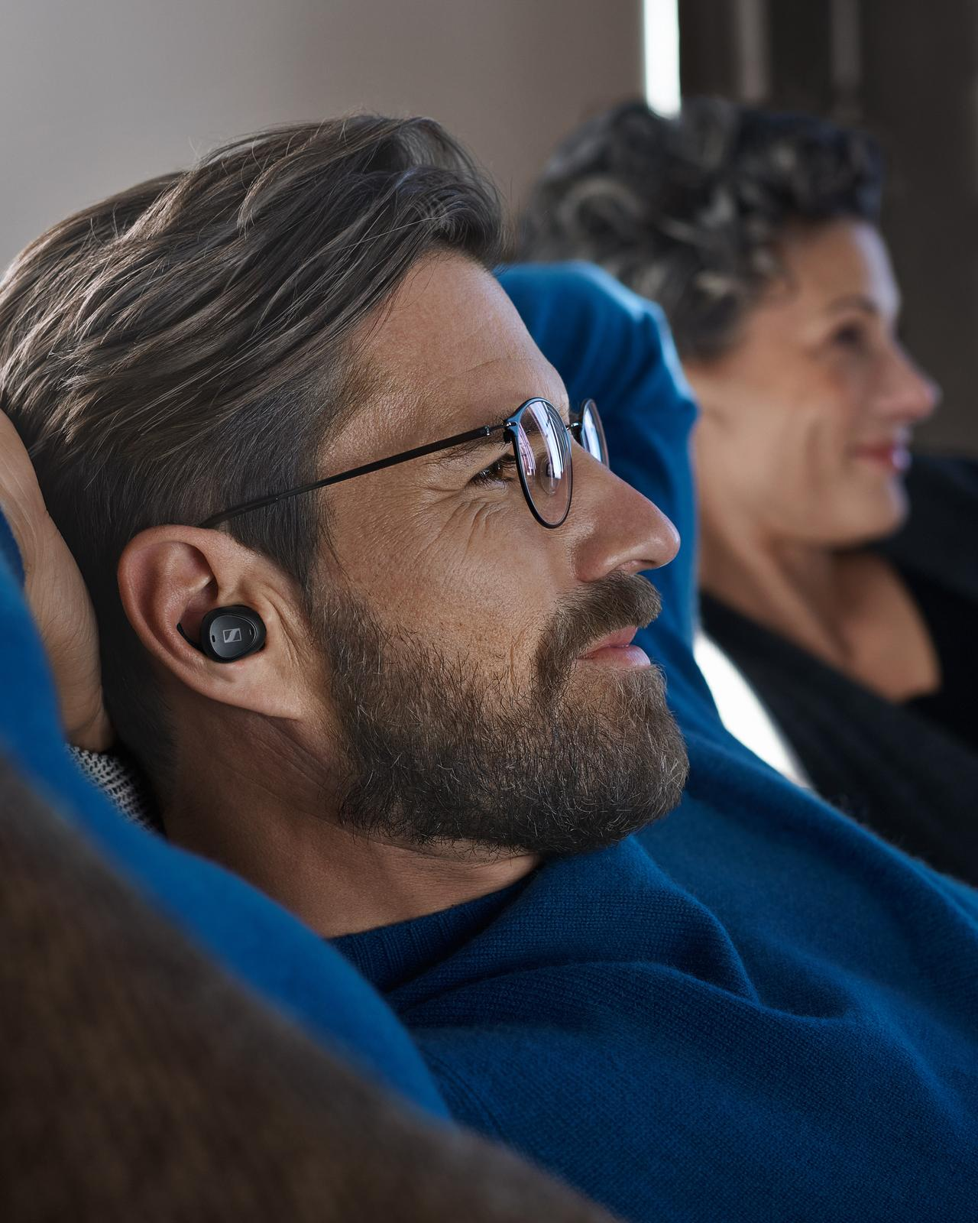

TV Clear lets you enjoy TV entertainment your way. For a personalised audio experience, you can choose from five speech clarity levels – providing up to 20 dB high-frequency amplification – to experience crystal-clear dialogue. You can also set your own preferred volume level on the earbuds independently from that of the television or other audio source when using them with the transmitter, to enjoy undisturbed viewing while others watch at a sound level comfortable for them.
​
​Listen alone or at your own preferred volume with friends
​As well as providing the option of watching your television without disturbing those around you or being distracted by external noise, TV Clear lets you choose to stay connected to others when desired. Its Ambient Awareness mode lets you hear external sound while wearing the earbuds – ideal for TV viewing with family or friends, or users can switch off the mode for more privacy.
​
​TV Clear is a universal solution that offers multiple device connectivity: link to televisions with the transmitter or seamlessly connect to multiple devices including televisions, tablets and smartphones via Bluetooth. For TV viewing, the transmitter’s low latency streaming technology keeps audio and video in sync for a great viewing experience.
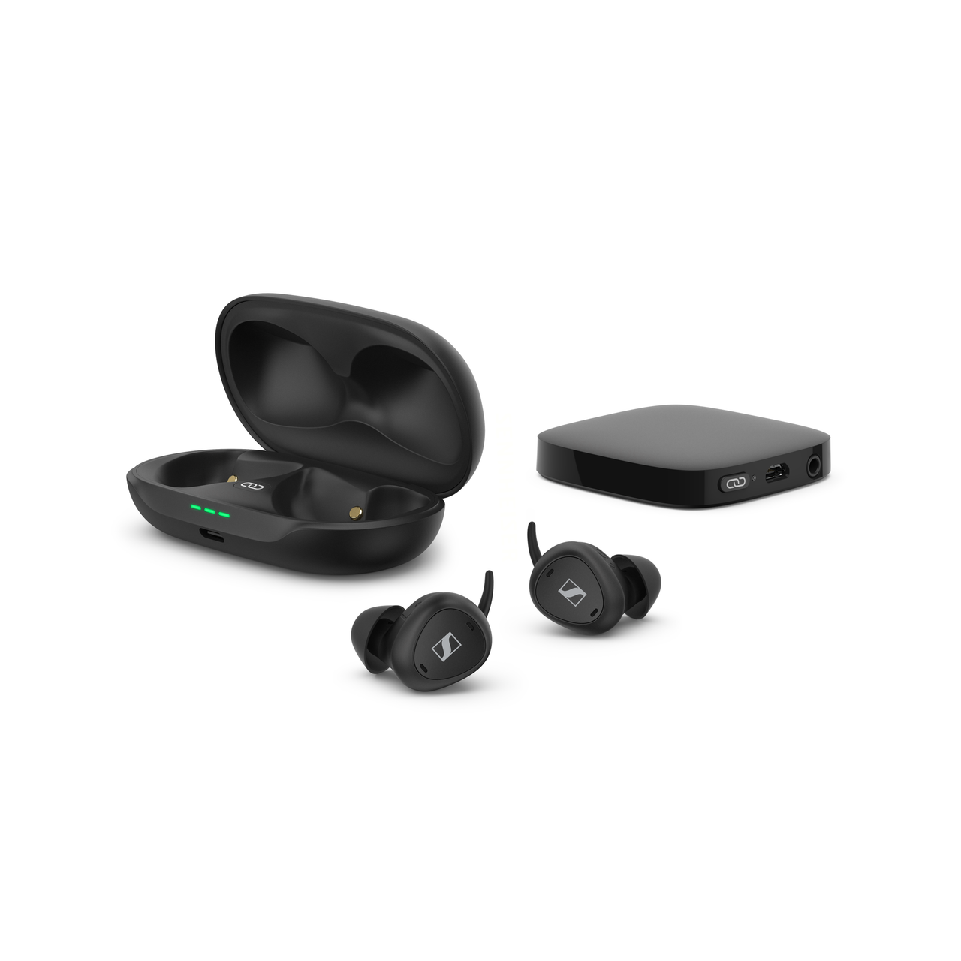

The 6.9g lightweight nature of the True Wireless earbud design is a revelation in comfort and convenience that can be worn for extra-long binge-watching sessions without interfering with your glasses or pressing on your temples. The inconspicuous wire-free design and secure fit provided by a selection of secure-fit ear tips and fins in different sizes let you move freely. Whether you want to sit back, lie down or walk around, the TV Clear earbuds will stay comfortably in place without disturbing your viewing pleasure.
​
​Personalise your experience with the TV Clear App
​TV Clear makes it simple to enjoy its advanced features thanks to its effortless ease of use. Customising the settings and listening experience is easy with the companion TV Clear App, which guides you through every step. The intuitive touch controls can also be customised according to individual preferences, so the earbuds can be controlled just the way you like. There is even a Find My Earbuds feature that makes them easy to locate.
​
​TV Clear also features a long-lasting battery that provides up to 15 hours of listening time on a single charge when used with the transmitter. The earbuds can be easily stored and recharged with the compact and stylish charging case to add a further 22 hours – letting you enjoy up to 37 hours of TV entertainment.
​
​Pricing and availability
​The Sennheiser TV Clear Set will be available from late June 2022, with an MSRP of £349.99.

About the Sennheiser brand
We live and breathe audio. We are driven by the passion to create audio solutions that make a difference. Building the future of audio and bringing remarkable sound experiences to our customers – this is what the Sennheiser brand has represented for more than 75 years. While professional audio solutions such as microphones, meeting solutions, streaming technologies and monitoring systems are part of the business of Sennheiser electronic GmbH & Co. KG, the business with consumer devices such as headphones, soundbars and speech-enhanced hearables is operated by Sonova Holding AG under the license of Sennheiser.

www.sennheiser.com
www.sennheiser-hearing.com

Press contact
Local Press Contacts
Milan Schlegel
PR and Influencer Manager EMEA, Sennheiser Consumer
Milan.Schlegel@sennheiser-ce.com

Harvard PR
Sennheiser UK&I PR agency
sennheiser@harvard.co.uk

