The Sennheiser Treasure Hunt
The holidays are coming earlier this year, so don’t miss the chance to score more ultimate audio treasures

Wedemark, November 2, 2021 – It’s time to go treasure hunting! Sennheiser has buried some secret codes across the web, and you could win some seriously superior audio treasures – whether for yourself or someone on your gift list. The more codes you uncover, the higher your chance of winning.
Drawing the winners
The Sennheiser Treasure Hunt will run from November 1 to 23, 2021. Every Tuesday, Sennheiser will announce the winners of the week, giving away many exclusive audio treasures. A few audio delights include the Sennheiser CX True Wireless, MOMENTUM True Wireless 2, HD 560S, and MOMENTUM Wireless. So, you just might be getting an early present.

But the grand prize? Drum roll please! The ultra-exclusive, one-of-a-kind, custom-made, golden version of the HD 820 & HDV 820 combo. To learn more, visit the Sennheiser Treasure Hunt landing page.

Sennheiser has been working together with some of its key retailers to organize the 2021 Sennheiser Treasure Hunt. This activation lets you embark on a virtual treasure hunt to win ultimate aural pleasures. The hunt is open for you if you’re from one of the following countries: US, Germany, France, Australia and New Zealand.

Time to go hunting for some secret codes across the web: The Sennheiser Treasure Hunt

Crawling the web for codes
To play, you need to search for secret codes hidden all over the web. You won’t just find them on Sennheiser.com, they’ll be on the headphone product pages of selected retail partners’ websites too. For the Sennheiser Treasure Hunt, you can find the full list of participating retailers on the Treasure Hunt website.

So, start browsing around and uncovering those codes! But keep your eyes peeled: The codes can be anywhere – hidden in images or even in between text. Here’s a hint for you, codes will look like this: ‘HUNTUSUXA’.

And listen closely, too. Sennheiser know how much you love a superior audio experience – maybe some codes are hidden in audio tracks. For even more hints and clues, you can follow our social media channels.

Entering the raffle
Just collecting codes won’t cut it; you will need to enter them, too. Once you find a code, head to the Sennheiser Treasure Hunt landing page to enter it, putting your name in the raffle. The more codes you submit, the better your chances are of winning.

Every week, Sennheiser will add new codes. For you, that means even more prizes can be won!

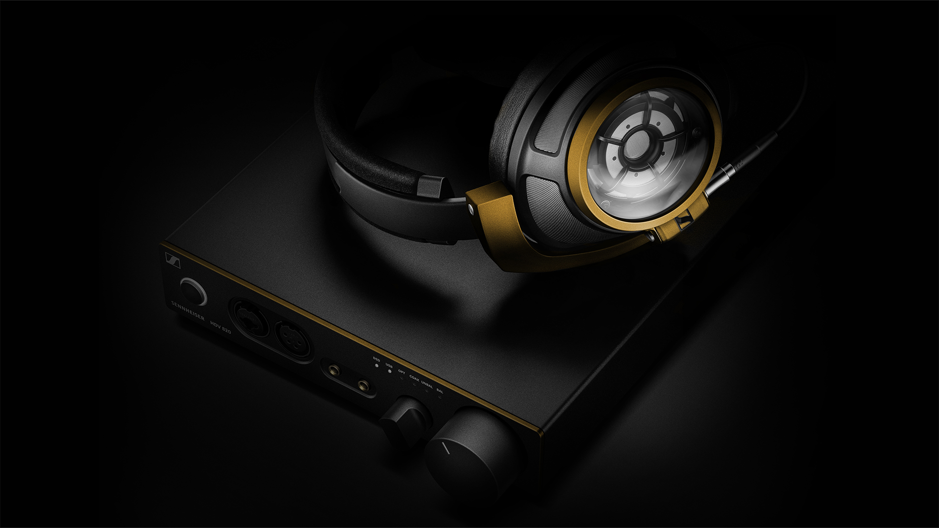 | The grand prize: The golden version of the HD 820 & HDV 820 combo

Drawing the winners
The Sennheiser Treasure Hunt will run from November 1 to 23, 2021. Every Tuesday, Sennheiser will announce the winners of the week, giving away many exclusive audio treasures. A few audio delights include the Sennheiser CX True Wireless, MOMENTUM True Wireless 2, HD 560S, and MOMENTUM Wireless. So, you just might be getting an early present.

But the grand prize? Drum roll please! The ultra-exclusive, one-of-a-kind, custom-made, golden version of the HD 820 & HDV 820 combo. To learn more, visit the Sennheiser Treasure Hunt landing page.

ABOUT SENNHEISER
Shaping the future of audio and creating unique sound experiences for customers – this aim
unites Sennheiser employees and partners worldwide. The independent family company,
which is managed in the third generation by Dr. Andreas Sennheiser and Daniel Sennheiser, is
today one of the world’s leading manufacturers of headphones, loudspeakers, microphones
and wireless transmission systems. In 2020, the Sennheiser Group generated turnover totaling
€573.5 million. www.sennheiser.com

Global Press Contact
Sennheiser electronic GmbH & Co. KG
Paul Hughes
Head of PR and Influencers
T +49 (0) 162 2921 861
paul.hughes@sennheiser-ce.com

