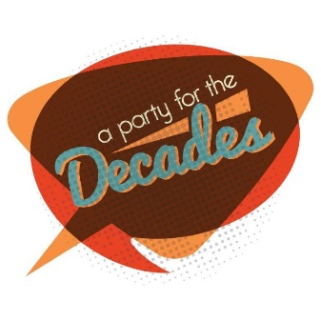

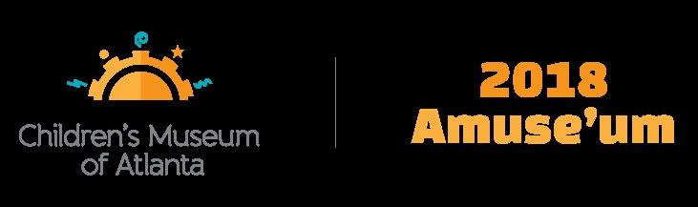

CONTACT:
Becca Meyer/Jennifer Walker
BRAVE PR, 404.233.3993
bmeyer@bravepublicrelations.com/
jwalker@bravepublicrelations.com
FOR IMMEDIATE RELEASE

Children’s Museum of Atlanta to host 15th annual
“Amuse’um: A Party for the Decades” fundraiser on March 3
Signature benefit allows adults to celebrate the power of play!

ATLANTA (January 30, 2018) – It’s time to boogie! Children’s Museum of Atlanta will host its 15th annual Amuse’um fundraiser, themed “A Party for the Decades,” on Saturday, March 3. From 7-11 p.m., Atlantans are invited to celebrate the city’s only children’s museum with a fabulous evening of flapper dresses, poodle skirts, parachute pants and bell bottoms. The blockbuster adults-only benefit, presented by Georgia Natural Gas, supports the Museum’s mission to spark imagination and inspire discovery and learning for all children through the power of play.

Amuse’um will include a full lineup of fun activities, including dancing, a DJ, raffle giveaways and live and silent auctions, with a chance to bid on a behind-the-scenes Macy’s Thanksgiving Day Parade experience, a ski trip to Snowshoe Resort, tickets to see Hamilton, a Roomba 980 from iRobot, James Avery jewelry and much more!

Amuse’um co-chairs Emily Graney and Elizabeth Kuney promise a groovy evening as the Museum honors two of its beloved, longtime friends, Molly and John Jamieson. John formerly served for six years on the Children’s Museum of Atlanta Board of Directors and Molly volunteers her time and talents to help the Museum whenever possible. The couple is actively engaged in the local community and focuses their efforts on aiding organizations that advance the education and welfare of Atlanta’s youth.

This annual event attracts a diverse crowd of more than 500 attendees from across the greater Atlanta area, who contribute to the ongoing and important work of the Museum. All proceeds support Children’s Museum of Atlanta’s early childhood educational programming and community outreach that touches the lives of more than 220,000 children and families annually. Serving the children, families and schools in Atlanta and throughout Georgia, the Museum has welcomed more than 2.7 million visitors since opening in 2003.

With the premise that meaningful play provides the essential foundation for life-long learning, Children’s Museum of Atlanta features hands-on exhibits designed to spark imagination and inspire discovery. By engaging children through the power of play, these exhibits introduce young learners to core educational concepts, laying the groundwork that will help children succeed in school and ultimately in the global economy.

Tickets are $150 per person. For more information on Amuse’um 2018: A Party for the Decades, visit childrensmuseumatlanta.org or call Laura Halad at 404.527.5908 for information regarding sponsorships. The Museum will be closed on Saturday, March 3 in preparation for Amuse’um.

About Children’s Museum of Atlanta:
Children’s Museum of Atlanta is the only educational venue of its kind in Atlanta, presenting educational programs and exhibits designed for young children ages 0-8. The Museum’s mission is to spark imagination and inspire discovery and learning for all children through the power of play. With six permanent learning zones consisting of bright, creative and hands-on exhibits, the Museum supports inventive play-based exploration and experiential learning focused on the whole child. Core competencies for literacy, math and science are promoted throughout all exhibits and programming in alignment with the state and national Core Performance Standards. Children’s Museum of Atlanta also offers parties, memberships, field trips, summer camp and private events. For more information or to support Children's Museum of Atlanta, visit childrensmuseumatlanta.org or call 404.659.KIDS [5437].

###

