RME’s New DTOX Series of Breakout Boxes Help Eliminate Cable Confusion
Available in four versions, the DTOX line of breakout panels replaces two usual multicore breakout cables with a 19-inch rack mount unit
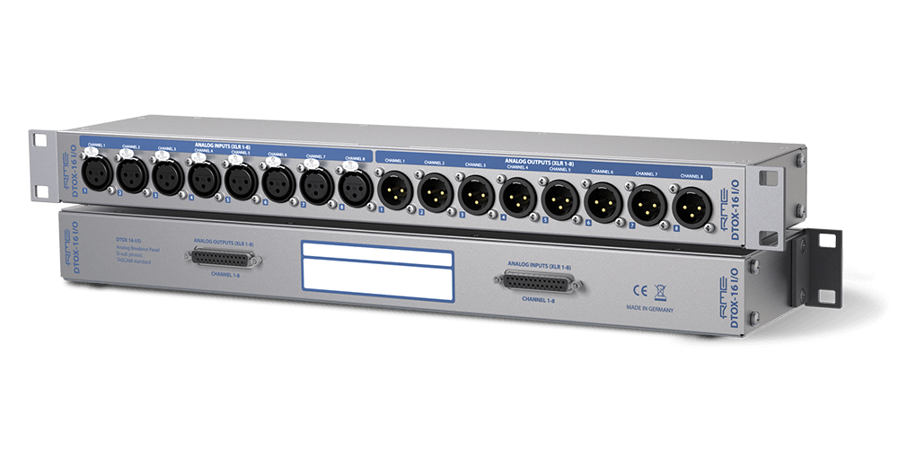
New York, October XX, 2018 – Premium German interface manufacturer RME [AES 2018 NY booth 414] has officially announced its DTOX series of D-sub to XLR breakout boxes. These boxes will be highlighted at RME’s booth 414 during AES 2018 from Oct 17–19, 2018, at the Javitis Convention Center in New York.
The DTOX breakout panels are the ideal rack solution for interconnecting multichannel XLRs with the common D-sub connector format.
“Using D-sub to XLR breakout cables where other XLR cables need to be plugged into poorly labelled XLR plugs can result in errors and connection issues,” said Derek Badala, Director of Sales, Americas for Synthax, distributor of RME. “The DTOX series of boxes provides a professional solution by replacing two usual multicore breakout cables with a space-efficient 19-inch rack mount unit — streamlining the process and eliminating confusion.”
Multiple Solutions: DTOX-32 & DTOX-16
Named after their primary function, D(-sub) to X(LR), the DTOX panels are 19-inch rack enclosures with 1 height unit featuring 16 XLR sockets on one side and 2 D-sub connectors on the other. Due to differences between digital and analog formats, the DTOX series is available in four different models.
The DTOX-32 is a double D-sub solution for AES/EBU signals with one D-sub converted to 4 XLR males and 4 XLR females each, equaling a total of 8 AES/EBU inputs and 8 AES/EBU outputs. The DTOX-32 is pin-compatible to the common TASCAM pinout as well as the popular Yamaha pinout. An internal connector allows the user to change between both formats separately for both D-subs.
For analog connections, the DTOX-16 is available in three versions: DTOX-16 I – with only inputs (XLR female); DTOX-16 O – with only outputs (XLR males); and DTOX-16 I/O – with 8 female and 8 male sockets.
All for DTOX units are available for $399 MAP.
For more information on RME, visit http://www.rme-usa.com/
About Synthax, Incorporated
Synthax Inc. is the exclusive USA distributor for RME digital audio solutions, Ferrofish advanced audio applications, myMix audio products, and ALVA cableware. We supply a nationwide network of dealers with these products for professional audio, broadcast, music industry, commercial audio, theater, military and government applications. For additional information, visit the company online at http://www.synthax.com.

Media Contacts:
Katie Kailus
Public Relations
Hummingbird Media
+1 (630) 319-5226
katie@hummingbirdmedia.com

Jeff Touzeau
Public Relations
Hummingbird Media
+1 (914) 602 2913
jeff@hummingbirdmedia.com

