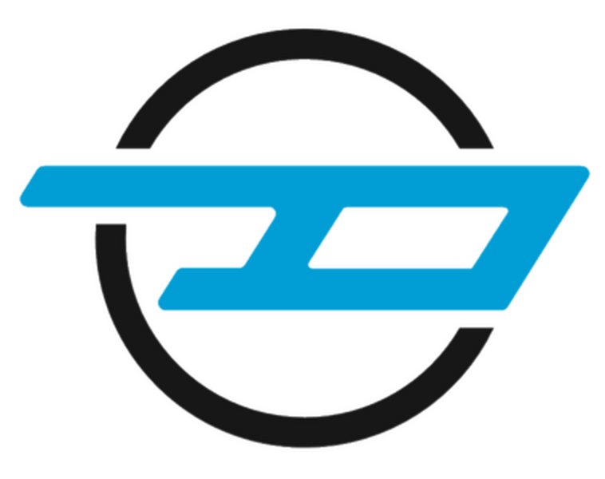
Dynamo Motor Company powers the future with world’s first fully electric Black Cab and confirms commitment to UK manufacturing and growth with latest fundraiser

- Dynamo Motor Company has confirmed it will continue to build the Dynamo Taxi - the world’s first fully electric Black Cab - in the UK as it enters its next growth phase
- Founded in 2018, it has delivered over 170 Dynamo Taxis since production started in 2020 with plans to expand all-electric options with additional Wheelchair Accessible Vehicles, alongside an increased volume carrying capacity last mile delivery van
- The expansion will be delivered in part by public investment, namely Seedrs, a leading public fundraising platform, with over £1,500,000 committed of its £2,000,000 target since launching on 12 July
- Investment could see an additional 275 jobs (300 total) in the UK with an opportunity to convert 10,000 per year zero emission taxis, commercial and privately owned vehicles at its Coventry, UK plant in 2026
- Dynamo Taxi is the world’s first fully electric Black Cab, offering cabbies a competitively costed, zero emission way to transport passengers around cities around the UK, already in use in London as well as Cardiff, Liverpool, Coventry, Nottingham, and Manchester
- The UK-based conversion specialist partnered with Nissan Motor Company to convert an e-NV200 Evalia MPV into a Black Cab, the Dynamo Taxi, which has a 170-mile range and a 40 kWh lithium-ion battery
- High resolution imagery here

Coventry, 22 July 2021

Committing to UK jobs, growth and future all-electric taxi and van conversions, Dynamo Motor Company has announced its next expansion phase, where it plans to recruit an extra 275 people (total team 300) in the UK and convert up to 10,000 taxis and commercial/privately owned vehicles per year in 2026. Through its Seedrs campaign Dynamo Motor Company plans to raise £2,000,000, of which it has received over £1,500,000 in one week, for its growth strategy. Said expansion will see Dynamo Motor Company’s all-electric Black Cab production increase and diversification into other mobility sectors that require wheelchair accessibility as well as a last mile delivery van added to its zero emission line-up.

Dynamo Motor Company released its first vehicle in 2019, the Dynamo Taxi, which became the world’s first all-electric Black Cab in 2020 when it entered production. Used in all major cities including London, the home of the London Black Cab, as well as Nottingham, Cardiff, Liverpool, Coventry and Manchester, it is still known as the only Black Cab that has zero emission status. Based on a Nissan e-NV200 Evalia MPV, the Coventry-based specialist has converted the commercial vehicle to work as a commercially viable all-electric Black Cab offering for drivers and fundraisers alike.

Today the company announces its next phase of growth in which it will add two further models to its all-electric line up, alongside an upgrade to its Dynamo Taxi Black Cab. With this increased production, Dynamo Motor Company will also make a commitment to expand its UK manufacturing site in Coventry, UK in which it believes there is opportunity to convert up to 10,000 vehicles per year by 2026. The core team would then consist of 275 more people (making total headcount 300) in the next five years and Dynamo Motor Company will continue to invest in UK suppliers for components and knowledge.

To enable this growth plan, Dynamo Motor Company has opened a public fundraising campaign via Seedrs, where it aims to raise £2,000,000, which has already reached over £1,500,000 in the first week. Committing an additional £500,000 to its £1,000,000 investment, Gluon Mobility Ventures (“Gluon”) has joined forces with Dynamo Motor Company, which will see it work with Gluon and its partner Zev Hub, with whom it will be looking to improve wheelchair accessibility across London and the Iberian Peninsula.

Brendan O’Toole, founder of Dynamo Motor Company said: “We’re on a mission to change the way people move around the UK, especially in built-up areas like cities where pollution is a problem. In 2019, exactly 100 years since the first new post-war taxi was launched, we introduced the world’s first zero emission Black Cab, Dynamo Taxi. Today, we have big plans to scale up our commitment to all-electric mobility conversions including an updated Black Cab, professionally and privately owned wheelchair accessible vehicle conversions. And to add further diversification we will launch a van with a higher roof conversion that increases volume capacity that is designed to offer couriers another option to help tackle the last mile deliveries in all major cities. Our fundraiser will assist in our mission to further our commitment to UK jobs and working with suppliers to increase their growth and further introduce all-electric mobility solutions.”

Each Dynamo Taxi has had over 1,000 modifications to the existing Nissan e-NV200 Evalia MPV to be classed as a Black Cab. From increasing the height of the Nissan e-NV200 Evalia MPV and be able to access the taxi from the kerbside including with a ramp, and of course the 25-feet turning circle and M1 certification, the R&D cost over £10,000,000. Despite this, prices of the Dynamo Taxi are considerably less than its plug-in hybrid competitor with Dynamo Motor Company’s calculations stating that drivers could save £10,000* opting for the Dynamo Taxi in comparison. Each Dynamo Taxi costs £47,995 (inc. VAT) RRP including £7,500 grant, excluding first £55 registration fee, with the option to finance and buy outright. Drivers can charge the 40 kWh version, capable of 170-mile range, in 40-60 minutes on a rapid charger, meanwhile a fast charger can be completed in as little as four hours and those opting for a 7 kw home charge can do so in seven hours.

The Dynamo Motor Company Seedrs campaign opened on 12 July and ends on 12 August available to view on www.seedrs.com/dynamotaxi. Drivers wishing to contact the Dynamo Motor Company team about the fundraiser, Dynamo Taxi and future taxi and van models, can email brendan.otoole@dynamotaxi.com.

*
LEVC Vista Comfort Plus Dynamo Taxi
£57,995 Price after Government Grant £47,995 Price after Government grant

- ENDS -

Media contacts:

Hannah Burgess
hannah@hannahburgesspr.com
+44 (0) 7730 570975

Orla Gadeselli
orla@hannahburgesspr.com
+44 (0) 7581 619687

About:

Dynamo Motor Company was founded in 2018 by Brendan O’Toole and is currently based in Coventry, UK. Production of its Dynamo Taxi, the world’s first all-electric Black Cab, began in 2020 and since then the company has delivered over 170 taxis to customers in large cities across the UK, including London, Nottingham, Cardiff, Liverpool, Coventry and Manchester. The team is currently made up of 25 people, all based at the company’s plant and headquarters in Coventry, UK, with plans to expand to a team total of 300 following public investment. With this investment, Dynamo Motor Company aims to see production of its Dynamo Taxi increase and diversify into other mobility sectors, including all-electric vehicles with wheelchair accessibility and last mile delivery vans.

Social media:

www.dynamotaxi.com
Twitter: www.twitter.com/DynamoMotor
Facebook: www.facebook.com/DynamoMotorCompany
LinkedIn: www.linkedin.com/dynamo-motor-company

