SENNHEISER aT IFA 2018
MOMENTUM True Wireless and forthcoming AMBEO Soundbar set benchmarks in audio

Wedemark/Berlin, August 30, 2018 – At IFA 2018, held in Berlin from August 31 to September 5, Sennheiser introduces the MOMENTUM True Wireless. These exquisitely crafted Bluetooth earphones bring the uncompromised audio performance and iconic style of the audio specialist’s MOMENTUM headphone range to a truly wireless form for the first time. The trade show also presents an opportunity to experience the forthcoming AMBEO Soundbar which is showcased in Europe for the first time. With the soundbar, Sennheiser has brought a 5.1.4 home entertainment experience into one single device, with sound performance that has to be heard to be believed. In a further showcase of the AMBEO program, Sennheiser will also present screenings of a new short film, FINAL STOP, which features stunning 3D audio recorded using the AMBEO SMART HEADSET.

“As an exceptional showcase for the very best in technology, IFA is the ideal place and time to share our most exciting innovations,” said Stephane Hareau, Global Head of Products – Consumer at Sennheiser. “Whether it is raising the bar for True Wireless headphones with the uncompromised audio quality of MOMENTUM, or discovering incredibly immersive AMBEO 3D sound, we invite visitors to IFA to hear the extraordinary.”

Introducing MOMENTUM True Wireless
At IFA, Sennheiser introduces the first model in a new generation of its iconic MOMENTUM headphone family - the MOMENTUM True Wireless. These exquisitely crafted Bluetooth earphones offer characteristic MOMENTUM style and comfort, while redefining the audio benchmark for true wireless ear buds with superior stereo sound performance ensured by Sennheiser’s audiophile 7mm dynamic drivers.
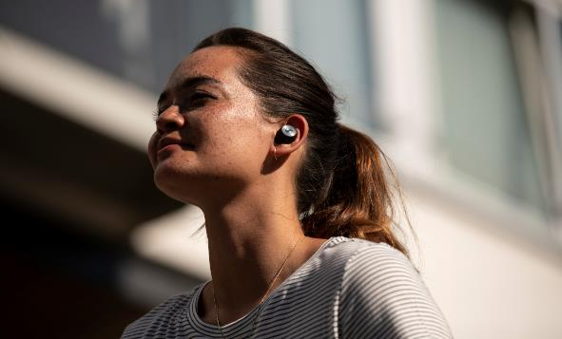

The new MOMENTUM True Wireless brings the uncompromised audio performance and iconic style of the MOMENTUM range to a truly wireless form for the first time.
Alongside the latest Bluetooth technology, AAC codec support as well as Qualcomm® aptXTM and aptXTM Low Latency compatibility, MOMENTUM True Wireless provides a more intelligent, personalized experience. On the move, the Transparent Hearing feature lets listeners hear ambient sounds for improved situational awareness, or for participating in conversations without removing the ear buds. Meanwhile, MOMENTUM True Wireless offers effortless interaction with the user’s digital eco system by enabling direct voice access to smart assistants such as Apple Siri or Google Assistant. Be entertained, communicate, and stay informed - all via a simple tap of the intuitive touch interface and natural voice commands.

The Bluetooth earphones have a 4-hour battery life that can be recharged via their compact case with integrated power bank for more than 12 hours of all-day enjoyment. Sennheiser’s MOMENTUM True Wireless will be available from mid-November for 299 EUR (MSRP).

Experience the AMBEO Soundbar
IFA presents one of the very first opportunities for the public to listen to Sennheiser’s forthcoming AMBEO Soundbar. The latest product developed under Sennheiser’s AMBEO trademark for 3D immersive audio, the soundbar offers a remarkably spatial sonic experience with immersive 5.1.4 sound and deep bass that has to be heard to be believed. All this is delivered by a single all-in-one device and without the need for an additional subwoofer. The AMBEO Soundbar delivers an incredibly immersive home entertainment experience optimized for each individual room thanks to its room calibration feature.

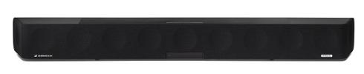
The forthcoming AMBEO Soundbar offers a remarkably spatial sonic experience with immersive 5.1.4 sound and deep bass.

Powered by 13 drivers and the latest virtualization technology which was jointly developed with Fraunhofer, the forthcoming AMBEO Soundbar will offer a new reference in HiFi sound quality. It will be compatible with 3D audio formats Dolby Atmos, MPEG-H and DTS:X while the soundbar’s Upmix Technology recreates stereo and 5.1 content as a thrillingly immersive 3D sound experience.

The Sennheiser booth at IFA features a dedicated listening room in which visitors can discover the remarkable as-if-there feeling created by the AMBEO Soundbar. The soundbar will be available from early 2019.
FINAL STOP: A new 3D Audio Thriller Recorded with the AMBEO SMART HEADSET
In cinema, the illusion created by what we see is completed by what we hear: At IFA, Sennheiser will be showing how 3D audio takes this phenomenon to the next level with screenings of its new short movie FINAL STOP. Written and directed by accomplished horror director Roxanne Benjamin and starring Australian actress Phoebe Tonkin, this gripping thriller uses its incredibly realistic 3D soundscape to chilling effect.

The 3D audio was recorded using Sennheiser’s AMBEO SMART HEADSET. Developed with A/D conversion specialist Apogee, the headset makes binaural audio recordings possible, thanks to microphones in each of the earpieces that record true-to-life ambient sounds. These recordings can be played back using any stereo headphones.

At IFA, Sennheiser will present the short film in special silent cinema screenings held each day at 11 a.m., 1 p.m. and 3 p.m. Viewers will be provided with MOMENTUM headphones to experience all the chills and thrills of a truly immersive movie experience.

Visit Sennheiser at IFA in hall 1.2 at booth 216.

about Sennheiser
Shaping the future of audio and creating unique sound experiences for customers – this aim unites Sennheiser employees and partners worldwide. Founded in 1945, Sennheiser is one of the world’s leading manufacturers of headphones, microphones and wireless transmission systems. With 21 sales subsidiaries and long-established trading partners, the company is active in more than 50 countries and operates its own production facilities in Germany, Ireland, Romania and the USA. Since 2013, Sennheiser has been managed by Daniel Sennheiser and Dr. Andreas Sennheiser, the third generation of the family to run the company. In 2017, the Sennheiser Group generated turnover totaling €667.7 million. www.sennheiser.com

Regional Press Contact
Hummingbird Media, Inc.
Jeff Touzeau
Public Relations
+1 (914) 602-2913
jeff@hummingbirdmedia.com

Global Press Contact
Sennheiser electronic GmbH & Co. KG
Jacqueline Gusmag
Public Relations Manager Consumer Electronics
T: +49 (0)5130 600-1540
jacqueline.gusmag@sennheiser.com

