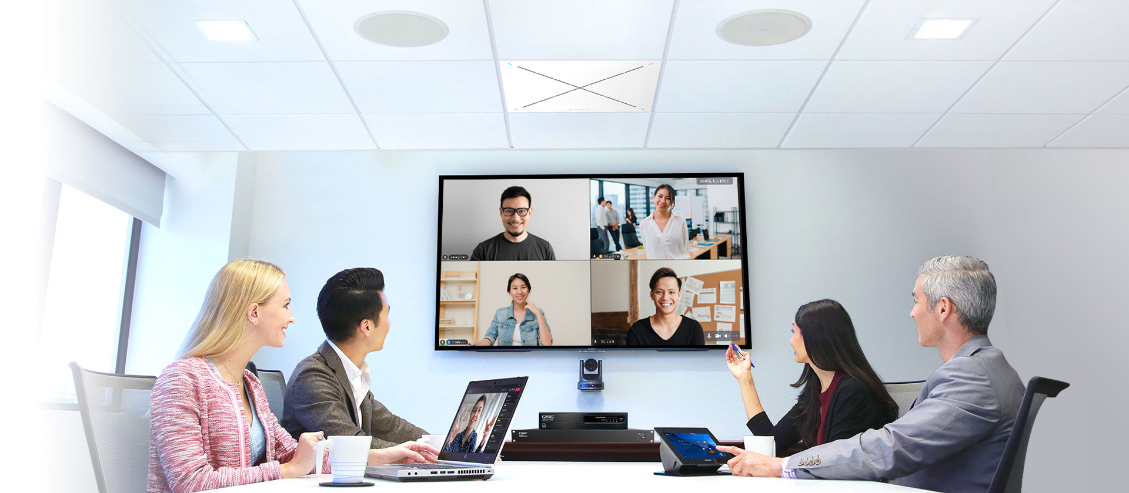
SENNHEISER TEAMCONNECT CEILING 2 ACHIEVES CERTIFICATION FOR TENCENT MEETING

Sennheiser and Tencent Meeting deliver the ultimate hybrid meeting experience

Beijing, 24 January 2023 — Sennheiser, the first choice for advanced audio technology that makes collaboration and learning easier, today announced that its TeamConnect Ceiling 2 (TCC2) microphone is now certified for Tencent Meeting. With this certification, TCC2 also officially becomes a member of Tencent Meeting's hardware certification ecosystem.

The certified Sennheiser and Tencent Meeting communications system solutions include TCC2, Q-SYS Core 110f, SPA Series amplifier, and an AcousticDesign Series loudspeaker. The partnership between Sennheiser and Tencent Meeting delivers a seamless, high-quality complete audio experience for hybrid office scenarios.

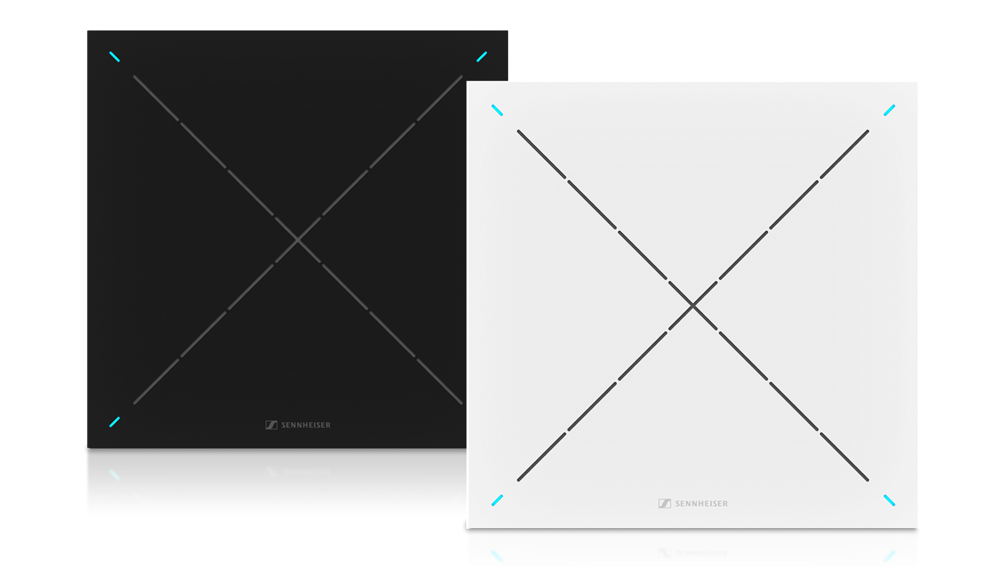

Thanks to its state-of-the-art audio technology and ease of installation, TCC2 pairs perfectly with Tencent Meeting Rooms to meet the requirements of various conference room settings, regardless of the space environment or configuration. TCC2’s patented adaptive beamforming technology automatically locates the speaker and reliably follows their voice, allowing them to move freely without having to carry or pass a microphone. With its TruVoicelift functionality, TCC2 significantly enhances the speaker's audio effect, reduces background noise, and improves speech intelligibility. Additionally, the Sennheiser Control Cockpit app allows the TCC2 to be controlled and managed at any node in the enterprise intranet easily and quickly, making it more user friendly to operate the whole audio system.

Tencent Meeting, with millions of registered users, a strong market share and global brand awareness, is one of the most influential video communications platforms in China. Its hardware certification standards are formulated by Tencent Ethereal Audio Lab. All hardware to be certified must undergo rigorous certification tests, including nearly 50 tests and over 200 test indicators, in terms of audio, video, system interaction, and SDK.

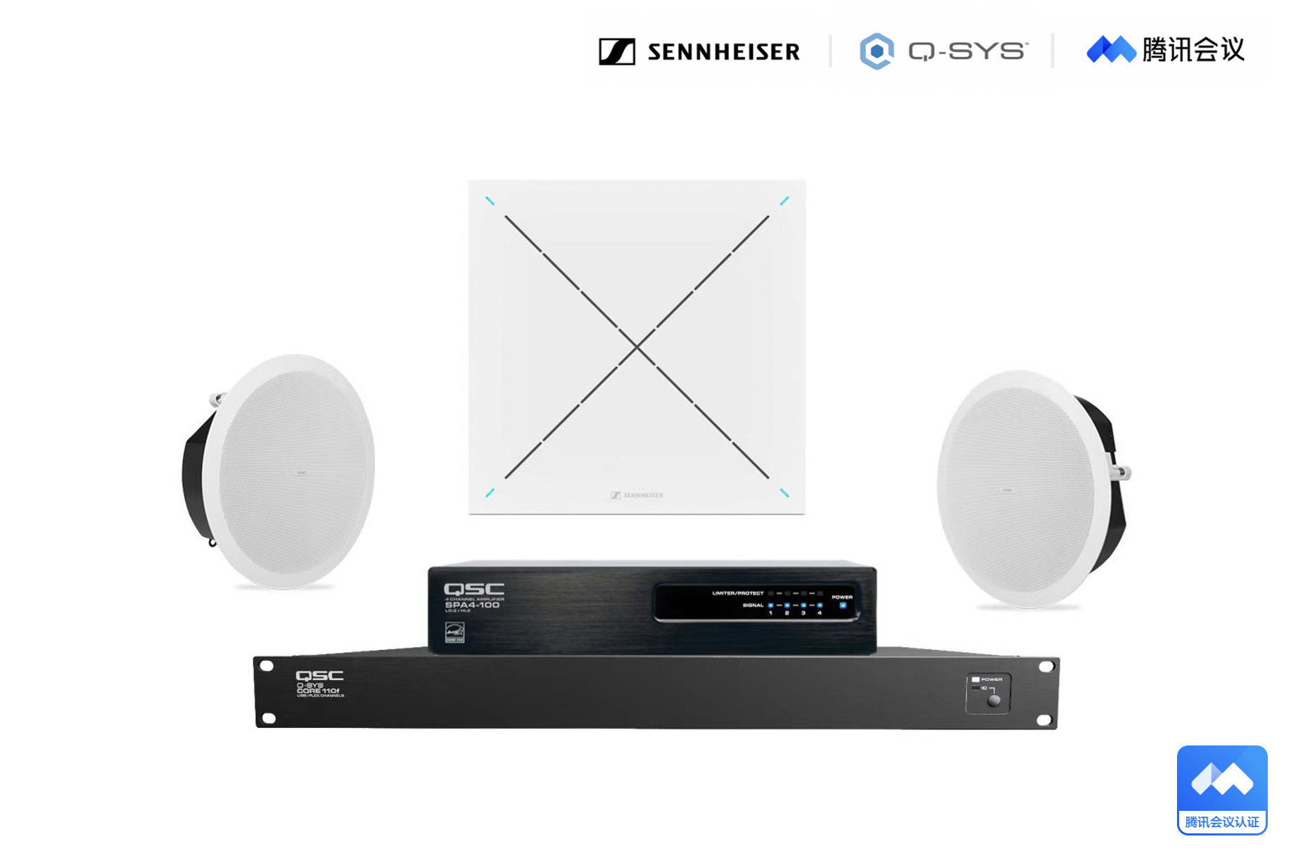
The certified communications system solutions include Sennheiser TeamConnect Ceiling 2 microphone, Q-SYS Core 110f, SPA Series amplifier, and AcousticDesign Series loudspeaker.

Following the Tencent Meeting hardware certification, TCC2 is now compatible with Tencent Meeting and Tencent Meeting Rooms. The advanced TCC2 provides Tencent Meeting’s business users with ultimate support in conference audio experience, in terms of stability, reliable audio pickup and ease of installation. Meanwhile, by partnering with Tencent Meeting, Sennheiser gets closer to users’ needs and provides vital support in more hybrid working and teaching scenarios.

TCC2’s patented adaptive beamforming technology automatically locates the speaker and reliably follows their voice, allowing them to move freely. TCC2 is designed for a completely touchless microphone solution, which is especially important under current pandemic situation.

"Sennheiser Business Communication is committed to continuously enhancing conference audio experience with cutting-edge technology, reliable products, and professional services to help our customers succeed," states Zhao Xiaochuan, Sales and Marketing Director of Sennheiser Business Communications in Greater China. “It means a lot to us to have Sennheiser TeamConnect Ceiling 2 and the Q-SYS system achieve solution certification for Tencent Meeting. It not only represents market recognition of our product, but also marks the beginning of our strong partnership. With innovation and high-quality products, we will jointly create carefree meeting environments with clear audio experiences to improve work efficiency and reduce communication costs."

"Tencent Meeting explores and innovates collaboration in today’s work scenarios, ensuring convenience and efficiency while enhancing the user experience,” says the Tencent Meeting Product Team. “We welcome Sennheiser TeamConnect Ceiling 2 microphone to join Tencent Meeting's hardware certification ecosystem, providing our users with advanced convenient audio solutions and a premium meeting experience. We look forward to further cooperating with Sennheiser, combining our advantages in channel, technology, and ecosystem, to offer better hybrid work and teaching experience and services to business users with innovative audio solutions."

"Recently, Q-SYS and Sennheiser completed the certification for Tencent Meeting in China, which has the most rigorous standard in the industry. It’s a bundle solution consisting of Q-SYS’s Core 110f audio processors, SPA Series amplifier and ceiling loudspeakers, and Sennheiser's TCC2 microphone. This certification fully proves that the powerful Q-SYS products fit perfectly with Sennheiser TCC2, and together with Tencent Meeting Rooms, we can bring professional audio and video conference experience to business users," concludes Li Jingjing, Market Development Manager of QSC China.

To learn more about TeamConnect Ceiling 2, please visit https://en-us.sennheiser.com/tcc2

About the Sennheiser brand
We live and breathe audio. We are driven by the passion to create audio solutions that make a difference. Building the future of audio and bringing remarkable sound experiences to our customers – this is what the Sennheiser brand has represented for more than 75 years. While professional audio solutions such as microphones, meeting solutions, streaming technologies and monitoring systems are part of the business of Sennheiser electronic GmbH & Co. KG, the business with consumer devices such as headphones, soundbars and speech-enhanced hearables is operated by Sonova Holding AG under the license of Sennheiser.

www.sennheiser.com
www.sennheiser-hearing.com

