# TeamMate and Sennheiser Deliver Secure, Functional and Stylish Solutions for Learning Spaces

***Sennheiser’s TeamConnect Bars added to TeamMate’s Active Learning Terminal wall mounted enclosure***

**Barcelona, Spain — February 5, 2025 —** [**Sennheiser**](http://www.sennheiser.com)**, the first choice for advanced audio technology that makes collaboration and learning easier, is pleased to announce a new collaboration with TeamMate, a designer of technical furniture solutions for education, corporate and specialist spaces. The collaboration enables streamlined installations of Sennheiser’s TeamConnect (TC) Bar Solutions with the TeamMate Active Learning Terminal (ALT) wall mounted enclosure. The perfect pairing of TC Bars with ALT strikes a balance of security and aesthetics for meeting rooms and seminar spaces, minimizes installation times and improves accessibility for integration and ongoing maintenance.**

TeamMate’s ALT is a wall-mounted enclosure designed to efficiently store AV over IP or small form-factor equipment. It features a removable perforated rack board and is finished with a fabric panel that can be slid aside to reveal a secure lock. The ALT can be further customized with an optional cable feedthrough channel and a mount for a variety of soundbars, including the TC Bars.

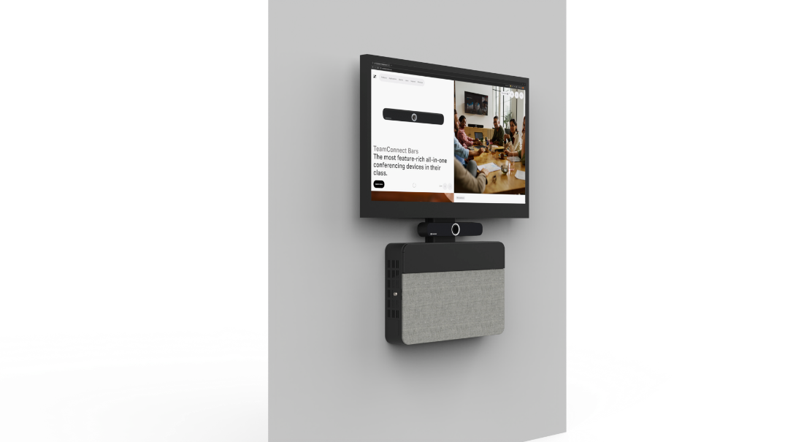

*TC Bar S with ALT*

Ideal for corporate and educational environments, the ALT can be installed in meeting or seminar spaces. It can be positioned beside or below the primary display, serving as a central terminal for cabling and mounting hardware. This design ensures streamlined servicing and integration, making setup and maintenance both quick and efficient. When combined with the TC Bar Solutions, TeamMate can help improve meeting spaces through its stylish and functional AV furniture solutions.

Closer look at TC Bar S with ALT

The TC Bars are the most feature-rich devices within their class and the first all-in-one audio and video conferencing bars in the market with Dante integration. With a 4K Ultra HD camera, Person Tiling and Auto-framing AI features, combined with Trusted Sennheiser Audio Quality, the TC Bars deliver a high video quality and outstanding audio experience that always ensures successful conferencing and collaboration in small or huddle and medium sized learning spaces.

There are two models of the TC Bars — TC Bar S and TC Bar M. The TC Bar S features four microphones and two speakers, while the TC Bar M features six microphones and four speakers. Dante integration allows for easy scalability through the addition of extension mics, such as Sennheiser’s TC Ceiling Medium, SpeechLine Digital Wireless products or others, further enhancing the TC Bars’ flexibility. Secondary PTZ cameras can also be added through a USB connection. As a simple plug and play device, with just one cable, the TC Bars are extremely easy to use, while ongoing management is quickly and effectively done through the Sennheiser Control Cockpit app, which also provides security during setup and configuration.

TeamMate develops a range of collaborative furniture, lecterns, screen stands, technical desking and completely bespoke solutions. The company’s goal is to maximize the potential of the customer’s space, enhancing both its efficiency and appeal.

For more information about the Sennheiser and TeamMate collaboration, visit <https://teammateworld.com/products/active-learning-terminal-alt/>. To learn more about the TC Bar Solutions, visit <https://www.sennheiser.com/en-us/product-families/tcb>.

###

**About the Sennheiser brand**

We live and breathe audio. We are driven by the passion to create audio solutions that make a difference. Building the future of audio and bringing remarkable sound experiences to our customers – this is what the Sennheiser brand has represented for more than 75 years. While professional audio solutions such as microphones, meeting solutions, streaming technologies and monitoring systems are part of the business of Sennheiser electronic GmbH & Co. KG, the business with consumer devices such as headphones, soundbars and speech-enhanced hearables is operated by Sonova Holding AG under the license of Sennheiser.

[www.sennheiser.com](http://www.sennheiser.com)

[www.sennheiser-hearing.com](http://www.sennheiser-hearing.com)