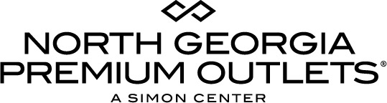

For more information:
McKenzie Riley
BRAVE Public Relations
404.233.3993
mriley@emailbrave.com

**MEDIA ADVISORY**

North Georgia Premium Outlets to host Labor Day Super Sale, August 31-September 3
Celebrate Labor Day in style with a weekend full of savings on sought-after brands!

DAWSONVILLE, Ga. (August 15, 2018) – Goodbye summer, hello savings! North Georgia Premium Outlets invites shoppers to get a head start on fall fashion shopping with a Labor Day Super Sale on Friday, August 31 - Monday, September 3. Dawsonville’s premium shopping destination offers a wide selection of popular brands with additional deals on top of enormous savings up to 65 percent off! Shoppers can shop back to school styles and fall fashion during extended hours from their favorite brands, including Columbia Factory Store, adidas, Vera Bradley, Armani Outlet, UGG and more!

WHAT: Labor Day Super Sale
Additional savings

WHEN: Friday, August 31 – Monday, September 3

Friday – Saturday: 9 a.m.-9 p.m.
Sunday: 10 a.m.-7 p.m.
Monday: 9 a.m.-9 p.m.

WHERE: North Georgia Premium Outlets
800 U.S. Highway 400 S.
Dawsonville, GA 30534

MORE INFO: For more information on this event, visit premiumoutlets.com/NorthGeorgia or connect with North Georgia Premium Outlets on Facebook and Instagram.

###

