Your Headphones, Your Sound
Sennheiser’s latest Smart Control App and firmware updates use the science of sound to custom-tailor an exquisite listening experience

Marlow, UK, 9 May, 2023 – The latest update introduces more ways to personalise the listening experience of the latest MOMENTUM headphones using the companion Smart Control App. The app is available on iOS and Android, with additional features coming to MOMENTUM True Wireless 3 earphones and MOMENTUM 4 Wireless headphones via firmware updates.

"Our latest Smart Control App update is the biggest yet, bringing the kind of features to let you connect with your music like never before,” says Polina Gartenfluss, Sennheiser Senior Product Owner. “We’re personalising the entire listening experience to make it as intimate and uniquely enjoyable as possible. From intelligent tuning algorithms to obtaining the perfect fit, Smart Control supercharges our latest MOMENTUM series.”

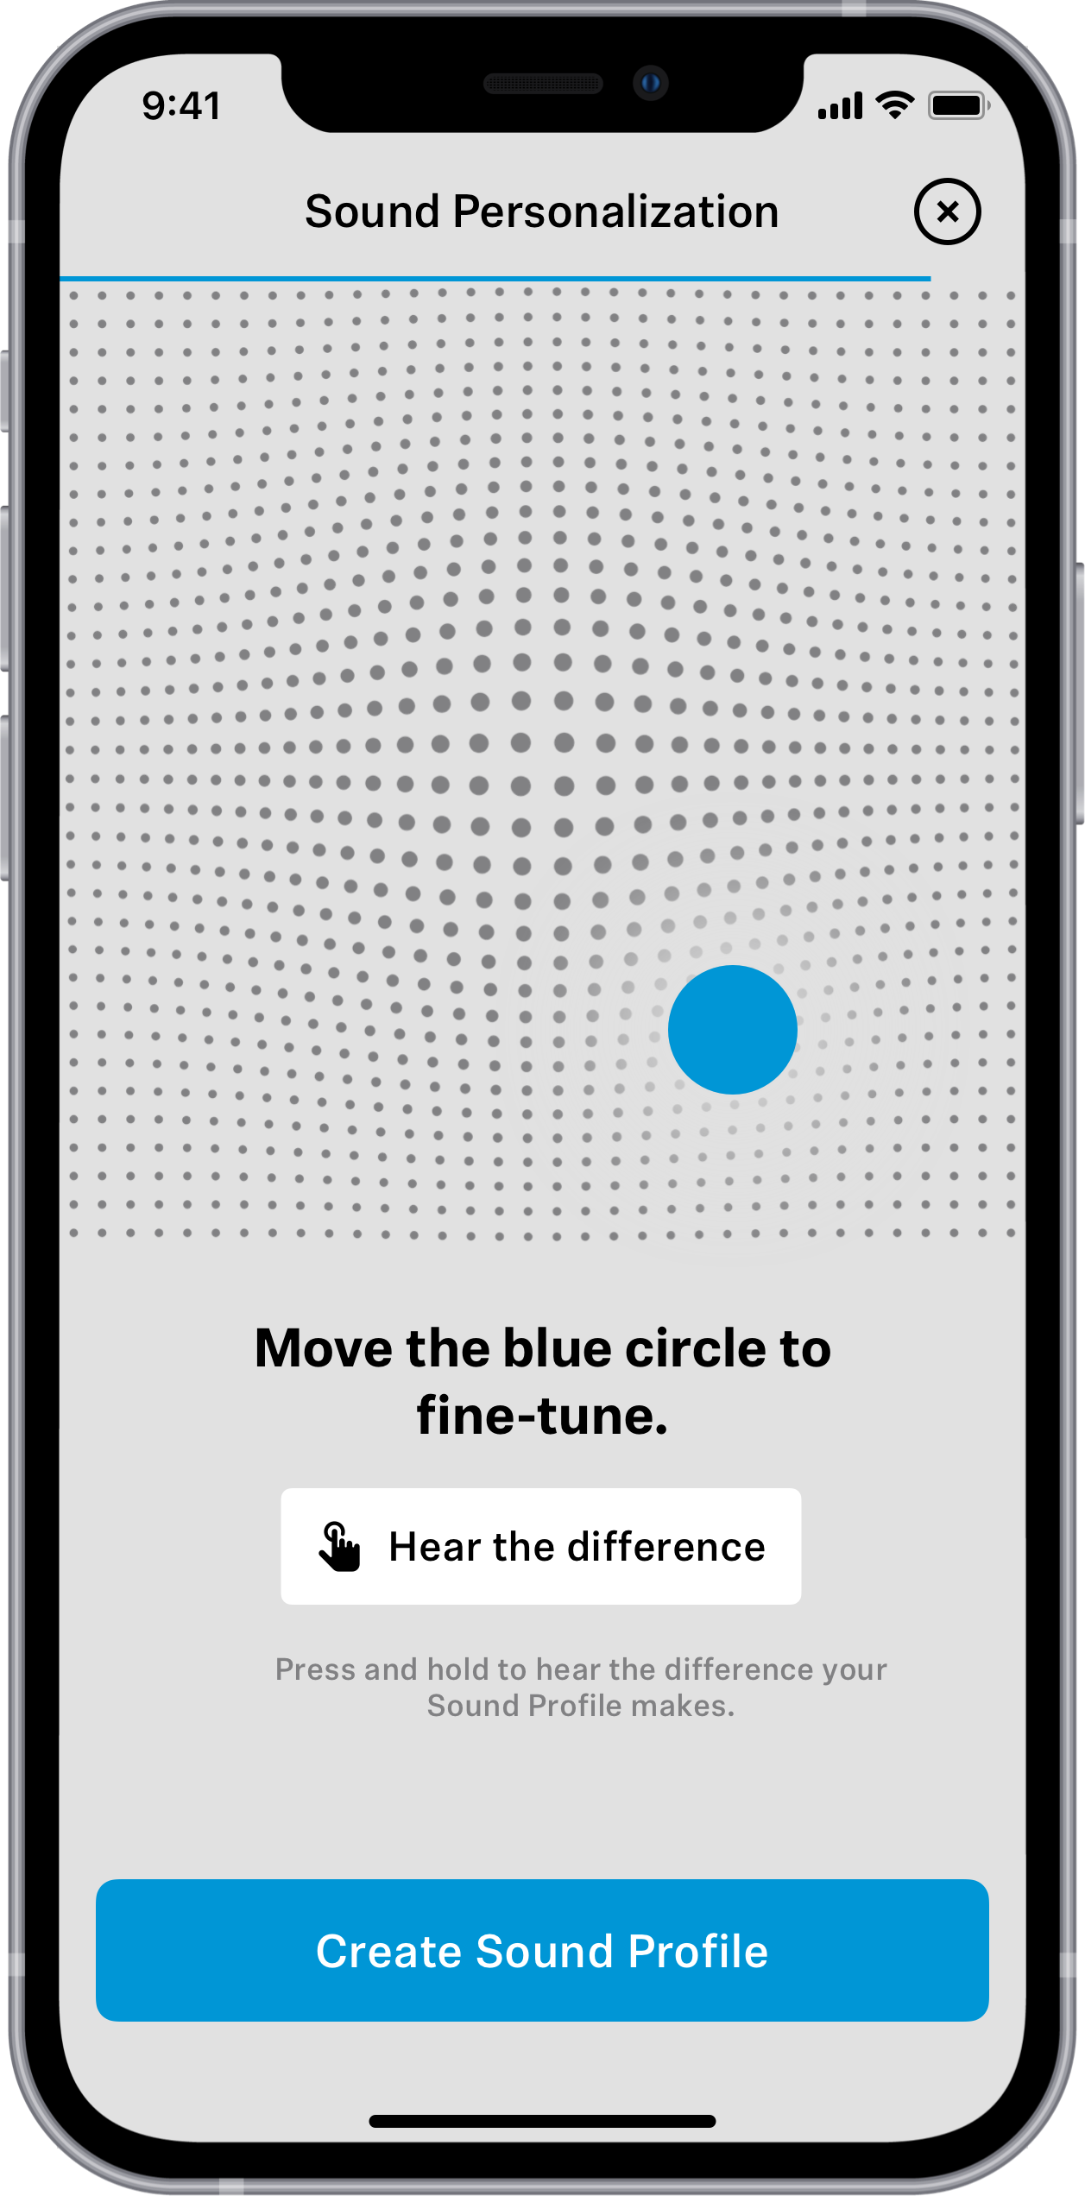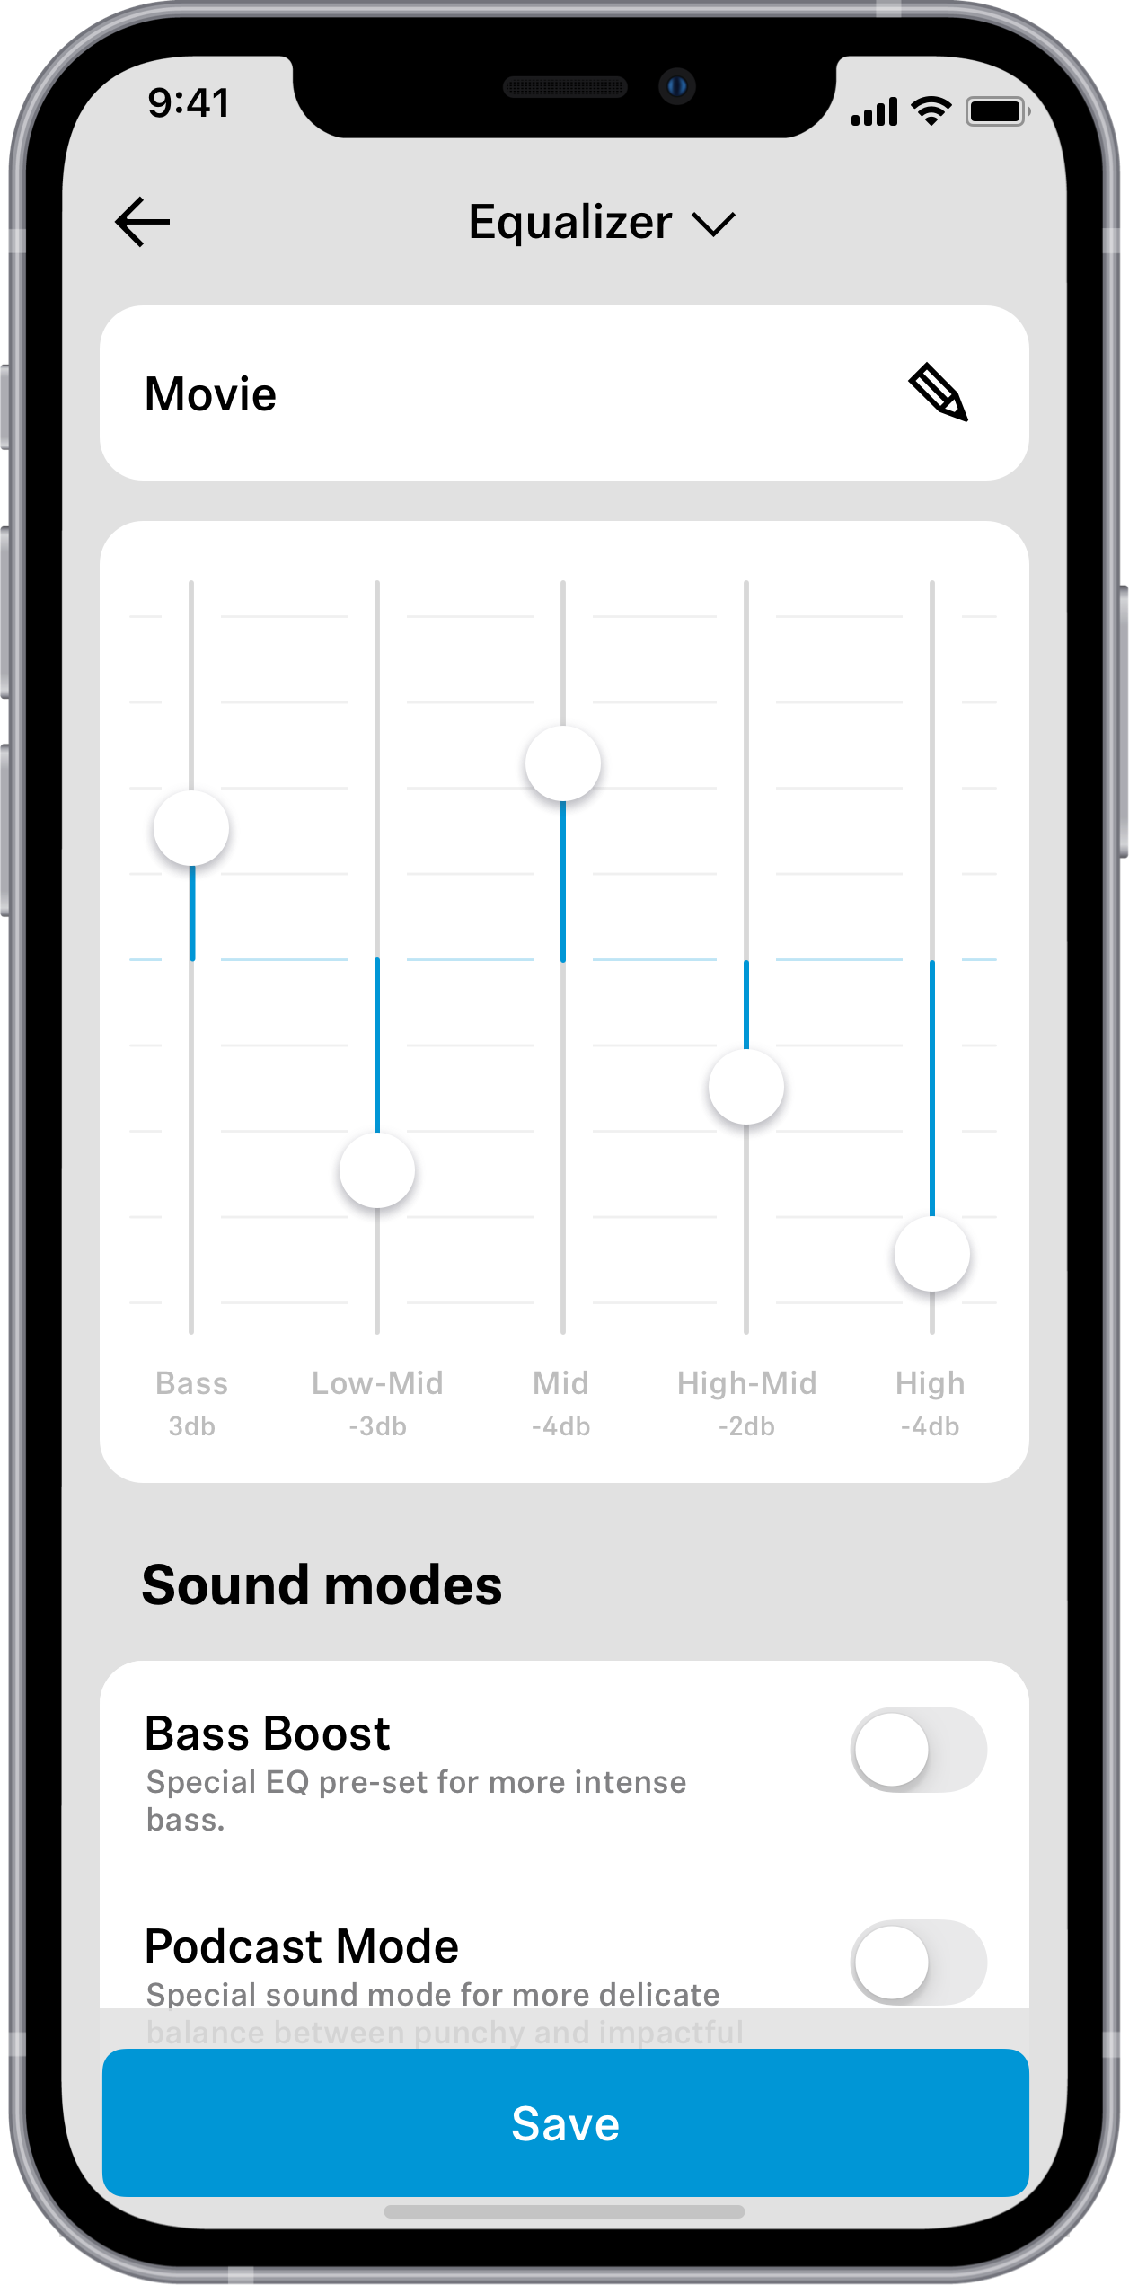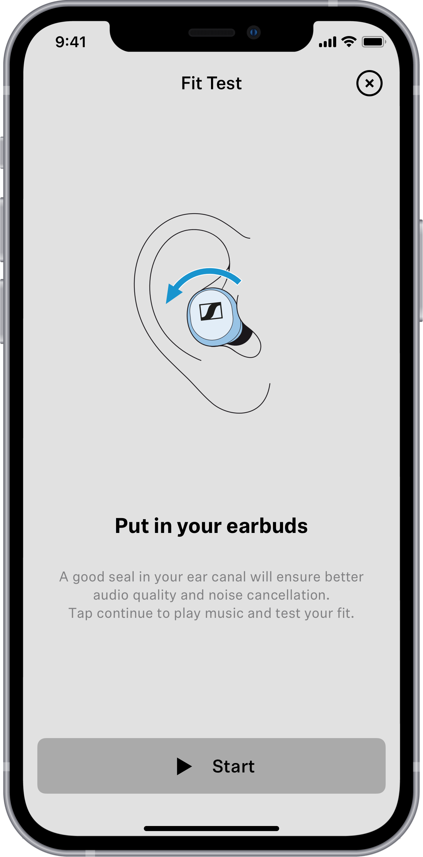
Take it personally
The premium listening experience offered by the MOMENTUM True Wireless 3 and MOMENTUM 4 Wireless becomes even more powerful thanks to the science of sound. Via an update, each model gains an expanded equaliser section and interactive Sound Personalisation mode—the latter developed with the renowned site for Hearing, Speech and Audio Technology at Fraunhofer Institute for Digital Media Technology IDMT in Oldenburg, Germany. Applying over a decade of the IDMT’s research into the intricacies of individual listening preferences, Sound Personalisation intelligently calibrates a custom audio profile from a sophisticated analysis of user reactions against a series of benchmark sound samples. From there, advanced audio processing algorithms shape the listening experience around the elements of music the wearer finds most pleasing. Following the benchmark analysis, the user can further fine-tune their profile on an interactive X-Y grid, then store the results in their profile or further adjust it without restarting the sample analysis.

“The unique feature of the Sound Personalisation is that it can account for differences in personal sound preferences that naturally occur due to different listening levels. For example, some listeners prefer more treble at low levels, and more bass at high levels. Sound Personalisation easily detects these differences and then adjusts the playback automatically. This ensures that the sound is optimally matched no matter what the listening volume is,” says Dr. Jan Rennies-Hochmuth, head of the group Personalised Hearing Systems at IDMT.
For those who prefer to calibrate their audio experience with graphic equalisation, the MOMENTUM True Wireless 3 and MOMENTUM 4 Wireless three-band EQ expands to five. Low-mid High-Mid sliders join the Low, Mid and High controls for additional sonic shaping potential. Like all Smart Control App EQ settings, users can save custom presets and Sound Personalisation profiles to their profile for instant recall—a boon for those that want to bring a state-of-the-art listening experience when moving to a new smartphone.

Next level performance
Echoing the late-2022 firmware update to MOMENTUM True Wireless 3 that unlocked a high-resolution sound mode, MOMENTUM 4 Wireless supports up to 24-bit depth and 96 kHz sample rate over a Bluetooth® connection. This user-enabled mode increases the Bluetooth bitrate up to 420 kilobits per second for wired-level sound quality on audio sources similarly using aptX™ Adaptive. Also via the MOMENTUM 4 Wireless’ firmware update, wearers may use the Smart Control App to toggle the headphone’s touch gesture capability on or off.

A perfect fit
The Smart Control App now incorporates a clever Fit Test to help listeners get the ideal seal for their MOMENTUM True Wireless 3 earbuds. Using the app-guided audio cues and packaged ear adapter kit, the app will suggest placement and even what size ear adapters to use within each ear to dial in the perfect fit for immersive sound and the most effective seal for active noise cancelling. Packaged inside the MOMENTUM True Wireless 3’s own firmware update, wearers can get a true wireless listening experience that sounds as good as it feels.

Optimisations & availability
The latest round of updates also features numerous optimisations for faster device connection, increased app stability, quicker OTA firmware updates and a host of other fixes and enhancements. These features are available in the just launched version 4.3 and up of the Smart Control App and can be installed from the App Store (iOS) or Google Play Store (Android). Additional features are available for MOMENTUM True Wireless 3 customers on firmware version 2.12.33 and up, while MOMENTUM 4 Wireless features are available on firmware version 2.13.18 and up. For more information about Smart Control App and MOMENTUM series headphones, visit sennheiser-hearing.com.

About the Sennheiser brand
We live and breathe audio. We are driven by the passion to create audio solutions that make a difference. Building the future of audio and bringing remarkable sound experiences to our customers – this is what the Sennheiser brand has represented for more than 75 years. While professional audio solutions such as microphones, meeting solutions, streaming technologies and monitoring systems are part of the business of Sennheiser electronic GmbH & Co. KG, the business with consumer devices such as headphones, soundbars and speech-enhanced hearables is operated by Sonova Holding AG under the license of Sennheiser.

www.sennheiser.com
www.sennheiser-hearing.com

Press contact
Sonova Consumer Hearing GmbH
Paul Hughes
Head of PR and Influencers, Sennheiser Headphone and Soundbars
T +49 (0) 162 2921 861
paul.hughes@sonova.com

Sennheiser UK&I PR agency
sennheiser@harvard.co.uk

