Press release

EVOC SPRING/SUMMER 2019: HIP PACK PRO 3l & HIP POUCH 1l
FREE YOUR BACK AND THE REST WILL FOLLOW: TWO NEW HIP PACK STARS TO CONQUER THE TRAILS IN 2019

GREAT STORIES DEMAND SEQUELS. THEREFORE, IT’S NO WONDER THAT THE SUCCESS STORY OF EVOC’S HIP PACKS WILL CONTINUE WITH THE COMPANY’S TEN-YEAR ANNIVERSARY: SPRING/SUMMER 2019 WILL SEE TWO NEW, SUPER-FUNCTIONAL BIKE HIP PACKS HIT THE MARKET – THE HIP PACK PRO 3l AND THE HIP POUCH 1l. BOASTING THREE NEW COLOUR SCHEMES EACH, THEY OFFER A LITTLE MORE SPACE, OR JUST ENOUGH FOR SHORT AFTER-WORK RIDES.

If it originates in Hollywood it generally requires a cautious approach but if it comes from EVOC it’s sure to be a blockbuster: The continuation of the 2017 “HIP PACK RACE 3l” success story promises to be another action-packed crowd pleaser in Spring/Summer 2019, with the HIP PACK PRO 3l and HIP POUCH 1l. Hardly surprising, because these convenient bike hip bags literally keep the weight off bike action heroes’ backs.

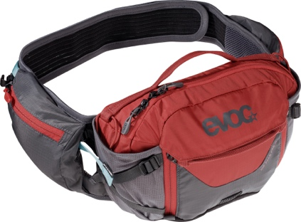
STARRING THE VENTI FLAP
Be it Mexico or Massa Vecchia: main thing is to make sure you don’t sweat unnecessarily on bike tours in high temperatures. Even in the heat of summer, the EVOC HIP PACK PRO 3l offers maximum ventilation and minimal contact with the back – sufficient water supply included. The perforated EVA pads of the AIR FLOW CONTACT SYSTEM on the inside, with ventilation channels and mesh covering, ensure reduced contact with the body. Plus, they prevent pressure points and make for optimum ventilation. The VENTI FLAP system does the rest: adjust the distance between the hip pack and your back in no time at all, and easily loosen it for strenuous ascents and tighten it for fast-paced downhill runs.

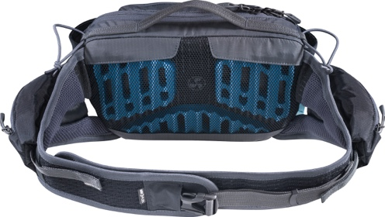
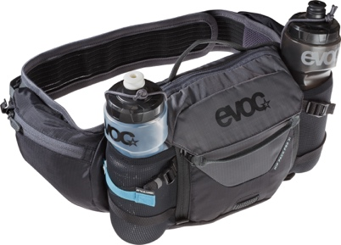
The flexible, length-adjustable AIRO FLEX hip belt deserves to be Oscar-nominated for its fit and all-out comfort. The two zipper pockets with key holder on the belt can be opened using only one hand, making them ideal for storing your mobile phone, energy bars or other essentials that you want to access quickly. The main compartment of the HIP PACK PRO 3l has space for a hydration system that holds up to 1.5 litres of liquid. An external, fold-down tool compartment with additional zipper pocket for small parts accommodates spare hoses and multi-tools. And to ensure that you never run out of liquids even when riding in unrelenting heat, there are two flexible pockets for extra water bottles on the right and left of the main compartment – naturally with straps and rubber retention bands because you want them to stay in place even on bumpy stretches. The new super star in the HIP PACK range also shines brightly at night, thanks to the BACKLIGHT CLIP. The pack comes in Carbon Grey, Carbon Grey/Chili Red or Sulphur/Moss Green and will be available from fall 2018.

HIP POUCH 1l: THE UP-AND-COMING TALENT FOR SHORT RIDES
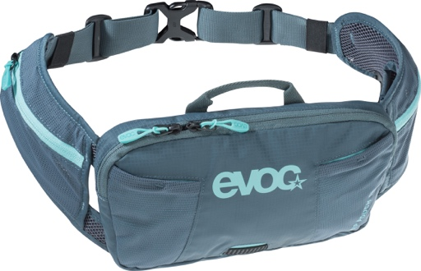
Fancy a summer, after-work ride around your local mountain, but the thermometer still shows 30 degrees Celsius? Too little to take to justify carrying a backpack? No problem with the EVOC HIP POUCH 1l: Pack your essentials for short tours in this small hip bag and give your back a break. The length-adjustable hip belt with wings made of moisture-wicking AIR MESH is extremely light and air-permeable. The two flexible zipper pockets on the outside are ideal for your wallet or small bits and pieces, while the main compartment has space for your keys, tools or a thin windcheater – just in case the “short” bike trip happens to end at the beer garden and it gets a little chillier and later than expected. You can then also attach the rear light to the BACKLIGHT CLIP.
Two external, flexible pockets on the main compartment are just right for muesli bars and the like. And of course, there is no need to sacrifice comfort with this little all-rounder: the AIR PAD SYSTEM with two Air Mesh covered pads in the lumbar area ensures maximum ventilation, ultimate moisture management and minimum pressure. The HIP POUCH 1l will be available from fall 2018, and comes in Slate, Loam and Black.

SPECIFICATIONS

HIP PACK PRO 3l
Volume: 3 l
Dimensions: 28 x 18 x 8 cm
Weight: 560 g
Colours: Carbon Grey, Carbon Grey/Chili Red and Sulphur/Moss Green
Sizes: One size fits most
Price: 90.00 € (120.00 € incl. hydration bladder)

HIP POUCH 1l
Volume: 1 l
Dimensions: 26 x 16 x 3 cm
Weight: 220 g
Colours: Black, Loam, Slate
Sizes: One size fits most
Price: 45.00 €

Date: May 2018
Subject to changes.

Media Contact: Dani Odesser | press@evocsports.com | +49 (0)170 3131812

Media Contact North America: UNCOMMON COMMUNICATIONS | Jordan Carr | jordan@uncommoncommunications.net

