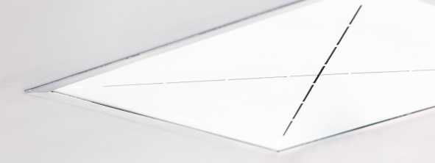

Sennheiser TeamConnect Ceiling 2 elevates conferencing experience at German Centre Beijing
German Centre Beijing selects Sennheiser’s TCC2 to provide state-of-the-art meeting and conferencing solutions for its tenants

Beijing, 26 October 2021 – The German Centre Beijing provides modern office spaces, offers conference and meeting facilities, and supports companies with practical advice and services. Located at the heart of Beijing’s business and diplomatic district, the German Centre takes care of the complete workspace infrastructure, so that tenants can entirely focus on their business. Since 1999, more than 500 companies have used the German Centre Beijing to start and grow their business in China. Currently, its 17,000 sqm space is home to more than 70 companies.

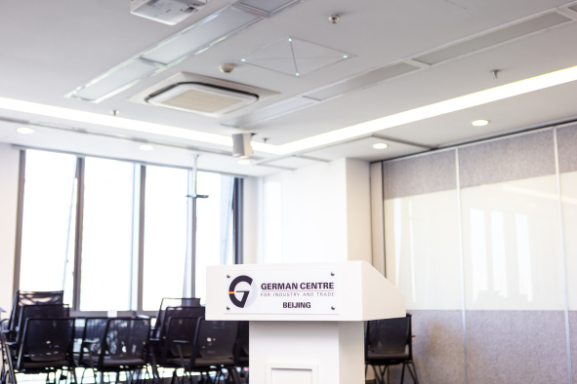 | The German Centre Beijing installed two Sennheiser TeamConnect Ceiling 2 microphone units in its Stuttgart meeting room

The German Centre offers different types of meeting rooms and facilities for both offline and online meetings and activities – in perfect sync with the needs of their tenants. Recently, the German Centre Beijing has installed two Sennheiser TeamConnect Ceiling 2 (TCC2) units in its ‘Stuttgart’ meeting room to improve the hybrid meeting and conferencing experience.

“With the COVID-19 pandemic, many meetings have moved online. We saw a huge increase in the demand for better meeting room audio and conferencing solutions to support this ‘new normal’,” said Jochen Tenhagen, Managing Director of the German Center Beijing.

The 72m² Stuttgart meeting room seats up to 50 people and is used for a variety of functions and business meetings. The room can be expanded into a larger conference area for up to 100 participants with different seating configurations.

A flexible and powerful audio and conferencing solution
TCC2 proved to be the perfect audio and conferencing solution for this space thanks to its adaptive beamforming technology and TruVoicelift functionality, which significantly increases speech intelligibility in a meeting or conference room, allowing participants to be heard clearly from every corner of the room.

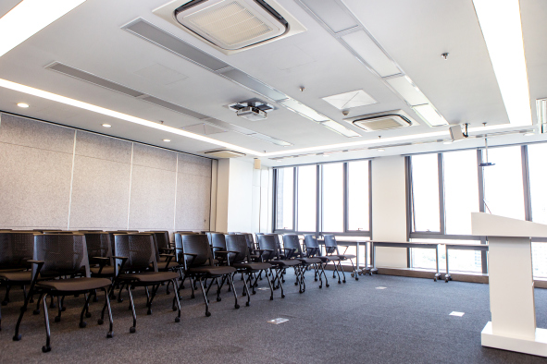 | TruVoicelift ensures a clear and pleasant listening experience for all participants, no matter where they are seated in the room

“TCC2 has enabled a truly contactless and wireless experience for our tenants, which has greatly reduced hygiene risks. The dynamic beamforming technology automatically follows the active speaker’s voice, allowing them freedom of movement in the room. Most importantly for us, this meant that the configuration of the room is flexible, and changing it will not impair the audio quality,” explained Jochen Tenhagen. With TCC2, it is also possible to define advanced exclusion zones within the meeting room to eliminate unwanted noise sources, and a priority zone for uninterrupted speech pick-up.

Jochen Tenhagen, Managing Director of German Centre Beijing, shared his experience using Sennheiser TeamConnect Ceiling 2 microphones | 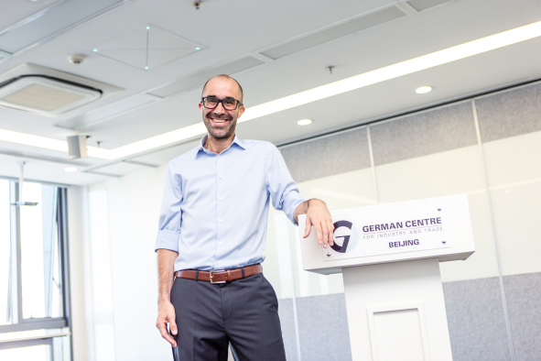

Users of the Stuttgart meeting room can now participate in meetings in a stress-free environment and can be confident that they would not miss any key information due to poor sound quality. Participants and guest speakers who join an event remotely will enjoy the same great sound quality: TCC2 will reliably pick up all speakers within a room and make the remote experience more life-like and engaging.

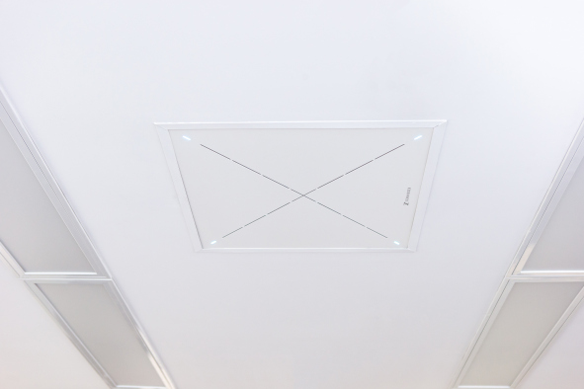 | The installation of TCC2 was easy and straightforward

The TCC2 is embedded in the meeting room ceiling and the installation was easy and straightforward. The integration of TCC2 with other solutions such as the Q-SYS Core 110f processor from QSC and Clickshare CX-30 conferencing solution from Barco was seamless, and together, they form an integrated smart system that can be controlled using the Crestron control panel.

Stuttgart Meeting Room - the most popular meeting room in German Centre Beijing
With the upgrade of the Stuttgart meeting room, TCC2 has not only made remote conferencing more convenient, but also elevated the in-room audio capabilities for live events and meetings. In fact, the Stuttgart meeting room has now become the most popular meeting room at the German Centre Beijing.

“I’m really happy with Sennheiser’s TCC2. We can now hear each other clearly from every part of the room, without the need to handle handheld microphones. The conferencing experience for participants who attend meetings and events virtually has also improved greatly with TCC2. Regardless of whether two or twenty participants attend, the sound quality of our virtual meetings is comparable to face-to-face meetings. I am very satisfied with this partnership with Sennheiser,” added Jochen Tenhagen.

The German Centre Beijing is confident that its tenants will continue to benefit from TCC2. TCC2 is compatible with leading video collaboration platforms such as Zoom and Tencent Meeting and is certified for Microsoft Teams when deployed with Microsoft-certified DSPs.

Watch a video about the German Centre Beijing here.

(Ends)

The high-resolution images accompanying this press release plus additional photos can be downloaded here.

About Sennheiser
Shaping the future of audio and creating unique sound experiences for customers – this aim unites Sennheiser employees and partners worldwide. The independent family company, which is managed in the third generation by Dr. Andreas Sennheiser and Daniel Sennheiser, is today one of the world’s leading manufacturers of headphones, loudspeakers, microphones and wireless transmission systems. In 2020, the Sennheiser Group generated turnover totaling €573.5 million. www.sennheiser.com

Global Press Contact

Stephanie Schmidt
Stephanie.schmidt@sennheiser.com
+49 (5130) 600 – 1275

Local Press Contacts

Sarah James Maik Robbe
sarahj@gasolinemedia.com maik.robbe@sennheiser.com
+44 (0) 1483 223333 +44 (0) 7393 462484

