For more information, please contact Marta de Paco
On +34 670 780 664 or email press@comunicahair.com

Important:
These images are only available for editorial content and social media.
Credits must be included.
Notification of their publication is expected.

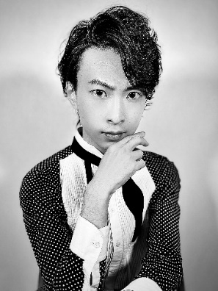
RYUTA TOMONO
REBIRTH OF ILLUMINARE Collection
JAPAN

Hair: Ryuta Tomono @ryuta_tomono
Hair Assistant: Daisuke Tanimoto, Kanta, Yohei Aok
@tanimoto.daisuke1994; @kyfrom2014; @ooooooyohei
Photography: Daiki Nakamura @daikinakamuraphotography
MUA: ASUKA @hairmake.asuka
Styling: BLGV @e.blgv
Models: Gold image model Keren Louis @kerenlouisofficial, Black image model, Alyona.B @aryon_jp

RYUTA TOMONO
REBIRTH OF ILLUMINARE Collection
JAPAN

The collection is inspired by Byzantine art with all the richness of its details and elements. It is also a vindication of craftsmanship by designing thousands of strands of hair, a technical and creative achievement for Ryuta Tomono.
When we contemplate the images, we perceive them as sculptures. For creating them, the hairdresser has modelled and used 3D printing for an impeccable and surprising fusion between art and hair. The looks represent the dichotomy between night and day. On the one hand, the world overflowing with the brightest light from the sun and, on the other, the one that is submerged in the darkness of the night illuminated only by the light of the moon and the stars. All expressed through the hair that adopts the necessary force to convey his message.
To achieve this amazing work, BLGV, as art director, ASUKA as makeup artist ASUKA and Daiki Nakamura as photographer have joined forces, merging their talents.

