Get closer to grandpa and grandma with great video sound
Experience smartphone videos with first-class Sennheiser sound

Wedemark, April 6, 2020 – In the current situation, responsible social distancing is helping to protect older and sick people in our society. Even so, grandparents won’t want to miss out on all those precious moments with grandchildren – like hearing some of their first words, watching them paint Easter eggs or listening to the debut home concert on a newly-learned instrument. Luckily, smartphones are always at hand – and family members not sharing the same household can still enjoy a lovingly created video message or a child’s homemade vlog at any time.

This is where Sennheiser can help: The audio specialist’s compact Memory Mic is a high-quality mic that virtually anyone can use. The handling is easy: at the push of a button, the “One Touch” audio-/video-synchronization perfectly aligns the sound with the picture. The Sennheiser Memory Mic can be comfortably attached to the clothing; the connection to the smartphone occurs automatically without inconvenient cables, thanks to Bluetooth technology.

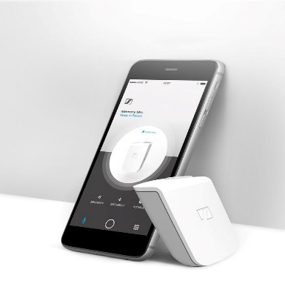
The housing of the Memory Mic is compact and robustly constructed but at the same time so lightweight that children easily forget they are wearing it on their clothes

The Sennheiser Memory Mic has a sleek white design and sturdy plastic housing that can be easily cleaned as needed, so that even younger children can handle the compact microphone. The Memory Mic weighs only 30 grams, so it will never restrict a child's joy of movement. On the contrary, the “little stars" usually forget very quickly that they are wearing a microphone at all. Now nothing stands in in the way of recording a video message or making a vlog.

The perfect companion for listening at home
For videos with great sound, the best way for family members to enjoy the experience in full is with great headphones. Sennheiser’s HD 450BT around-ear headphones are the ideal choice for feeling like you’re there in the room. The sound can be personalized via Sennheiser’s Smart Control app and there’s even a podcast mode to help optimize the comprehensibility of speech content like family vlogs, podcasts or audio books – perfect for getting more out of staying in.
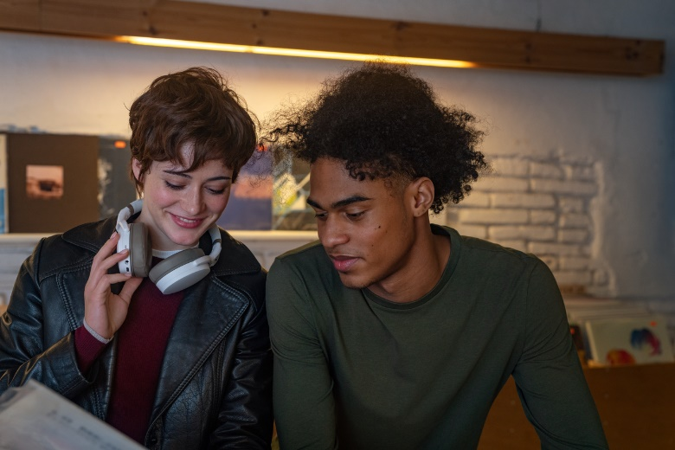
The HD 450BT has a great sound and can even help make voice recordings clearer thanks to its dedicated podcast mode

The HD 450BT headphones also impress with their ergonomic comfort and minimalist style. Active Noise Cancellation blocks out ambient noise so that no matter how noisy your environment, you can still perfectly hear your loved ones’ voices.

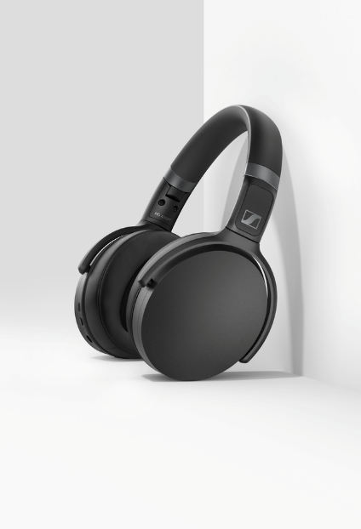
Understanding your loved ones clearly is no problem, even in a noisy environment, thanks to the HD 450BT’s ANC function
Shooting home videos with your smartphone and a Sennheiser Memory Mic is a great way for the whole family to enjoy their leisure time. It encourages creativity and keeps the family entertained, while letting remote family members take part in your life. When great video is so simple, you just need to ask “What will we record today?”.

To celebrate the audio specialist’s 75-year anniversary, the Sennheiser Memory Mic is available for a special price of 99 EUR (MSRP) from April 6 until May 31. Available in black or white, the HD 450BT retails for 179 EUR (MSRP). An alternative to the HD 450BT is Sennheiser’s HD 350BT without ANC, which is available in black or white at 99 EUR (MSRP).

About Sennheiser
Founded in 1945, Sennheiser is celebrating its 75th anniversary this year. Shaping the future of audio and creating unique sound experiences for customers – this aim unites Sennheiser employees and partners worldwide. The independent family company, which is managed in the third generation by Dr. Andreas Sennheiser and Daniel Sennheiser, is today one of the world’s leading manufacturers of headphones, loudspeakers, microphones and wireless transmission systems. In 2018, the Sennheiser Group generated turnover totaling €710.7 million. www.sennheiser.com

Global Press Contacts
Stephanie Schmidt Jacqueline Gusmag
stephanie.schmidt@sennheiser.com jacqueline.gusmag@sennheiser.com
T +49 0(5130) 600 – 1275 T +49 0(5130) 600 – 1540

