EMBARGOED UNTIL MONDAY, FEBRUARY 12TH 10:00 A.M. EASTERN
Listen Up: Sonarworks Adds a Plethora of New Headphone Models
to its True-Fi Software for CanJam New York
True-Fi puts studio sound within reach — on over 125 headphone models and counting
New York, February 12, 2018 – European audio software developer Sonarworks announced the addition of more than ten new headphone models to its consumer-facing headphone calibration software platform, True-Fi. The new headphone profiles, which have been meticulously measured and incorporated as a complimentary software upgrade for existing True-Fi users, will be available on the first day of CanJam in New York on February 17th.

The new headphone models are listed below and on Sonarworks website here: https://www.sonarworks.com/truefi/headphones
- Audio Technica ATH-DSR9BT
- Beyerdynamic DT 770 Pro 32 Ohm
- Bose QuietComfort 35 II
- Hyperx Cloud II
- Plantronics Backbeat Pro 2
- Sennheiser HD-280 PRO
- Sennheiser HD 518
- Sennheiser RS 120 II
- Sennheiser Momentum 2.0
- Sony WH-1000XM2

Sonarworks' True-Fi technology, which made its debut in the consumer market in November of 2017, removes unwanted sound coloration from headphones so consumers can experience the artists' true intentions — on a sonically balanced listening canvas. The consumer-based software — which is available on both Mac and PC platforms — is priced at just $79 USD and was awarded 'Best in Show' in the music listening category at CanJam Europe in Berlin last November.

The True-Fi software platform, which now supports more than 125 popular headphone models, takes just seconds to configure and employs measurement-based compensation profiles to correct tonal discrepancies that are caused by the headphones' physical construction. The result is 'studio reference sound' — closer to the artist's intentions and resulting in a more emotionally engaging listening experience.

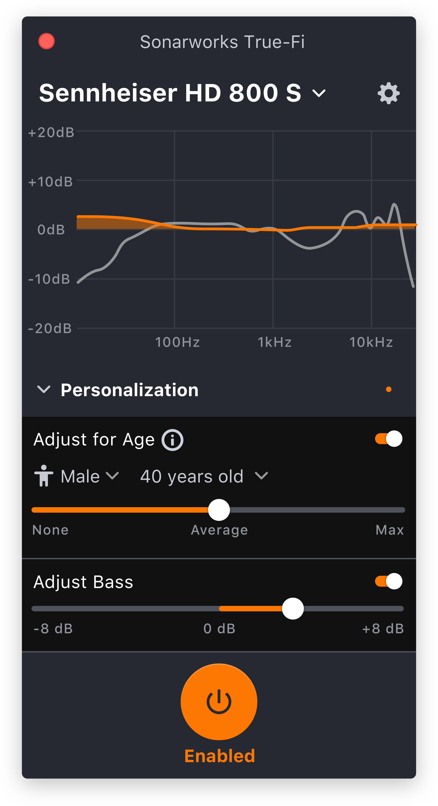
Pro audio heritage
The recent launch of True-Fi reflects Sonarwork's deep expertise in the recording studio industry. Currently, the company's professional software is installed in thousands of recording studios and relied on by top studio mixers and mastering engineers around the world. In 2015, the company's professional audio software offering, Reference 3, received an 'Editor's Choice' award from respected UK-based publication Sound on Sound. Recently, the company launched its latest professional software offering: Reference 4.

"The biggest problem music listeners experience today is not in the file and stream quality, but the playback," commented Helmuts Bēms, CEO and co-founder of Sonarworks. "True-Fi uses proprietary, research-driven technology to audibly improve the performance of loudspeakers and headphones. True-Fi stays true to the promise in its name, helping listeners experience the artists' true intention."

Sonarworks, which is constantly adding new headphone models to its calibration profiles, will soon be available on mobile devices at no additional charge to existing users. Further, new features such as personal listening profiles and age-based hearing compensation, will be introduced in the coming months. Currently, the software supports sample rates of up to 96kHz and the company plans to announce support of higher sample rates in the near future.

True-Fi is available for purchase on Sonarworks' website. For more information about Sonarworks' True-Fi, please visit https://www.sonarworks.com/truefi.
About Sonarworks
Sonarworks is a Europe-based audio software development company specializing in acoustic calibration and DAW plugins. Accurate sound is our passion. The company was founded in 2013 and entered the pro audio market in 2015. Sonarworks software is relied upon by many Grammy winning artists and engineers around the world.

Media Contact:
Jeff Touzeau
Hummingbird Media
+1 (914) 602-2913
jeff@hummingbirdmedia.com

