EBOLA IN DEMOCRATIC REPUBLIC OF CONGO (DRC)
CRISIS INFO #1
29/05/2018

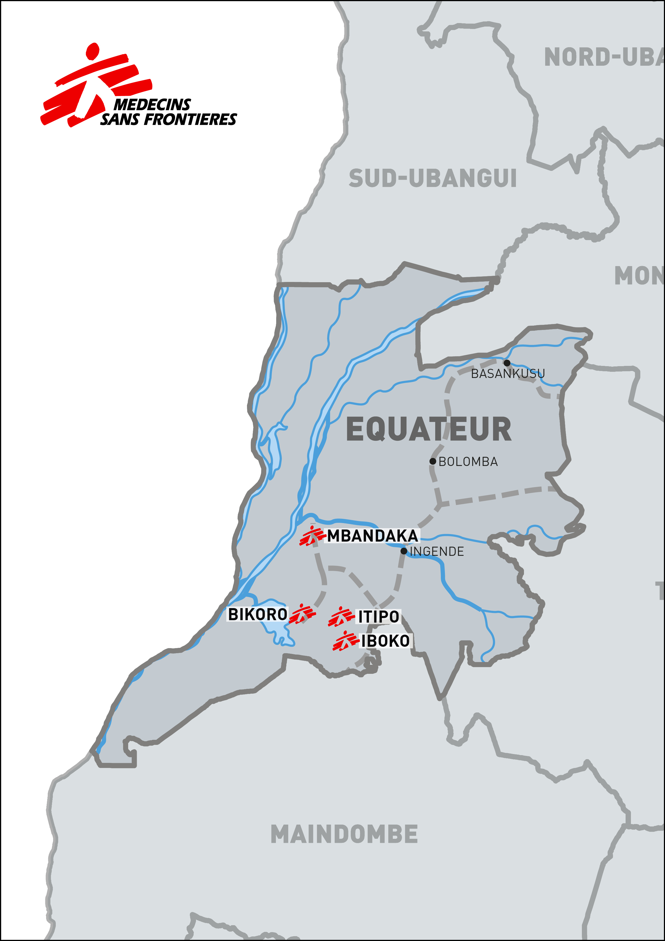

- Global overview

>>> Latest figures (source: DRC Ministry of Health) – date of info: 28 May 2018
Since the Ebola epidemic in DRC was declared on 8 May 2018, 54 people who presented symptoms of haemorrhagic fever, including 35 confirmed Ebola cases and 25 deaths (of whom 12 were confirmed as Ebola), have been notified by the national health authorities in the Equateur region, where the outbreak started.
 | Suspect cases | Probable cases | Laboratory-confirmed cases | Deaths
Mbandaka | 1 | 0 | 4 | 3
Bikoro | 1 | 11 | 10 | 16
Iboko | 4 | 2 | 21 | 6
TOTAL | 6 | 13 | 35 | 25

>>> Context

The outbreak is currently affecting the city of Mbandaka and the health zones of Bikoro (Bikoro and Ikoko villages), and Iboko (Itipo and Iboko villages). Bikoro, a small city where some Ebola cases have been detected, is approximately four hours’ drive from Mbandaka. Connections with Bikoro are also possible via Lake Tumba, which the local community uses to reach the Congo River.
This is the ninth Ebola outbreak in DRC in the last 40 years. So far, most of the previous outbreaks have occurred in relatively remote and isolated areas, with little spread of the disease. The last Ebola outbreaks in DRC occurred in Likati district in May 2017, with eight people infected, of whom four died, and in Boende (Thsuapa region) in 2014, with 66 people, of whom 49 died.
Unlike in previous Ebola outbreaks in DRC, where cases have been concentrated in remote villages, patients have now been diagnosed in Mbandaka, a Congo River port city of more than one million inhabitants. While easy access to transport increases the risk of the virus spreading, surveillance is being reinforced, and as of 29 May 2018, only four lab confirmed patients have been identified in Mbandaka. For now, it’s important to emphasise that the epidemic has not spread widely within the city. With the correct intervention and careful monitoring of the situation, it is possible to limit the spread of the outbreak.
During the past few weeks, MSF has been working closely with the Congolese Ministry of Health (MoH) and with other organisations on the ground to coordinate the response. The response is based on the ‘six pillars’ of Ebola intervention (1. care of diagnosed patients and isolation; 2. outreach activities to find patients; 3. tracing and follow-up with patient contacts; 4. health promotion activities to inform people about the risks and how to avoid them; 5. support of regular healthcare; 6. safe burials to avoid infections). We are currently carrying out activities in Mbandaka, Bikoro, Iboko and Itipo.
MSF and its research unit, Epicentre, are working with the local health authorities and the World Health Organization (WHO) to participate in the implementation of the Ebola vaccine rVSVDG-ZEBOV-GP, which is being used as part of the overall strategy to control the Ebola outbreak.
- MSF operational highlights

To tackle the Ebola epidemic and limit the spread of the virus, Médecins Sans Frontières (MSF) is stepping up its response in the affected areas.

MSF emergency teams are present in four locations where suspect and confirmed patients have been identified, and are working in collaboration with DRC’s Ministry of Health (MoH) and the WHO.

The organisation currently operates two Ebola Treatment Centres (ETC), with a total of 32 beds in isolation, and one transit centre in Itipo. As of 29 May, we are currently caring for 19 patients.

Around 60 tonnes of supplies have been shipped to Kinshasa and dispatched to the affected areas since the beginning of the epidemic.

MSF’s Ebola response in DRC started on 5 May, with an epidemiological alert in the Equateur region. A small team from MSF’s Congo Emergency Pool (PUC) assessed the situation, together with teams from the MoH and WHO. When the Ebola epidemic was officially declared on 8 May, experts from MSF’s emergency pools arrived in the field to deploy a rapid response in the Ebola hotspots. Among the MSF staff on the ground are some of the organisation’s most experienced Ebola field workers, including medical personnel, experts in infection control and logisticians.

Mbandaka
At the beginning of the outbreak, we set up an isolation zone with five beds in Mbandaka’s main hospital (Wangata hospital). An MSF ETC with 12 beds was also built, and has been operational since 28 May. The bed capacity in the ETC can be upgraded to 40 if needed. This will allow the main hospital to refocus on providing non-Ebola healthcare to the local population.

In addition to the treatment and isolation of suspected and confirmed Ebola cases, the focus of MSF’s response is on surveillance, investigation of new cases and contacts, infection control and prevention, health promotion and training activities.

Bikoro
The team is also intervening in Bikoro, where an MSF ETC with 20 beds has been built, and continues to reinforce outreach activities including investigation on contact cases, monitoring and surveillance.

Itipo/Iboko
MSF teams are also present in the remote areas of Itipo and Iboko, where suspected and confirmed Ebola cases have been identified. In Itipo, a transit centre with isolation capacity is already functional. In this transit centre, suspected cases are isolated and cared for, and samples are taken to confirm diagnosis. If Ebola is confirmed, they are transferred to the Bikoro ETC.

In Iboko, an isolation area has been built in the main hospital and the team is constructing a further ETC.

Vaccination
MSF and its research unit (Epicentre) are working closely with the MoH and the WHO on the implementation of the Ebola vaccine rVSVDG-ZEBOV-GP, as an additional measure to control the outbreak.

>>> Overview of operations
- Patients treated – date of info: 29 May 2018 (source: MSF)
Where | Patients
Mbandaka (Wangata hospital –isolation zone) | 0
Mbandaka (MSF ETC) | 0
Bikoro (MSF ETC) | 10 confirmed
Itipo (Ebola Transit and Treatment Centre) | 6 suspects
Total | 19 patients
- Staff on the ground - date of info: 28/05/2018
TOTAL: 60 international and 106 national staff are currently working in Equateur province in response to the Ebola outbreak.

- Supply material - date of info: 26/05/2018
Supply material includes: medical kits; protection and disinfection kits (isolation items such as gloves, boots and Personal Protective Equipment-PPE, etc.); logistic and hygiene kits (plastic sheets, jerry cans, water distribution kits, chlorine spray kits, water treatment kits, etc.); drugs; transport (cars and motorbikes); tents and construction material for building ETCs.
As part of MSF’s emergency preparedness in DRC, some supplies were already available in Kinshasa. These were sent to hotspot zones as soon as the outbreak started.

Sixty tonnes of supplies (sent from MSF supply centres in Europe) have been received in Kinshasa. A total 45 tonnes of supplies (medical and logistical supplies, including six vehicles and 10 motorbikes) have already been sent to Mbandaka and Bikoro, with more to be sent in the coming days.

- Main messages

- MSF has a lot of experience and expertise working in Ebola epidemics. We have several teams working in four different locations. Some of our most experienced staff is working on the ground. We’re determined to do everything we can to help the population and stop this epidemic.

- Ebola epidemics can be contained through the ‘six pillars’ of intervention:
  - Early care and isolation of people who present with symptoms
  - Tracing and following up patient contacts
  - Informing people about the disease, how to prevent it and where to seek care
  - Supporting existing healthcare structures
  - Temporarily adapting cultural behaviour to make funerals safe
  - Outreach activities (pro-active case finding)

If this intervention is followed well, an Ebola epidemic can often be contained in a relatively short period of time.

- For all these activities, building a good understanding with local communities is vital. Medical and health promotion teams are working hard to explain to the population; what the symptoms of Ebola are, how to avoid contamination, the importance of coming to health structures as quickly as possible if they suffer from symptoms, and the importance of isolation measures to contain the disease. If patients are admitted and receive medical care quickly, the sooner their families are protected and there is a greater chance of limiting the spread of the epidemic.

- Beyond the six pillars of intervention, MSF is working with the Congolese MoH and the WHO to run a clinical study of the Ebola vaccine rVSVDG-ZEBOV-GP:
Rather than launch a mass vaccination campaign, vaccines will be targeted at the contacts of confirmed Ebola patients (as well as the contacts of these contacts), and Ebola health workers in Bikoro. This is the same strategy used to eradicate small pox, and during the previous clinical study with this vaccine in Guinea in 2015. It can hopefully help to stop the outbreak. The vaccinations are voluntary and free-of-charge. This vaccine has not yet been licensed and is therefore being implemented through a study protocol, which has been accepted by the national authorities and the ethical review board in Kinshasa, as well as MSF’s ethical review board.
- While it is understandable that the word “Ebola” causes fear across the world, the outbreak is currently quite contained in remote areas of DRC.
Neighbouring countries, as well as DRC’s overcrowded capital of Kinshasa, are implementing screening and surveillance activities to ensure that if the disease does spread, it is contained swiftly. This is the ninth outbreak of Ebola in DRC in recent years, most of which were contained relatively quickly.

- Ebola facts (from http: //www.msf.org/en/diseases/ebola)

- Transmission: The Ebola virus is introduced into the human population through close contact with the blood, secretions, organs or other bodily fluids of infected animals. Human-to-human transmission occurs through direct contact with blood or other bodily secretions of sick people with mucous membranes, such as the mouth or nostrils. This often happens when patients are tended to without proper protection measures; or during the burial (the body remains infectious even after the patients have died).
- Signs and symptoms: Sudden onset of fever, fatigue, muscle pain, headache and sore throat is followed by vomiting, diarrhoea, rash, symptoms of impaired kidney and liver function, and in some cases both internal and external bleeding.
- Diagnosis: On a clinical basis, Ebola is difficult to distinguish from a number of other infectious diseases such as malaria. Confirmation of infection with Ebola virus can only be obtained with a lab test on a sample of bodily fluid.
- Vaccination: beyond the six pillars of the Ebola response, Ebola vaccine rVSVDG-ZEBOV-GP is being administered by following a “ring approach”, and on a voluntary and free-of-charge basis. This vaccine has not yet been licensed and is being implemented through a study protocol.
- Prevention and control: Outbreak control requires a package of interventions, including case management, surveillance and contact tracing, laboratory services, safe burials and social mobilisation.

For more, consult WHO Ebola factsheet:

http://www.who.int/en/news-room/fact-sheets/detail/ebola-virus-disease

Previous outbreaks in DRC: Yambuku (1976) 318 cases - 280 deaths; Tandala (1977) 1 case -1 death; Kikiwit (1995) 315 cases- 250 deaths; Mweca (2007) 264 cases - 187 deaths; 2008-2009- 32 cases - 15 deaths; Isiro (2012) 36 cases - 13 deaths; Djera-Boende (2014) 66 cases - 49 deaths; Likati (2017) 8 cases - 4 deaths (source: DRC Ministry of Health)

