The xx present ‘We See You – Berlin’, a short film by Sylvie Weber

The first of a series of ‘We See You’ films, supported by YouTube

Watch it HERE <link>

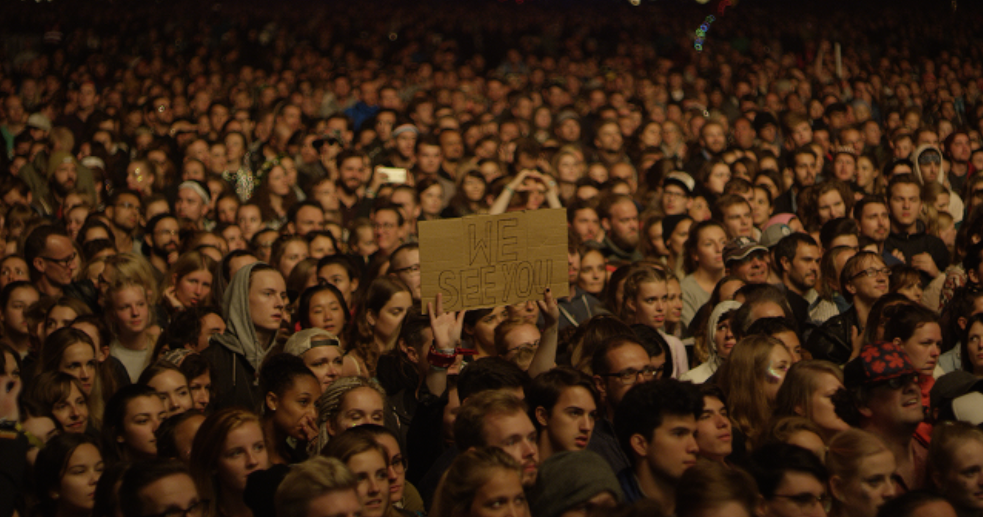

(download a series of film stills HERE)

In November 2016 - just over a year ago to the day - The xx’s Romy Madly Croft, Oliver Sim and Jamie Smith announced their return with a brand new single ‘On Hold’ and news of a third full length album, I See You. Recorded between New York, Marfa TX, Reykjavik, Los Angeles and London, and released in January 2017, I See You would go on to become a huge critical and commercial success, building on the achievements of The xx’s two previous albums, xx and Coexist. The xx’s three albums now have now sold over 4 million copies between them.

In the intervening twelve months, The xx embarked on an extensive I See You world tour that has seen them performing to millions of fans, including several festival headline appearances and a record breaking run of seven nights at London’s legendary Brixton Academy in front of over 35,000 hometown fans.

To celebrate the incredibly close bond between The xx and their fans, the band set out to create a series of short films, supported by and exclusively available on YouTube, that affectionately turn the spotlight onto their audience. Today, The xx present the first of these films: ‘We See You – Berlin’. The film sees The xx teaming up with Berlin-based filmmaker Sylvie Weber for a piece that features live and documentary footage from the band’s headline set at Berlin’s Lollapalooza festival in September, alongside intimate portraits of some of the people who attended the show. ‘We See You – Berlin’ sees Weber creating an emotive depiction of fans in this city, exploring their relationship with the band, and in turn the band's relationship with the city and the fans there.

Watch ‘We See You – Berlin’ HERE <link>

Of the collaboration, Sylvie Weber says: “My process as a filmmaker speaks to a consistent desire within me to unveil the character within, I keep an aesthetic and cinematic visual in mind when on set, cautiously leading the protagonists while allowing them to slowly become more themselves on screen.

In the case of ‘We See You’, coming across truly engaged and earnest individuals was not difficult, the vulnerability that The xx expose in their music is the basis for their incredibly close connection to the fans themselves. I think we've managed to represent in these four stories the feeling of the many millions who are so profoundly affected by the harmonies of Romy, Oliver and Jamie.”

While The xx add: “A huge thank you to Sylvie Weber for capturing some truly intimate moments from our show in Berlin earlier in the year. We’re genuinely moved by the incredibly beautiful portraits of our fans. We see you Berlin. We love you xx The xx.”

Cast List

Dustin Eulenberg
Fine Simonsen
Qichao Fan
Arianna Morales

Credits:

Directed by Sylvie Weber
Producers: Flo Hettenbach & Michael Tarzia
Director of Photography: Henk Otte
Super 8 Operator: Sylvie Weber
Editor: Andi Pek
Colorist: Bowcouleur
Sound Engineer: Victor Brand
Supported by YouTube

The xx online:
Official / Instagram / Twitter / Facebook

More information from:
Jon Wilkinson / Technique Publicity, 1 Codrington Mews, London W11 2EH /
jon@technique-pr.com

