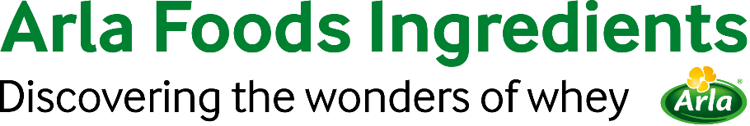

5th August 2021

PRESS RELEASE

New ingredient meets demand for
high-protein, clean-label yogurts

Arla Foods Ingredients has launched a new whey protein ingredient to help meet the growing demand for high-protein yogurts with health credentials and a premium positioning.

Nutrilac® FO-7875 allows manufacturers to develop yogurts (both spoonable and drinkable) with significantly higher protein content than typical products, which generally range from 5% to 9%. For example, it can be used to create a drinking yogurt with 11% protein and only 0.8% fat.

As well as enhancing health credentials, Nutrilac® FO-7875 is highly functional. It delivers a creamier and smoother texture, even in low-fat recipes, and does not increase viscosity. Furthermore, it does not require the addition of stabilizers, thus allowing cleaner labels.

Nutrilac® FO-7875 was developed in response to growing demand for high-protein yogurt products, the global market for which has been forecast to grow at a CAGR of over 8% to 2030. Produced in Argentina, its arrival is particularly good news for South American producers, who will benefit from proximity and greater purchase flexibility.

Ignacio Estevez, Application Manager, South America at Arla Foods Ingredients, said: “Nutrilac® FO-7875 meets a range of market needs. It can be used to create clean-label yogurts that are not only rich in high-quality protein, but also low in fat, as well as smooth and creamy. This combination of benefits will allow even more manufacturers to expand their lines to include premium products that enhance brand image. We’re particularly excited about the unprecedented opportunities it offers in South American markets, where manufacturers will benefit from reduced transit time and no import fees.”

For more information contact:

Steve Harman Ingredient Communications
Tel: +44 (0)7538 118079 | Email: steve@ingredientcommunications.com

About Arla Foods Ingredients
Arla Foods Ingredients is a global leader in value-added whey solutions. We discover and deliver ingredients derived from whey, supporting the food industry with the development and efficient processing of more natural, functional and nutritious foods. We serve global markets within early life nutrition, medical nutrition, sports nutrition, health foods and other foods and beverage products.

Five reasons to choose us:
- We have R&D in our DNA
- We offer superior quality
- We are your trusted business partner
- We support sustainability
- We ensure security of supply

Arla Foods Ingredients is a 100% owned subsidiary of Arla Foods. Our head office is in Denmark.

LinkedIn
http://www.linkedin.com/company/arla-foods-ingredients

LinkedIn (Latin America)
https://www.linkedin.com/showcase/arla-foods-ingredients-latin-america/

LinkedIn (China)
https://www.linkedin.com/showcase/arla-foods-ingredients-china/

Future Market Insights, July 2020

